

Project Implementation Unit (PIU)

Khyber Pakhtunkhwa Rural Investment and Institutional Support Project (KP-RIISP)

Public Health Engineering Department (PHED)

Government Of Khyber Pakhtunkhwa (GoKP)

Environmental & Social Management Plan (ESMP)

Integrated Water Supply and Sanitation - Rehabilitation of Existing Drinking Water Supply Schemes, Tehsil Bara, Jamrud, Landi Kotal and Mula Gori, District Khyber
April, 2026

Table of Contents
1. Executive Summary 1
2. INTRODUCTION 3
2.1 Project Description with scope of work 3
2.2 Project Background 3
2.3 Project Development Objective 3
2.4 Area of Influence of the Subproject 11
3. LEGAL, POLICY FRAMEWORK, AND REGULATORY REQUIREMENTS 12
3.1 Applicable Environmental and Social Policies 12
3.2 National and Provincial Legal and Regulatory Framework 12
3.3 Institutional Responsibilities 13
4. ENVIRONMENTAL AND SOCIAL BASELINE (District Khyber) 14
4.1 Environmental Baseline 14
4.2 Social Baseline 15
5. STAKEHOLDER ENGAGEMENT AND INFORMATION DISCLOSURE 16
5.1 Stakeholder Identification and Public Consultation 16
5.2 Stakeholder Analysis 18
5.3 Stakeholder Engagement Plan (SEP) & Disclosure 20
6. ENVIRONMENTAL AND SOCIAL MONITORING PLAN 21
6.1 Potential Environmental and Social Impacts, Mitigation Measures, and Monitoring Plan 21
6.2 Grievance Redress Mechanism (GRM) 51
6.3 Capacity Building and Training 54
6.4 Institutional Arrangements and Roles 55
6.5 Labor Camp Management 57
6.6 Occupational Health and Safety 57
6.7 GBV/SEA/SH Risk Mitigation: 58
6.8 Budget for ESMP Implementation 58
6.9 Reporting Requirements 61
6.9.1 Monitoring and Reporting Responsibilities 61
6.9.2. Types of Reports Required 61
6.9.3. Stakeholder Reporting 62
6.9.4. Emergency and Contingency Reporting 62
6.10 Labor Management Procedures (LMP) 63

List of Tables

Table 1: Details of selected schemes and proposed scope of work 5
Table 2: DWS Rehabilitation Schemes and identified sensitive receptors 11
Table 3: Stakeholder Recommendations and the Respective Response 15
Table 4: Stakeholders Identification and their respective Interest and roles 17
Table 5: Engagement Activities and Methods (During Construction) 19
Table 6: Environmental and Social Management Plan 20
Table 7: ‘Pre-Construction’ Monitoring Plan for Baseline Development 48
Table 8: Construction Phase Monitoring Requirements 48
Table 9: Operation Phase’s Environmental Monitoring Plan 51
Table 10: Personnel Training Program 54
Table 11: Budget for ESMP Implementation (Water Supply REHAB & Integrated Sanitation Component) 58
Table 12: Types, frequency and purpose of reports 61

List of Figures

Figure 1: Location of Selected Schemes (21) for Rehabilitation in District Khyber 17
Figure 2: Organizational Setup for Implementation of ESMP 50

Annexes

Annex 1. Environmental and Social Screening
Annex 2. Labor Management Procedures (LMP)
Annex 3. Maps and Architectural Diagrams
Annex 4. EPA Environmental Assessment Rules
Annex 5. Water Quality test reports
Annex 6. Participants’ List of Stakeholders’ Consultation
Annex 7. Photos (with captions) of the Consultations
Annex 8: Components of Site Specific OH&S Plan
Annex 9: KPRIISP Code of Conduct
Annex 10: E&S Monitoring Checklist (sample)
Annex 11: Incident Reporting Format (ESIRT) Form
Annex 12: Waste Management Plan
Annex 13: Voluntary land Donation (VLD) document and VLD Due Diligence screening checklist template

List of Acronyms

Public Health Engineering Department PHED
Construction Contractors CC
Contractor Environmental and Social Management Plan CESMP
Environmental Engineer EE
Environmental Impact Assessment EIA
Environmental Protection Agency EPA
Environmental Protection Ordinance EPO
Environmental and Social Framework ESF
Environmental and Social Management Plan ESMP
Environmental and Social Standards ESS
Federally Administered Tribal Area FATA
Frontier Regions FRs
General Environmental Assessment GEA
Government of Khyber Pakhtunkhwa GoKP
Government of Pakistan GOP
Grievance Redress Mechanism GRM
Initial Environmental Examination IEE
Khyber Pakhtunkhwa KP
KP Rural Infrastructure and Institutional Support Project KPRIISP
Newly Merged Districts NMDs
National Environmental Quality Standards NEQS
Planning & Development Department P&D Department
Pakistan Environmental Protection Act PEPA
Pakistan Environment Protection Agency Pak-EPA
Personal Protective Equipment PPEs
Project Coordination & Management Unit PCMU
Project Director PD
Project Implementation Unit PIU
Pakistani Rupees PKR
Supervision Consultants SC
Contractor’s Environmental and Social Specialist C-E&S Specialist
Drinking water Supply Scheme DWSS

Executive Summary
In the wake of the merger of the Federally Administered Tribal Areas (FATA) with Khyber Pakhtunkhwa (KP), the Government of Khyber Pakhtunkhwa (GoKP), with support from the World Bank, has launched the Khyber Pakhtunkhwa Rural Investment and Institutional Support Project (KP-RIISP). This initiative aligns with the GoKP’s Tribal Decade Strategy (TDS) 2020–2030, focusing on citizen-centric service delivery and institutional reform. Access to safe drinking water and adequate sanitation is fundamental to public health and sustainable development. Under KP-RIISP, the Public Health Engineering Department (PHED) is responsible for implementing various water supply and sanitation schemes across the Newly Merged Districts (NMDs). The aim is to develop a guided and strategic approach for improving the provision of drinking water and sanitation services in accordance with the Khyber Pakhtunkhwa Drinking Water and Sanitation Policies. Special emphasis is placed on participatory local governance, institutional strengthening, and empowering women in decision-making processes.
Under KPRIISP, in this sub-project titled “Integrated Water Supply and Sanitation - Rehabilitation of Existing Drinking Water Supply Schemes, Tehsil Bara, Jamrud, Landi Kotal and Mula Gori, District Khyber”, a total of 21 government-operated Drinking Water Supply (DWS) schemes have been identified for rehabilitation and solarization works. Out of the 21 identified schemes, 11 schemes are part of the integrated sanitation component, the remaining 10 schemes are not part of this sanitation sub-project because they are covered in other new sanitation schemes sub-projects.
The overall aim of the proposed rehabilitation and solarization works is to ensure the efficient working and operational capacity of the existing water supply schemes to ensure supply of water to all the households, public places (mosques, markets, schools etc.) that are located in the vicinity of the sub-project DWS schemes. The rehabilitation works include multiple civil, mechanical and electrical works including; Pumping machinery, Micro Controller Unit (MCU), Complete Solar system including PV Panels, Charge Controller/Inverter and allied accessories, Water reservoirs including Ground and Overhead reservoirs, Supply Main and Distribution lines including repair of existing pipelines, Pumping Room/Chamber and Chowkidar Hut including architectural and structural assessment and Boundary Wall.
The integrated water and sanitation approach not only focuses on the rehabilitation of physical infrastructure but also emphasizes the interdependence between water supply and sanitation systems. This ensures that improved water supply does not lead to increased wastewater generation without adequate provisions for safe collection, conveyance, and disposal. By aligning the rehabilitation of water supply schemes with sanitation planning, the study aims to reduce health risks, prevent environmental degradation, and create opportunities for energy-efficient and climate-resilient service delivery. The sanitation component includes construction of septic tanks, soakage pits and laying of sewerage lines for households in the vicinity of the respective 11 schemes.
The ESMP ensures compliance with the World Bank’s Environmental and Social Framework (ESF) and KP’s Environmental Protection Act (2014), adopting proactive measures to mitigate risks. A stakeholder consultation, involving key district stakeholders, at the Tehsil level was held, aimed at evaluating the site's accessibility, safety, and sustainability. Environmental protection measures include waste management, a proper drainage system, and additional plantation of native species, recommended to promote sustainability. Continuous stakeholder consultations via community briefings and a Grievance Redress Mechanism (GRM) accessible via phone, email, or in-person are part of the ESMP.
The ESMP provides a structured framework for potential environmental and social risks, defining mitigation targets, assigning responsibilities, and ensuring adequate resource allocation. Key focus areas during the design/pre-construction phase include compliance with sustainable drainage planning, solid waste management, and detailed health and safety measures. In the construction phase, it addresses critical concerns such as air and water pollution control, noise and vibration mitigation, soil conservation, traffic management, labor safety, communicable disease prevention, and preservation of flora and fauna. It emphasizes proactive planning, continual monitoring, and strict adherence to environmental safety protocols.
A Capacity Building and Training component provides support to the effective implementation of the ESMP by enhancing the skills and environmental awareness of project personnel. This includes targeted training programs for the contractor’s workforce and client-side professionals. A well-defined institutional framework that assigns clear roles and responsibilities across project stakeholders. The primary entities responsible include the Project Implementation Unit (PIU), the Supervision Consultant’s Environmental and Social Specialists, the Contractor’s E&S Specialist, and the Khyber Pakhtunkhwa Environmental Protection Agency (EPA) as the regulatory authority. A project's reporting framework is developed to ensure transparency, accountability, and timely communication with all relevant stakeholders, particularly concerning environmental and social performance.
The total Environmental & Social (E&S) implementation budget of the ESMP is PKR 12,121,960/-, covering mitigation measures, GRM operation, community engagement, and monitoring. This integrated approach prioritizes sustainability, social inclusion, and transparency throughout the project lifecycle.

2. INTRODUCTION

2.1 Project Description with scope of work
Access to safe drinking water and adequate sanitation is fundamental to public health and sustainable development. In the wake of the merger of the Federally Administered Tribal Areas (FATA) with Khyber Pakhtunkhwa (KP), the Government of Khyber Pakhtunkhwa (GoKP), with support from the World Bank, has launched the Khyber Pakhtunkhwa Rural Investment and Institutional Support Project (KP-RIISP). This initiative aligns with the GoKP’s Tribal Decade Strategy (TDS) 2020–2030, focusing on citizen-centric service delivery and institutional reform.

2.2 Project Background

Khyber Pakhtunkhwa, Pakistan’s third-most populous province, has made strides in poverty reduction, but significant disparities remain, particularly in rural and underserved areas, where approximately 85% of the population resides. Basic services, such as access to clean drinking water, remain inadequate. For instance, access to piped water in rural KP declined from 40% in 2005 to 29% in 2015, largely due to aging infrastructure. Coupled with poor sanitation and hygiene, this has led to critical public health challenges, including high rates of childhood stunting, approximately 40% in KP and 49% in the Newly Merged Areas (NMA).
The merger of FATA into KP in 2018 presented an opportunity to enhance service delivery in the Newly Merged Districts (Bajaur, Mohmand, Khyber, Kurram, Orakzai, North Waziristan, and South Waziristan), which, along with six Frontier Regions (FRs), cover over 27,200 square kilometers and house nearly 4.8 million people. Historically marginalized, these areas have long lacked adequate infrastructure, education, healthcare, and clean water. The local population has since expressed strong expectations for improved access to essential services, particularly in clean water, food security, health, and education.

2.3 Project Development Objective

Under KP-RIISP, the Public Health Engineering Department (PHED) is responsible for implementing various water supply and sanitation schemes across the Newly Merged Districts (NMDs). The aim is to develop a guided and strategic approach for improving the provision of drinking water and sanitation services in accordance with the Khyber Pakhtunkhwa Drinking Water and Sanitation Policies. Special emphasis is placed on participatory local governance, institutional strengthening, and empowering women in decision-making processes.

Sub-Project Details
In line with the World Bank’s recommended guidelines for adopting an integrated approach to water supply and sanitation planning, the Design and Supervision Consultant (DSC) has undertaken a comprehensive and detailed technical assessment of the existing and identified systems in District Khyber. The objective of this approach is to ensure that rehabilitation of water supply interventions is not planned in isolation, but rather in conjunction with sanitation measures, thereby promoting long-term sustainability, improved service delivery, and enhanced public health outcomes.

Under KPRIISP, in this sub-project titled “Integrated Water Supply and Sanitation - Rehabilitation of Existing Drinking Water Supply Schemes, Tehsil Bara, Jamrud, Landi Kotal and Mula Gori, District Khyber”, a total of 21 government-operated Drinking Water Supply (DWS) schemes have been identified for rehabilitation, solarization and sanitation works. Out of the 21 identified schemes, 11 schemes are assessed in this integrated sanitation component, the remaining 10 schemes’ sanitation component are not a part of this sub-project because they are covered in other New Sanitation schemes under KP-RIISP.
- Rehabilitation Component:
A total of 21 government-operated Drinking Water Supply (DWS) schemes have been identified for rehabilitation and solarization works. The 21 Nos. selected schemes are listed in table 1. These schemes are spread across all four (04) Tehsils of Khyber District. Each scheme was examined in terms of its operational capacity, infrastructure condition, energy requirements, population coverage, and service delivery efficiency.
The overall aim of the proposed rehabilitation and solarization works is to ensure the efficient working and operational capacity of the existing water supply schemes to ensure supply of water to all the households, public places (mosques, markets, schools etc.) that are located in the vicinity of the sub-project DWS schemes. The rehabilitation works include following civil, mechanical and electrical works:
1. Pumping machinery, Micro Controller Unit (MCU), Complete Solar system including PV Panels, Charge Controller/Inverter and allied accessories, Water reservoirs including Ground and Overhead reservoirs, Supply Main and Distribution lines including repair of existing pipelines, Pumping Room/Chamber and Chowkidar Hut including architectural and structural assessment and Boundary Wall.
2. The sub-project also includes solarization of those schemes which are grid-tied and those that don’t have any alternate source of power. Solarization of those schemes will ensure cheap and uninterrupted source of power for water supply.

- Integrated Sanitation Component:

The integrated water and sanitation approach only focuses on the rehabilitation of physical infrastructure but also emphasizes the interdependence between water supply and sanitation systems. This ensures that improved water supply does not lead to increased wastewater generation without adequate provisions for safe collection, conveyance, and disposal. By aligning the rehabilitation of water supply schemes with sanitation planning, the study aims to reduce health risks, prevent environmental degradation, and create opportunities for energy-efficient and climate-resilient service delivery.

Out of the 21 identified schemes, 11 schemes are assessed in this integrated sanitation component, the remaining 10 schemes are not part of this sub-project because they are covered in other New Sanitation schemes sub-projects. The 11 Nos. schemes for integrated sanitation are listed in table 1. The sanitation component includes construction of septic tanks, soakage pits and laying of sewerage lines. 9 types of septic tanks/soakage pits (SM-1 to SM-9) have been proposed for this sub-project. The type of septic tank and its location is based on the location of the households; type-1 septic tank (SM-1) being used for a single household while type-9 (SM-9) serving the purpose of treating sewage from up to 50 households. The details of the sanitation modules and sewerage systems for each of the 11 sanitation schemes are attached in annex-3.

Land Availability:
Out of the total 21 DWS schemes; 11 schemes do not require any type of land acquisition/land donation and the rehabilitation/ solarization works will be performed in the existing PHED (GoKP) owned lands. While for the remaining 10 schemes, following the KPRIISP ESMF guidelines, Voluntary Land Donation (VLD) mechanism has been adopted. For the 11 integrated sanitation schemes, the proposed septic tanks are located along the revenue paths or communal pathways, therefore, VLD procedure is not required; however, to encourage community participation and mitigate future disputes, a communal VLD procedure will be performed in each scheme for septic tanks/soakage pits planned on communal pathways.
VLD process ensures that donation is based on free, prior, and informed consent of the landowner without coercion, that the land does not exceed 10% of total holdings and does not adversely affect livelihoods, and that the donor is not from a vulnerable group. A formal VLD agreement will be signed, witnessed, and verified by relevant authorities and the PIU. The donor will be informed of the GRM and retains the right to raise grievances. The VLD process will be fully completed and documented prior to commencement of civil works.
The VLD procedure is under process and it will be completed before 15th May, 2026. The contract packages for this scheme are currently under preparation and the award and the mobilization of the contractor is expected in June, 2026 while the VLD procedure will be completed by then.
To ensure effective VLD documentation and verification, and to avoid coercion or disputes; following the cultural norms a community elder is made witness to the VLD procedure and documentation, government elected representatives including village council (VC) chairman/secretary and tehsildar perform verification of the land ownership transfer procedure.
To ensure that the donated land is free from any ownership disputes and is not a protected/religious/heritage site; following the KPRIISP ESMF guidelines, a VLD due diligence checklist is filled at the time of E&S screening.

VLD document template and VLD due diligence checklist to be used for VLD procedures are attached as annex – 13

Project Components
A total of 21 government-operated Drinking Water Supply (DWS) schemes have been identified for rehabilitation and solarization works. These schemes are spread across all four (04) Tehsils of Khyber District. Each scheme was examined in terms of its operational capacity, infrastructure condition, energy requirements, population coverage, and service delivery efficiency. The 21 Nos. selected schemes are listed in the following table.

Table 1: Details of selected schemes and proposed scope of work
S. No | Tehsils | DWS Rehabilitation Schemes (Names and Location Coordinates) | Existing  Status | Reasons for Non or Partial Functionality | Proposed Civil, Mechanical and Electrical Works | Proposed Solarization Works | Proposed Integrated Sanitation Works
 | Bara | - DWS Hissara Shalobar  (33.928699, 71.417222) | Partially Functional | Inefficient Solar System | OHR repair, Repair of distribution line pipes. | Upgradation of existing solar system (Proposed solar panels: 8.2 KW,  Inverter 15 KW) | Construction of 13 communal/individual septic tanks and laying of sewerage lines (0.23 km)
 | Bara | - DWS Ghazi Tubewell Nala MDK  (33.917473, 71.46415) | Partially Functional | Damaged distribution network | Renovation of pump chamber and compound wall, Replacement of Valves. OHR repair. Replacement of Damaged distribution network. | No solar works | Construction of 28 communal/individual septic tanks and laying of sewerage lines (0.5 km)
 | Bara | - DWS Hakim Khan Killi  (33.899656 71.446711) | Non-Functional | Dried source and damaged distribution network. | Complete laying of rising main & distribution system, new bore hole, Construction of 10,000 gallons OHR | Installation of new solar system | Construction of 28 communal/individual septic tanks and laying of sewerage lines (0.65 km)
 | Bara | - DWS Bara Tehsil  (33.917473, 71.46415) | Partially Functional | Damaged pumping machinery, Inefficient solar system and damaged pipeline | OHR repair, Installation of pumping machinery, Renovation of pump house | Upgradation of existing solar system (New Solar panels: 13.9 KW,  Inverter: 15 KW) | No Sanitation Works (covered in new sanitation schemes sub-projects)
 | Bara | - DWS Malik Doran Gul Fort Slop MDK  (33.903041, 71.344107) | Non-Functional | Damaged borehole due to fallen submersible pump | New bore hole, re-laying and repair of distribution system, installation of pumping machinery with all required accessories | Installation of new solar system | Construction of 17 communal/individual septic tanks and laying of sewerage lines (0.4 km)
 | Bara | - DWS Sam Baba Zone-B  (33.938099, 71.372276) | Non-Functional | Damaged borehole. Unreliable source of electricity for tubewell and damaged distribution network | New bore hole, OHR repair, rising main laying and repair of distribution line | Installation of new solar system | No Sanitation Works (covered in new sanitation schemes sub-projects)
 | Bara | - DWS Sam Baba Zone A (Spin Dand)  (33.932468, 71.381724) | Non-Functional | Unreliable source of electricity for tubewell and absence of pumping machinery | Repair of pump room, OHR repair, rising main laying and repair of distribution line | Installation of new solar system | No Sanitation Works (covered in new sanitation schemes sub-projects)
 | Bara | - DWS Haji Abdul Qayum Toot Dand BQK  (33.940787, 71.35788) | Non-Functional | Damaged borehole. Unreliable source of electricity for tubewell and damaged distribution network | New bore hole, replacement of distribution network | Installation of new solar system | No Sanitation Works (covered in new sanitation schemes sub-projects)
 | Bara | - DWS Nowgazi Baba Remaining Area  (33.929693, 71.439073) | Non-Functional | Damaged borehole | New bore hole, OHR repair, rising main and distribution line replacement, installation of pumping machinery with all required accessories | No solar works | No Sanitation Works (covered in new sanitation schemes sub-projects)
 | Bara | - DWS Janis/Tawas Khan Killi BQK  (33.93998, 71.36746) | Non-Functional | Damaged borehole and solar system | New bore hole, OHR repair, rising main and distribution line replacement | Installation of new solar system | No Sanitation Works (covered in new sanitation schemes sub-projects)
 | Bara | - DWS Ghulam Sakhi Arjali Nadi  (33.915397, 71.410956) | Non-Functional | Depletion of source and unreliable source of electricity for tubewell and damaged network | New bore hole, replacement of distribution line | Installation of new solar system | Construction of 19 communal/individual septic tanks and laying of sewerage lines (0.31 km)
 | Bara | - DWS Fazal Malik Killi Shalobar  (33.936007, 71.441686) | Partially Functional | Inefficient pumping machinery and damaged pipeline | OHR repair, repair of distribution line, Installation of pumping machinery with all required accessories | No solar works | No Sanitation Works (covered in new sanitation schemes sub-projects)
 | Bara | - DWS Malik Jan Killi BQK Bara (Faresh Kallay)  (33.92156, 71.358635) | Non-Functional | Damaged solar system and faulty pumping machinery | OHR repair, rising main and distribution line replacement, installation of pumping machinery with all required accessories | Installation of new solar system | No Sanitation Works (covered in new sanitation schemes sub-projects)
 | Jamrud | - DWS Ghundi Sher Khan Khel  (34.056263, 71.392029) | Non-Functional | Transformer coil problem, unreliable source of electricity, multi repaired pumping machinery and damaged pipeline network | Repair, laying of rising main & damaged distribution pipeline, construction of new compound wall for PV system | Installation of new solar system | Construction of 28 communal/Individual septic tanks and laying of sewerage lines (0.5 km)
 | Jamrud | - DWS Malak Sadullah Khan  (34.006808, 71.388019) | Partially Functional | Inefficient Solar inverter and pumping machinery, damaged distribution network | Renovation of pump house, replacement of valves. Pressure gauge and flow meter installation, OHR repair | No solar works | No Sanitation Works (covered in new sanitation schemes sub-projects)
 | Jamrud | - DWS TD Bazar Jamrud Wali Baba  (33.998905, 71.365928) | Partially Functional | Damaged bore hole due to fallen submersible pump. Temporary arrangement has been made to feed a few houses | OHR repair, repair and laying of missing distribution line pipes, new borehole | Upgradation of existing solar system (Additional Solar panels (8.8 KW) and allied accessories) | No Sanitation Works (covered in new sanitation schemes sub-projects)
 | Jamrud | - DWS Jamal Khel  (33.99555, 71.56666) | Partially Functional | Unreliable source of electricity and damaged distribution system | Renovation of pump house, replacement of valves. Pressure gauge and flow meter installation | Installation of new solar system | Construction of 27 communal/individual septic tanks and laying of sewerage lines (0.50 km)
 | Landi Kotal | - DWS H. Hayat Niki Khel  (34.068081, 71.196927) | Partially Functional | Unreliable source of electricity for tubewell damaged distribution system | Renovation of pump house, rising main repair and replacement of distribution line | Installation of new solar system | Construction of 28 communal/individual septic tanks and laying of sewerage lines (0.71 km)
 | Landi Kotal | - DWS Wali Khel Gul Wali  (34.072718, 71.215728) | Non-Functional | Faulty submersible pump and unreliable source of electricity. | Construction of compound wall for PV system and pumping chamber, installation of pumping machinery with all required accessories | Installation of new solar system | Construction of 22 communal/individual septic tanks and laying of sewerage lines (0.63 km)
 | Mula Gori | - DWS Lowera Maina  (34.158407, 71.344880) | Non-Functional | Damaged pumping machinery | Renovation of pump house, replacement of valves, repair of existing pumping machinery, repair of rising main & replacement of damaged distribution pipeline | No solar works | Construction of 75 communal/individual septic tanks and laying of sewerage lines (1.44 km)
 | Mula Gori | - DWS Kam Shalman  (33.932971, 71.381512) | Partially Functional | Damage network and faulty pumping machinery and inefficient solar system. | Pump house renovation, installation of pumping machinery | Upgradation of existing solar system (additional solar panels (17.7 KW), along with an inverter (15 KW) | Construction of 34 communal/individual septic tanks and laying of sewerage lines (0.76 km)

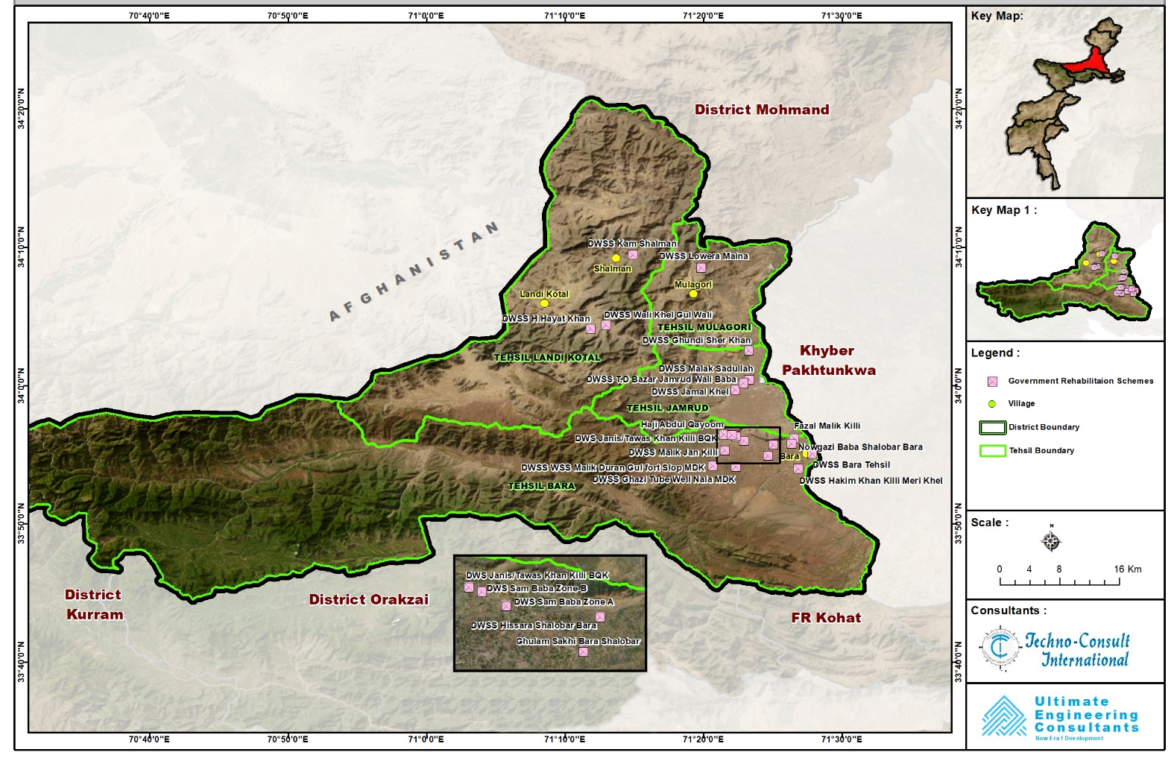
Figure 1: Location of Selected Schemes (21) for Rehabilitation in District Khyber
Note: The maps of the Tehsil wise distribution of schemes and distances between the schemes are attached in annex-3

2.4 Area of Influence of the Subproject
The location of the sensitive receptors e-g religious sites, educational institutions, healthcare facilities etc. were identified in the surroundings of the scheme(s) during the E&S screenings. Keeping in view the low impact of the proposed rehabilitation and sanitation activities on the surrounding infrastructure and communities, the sensitive receptors identified within the 100 m radius of the schemes are considered. Out of the 21 schemes, sensitive receptors were identified in 6 schemes, the name of the scheme(s) and surrounding sensitive receptors are listed in the table below:

Table 2: DWS Rehabilitation Schemes and identified sensitive receptors
S. No | Tehsils | DWS Rehabilitation Schemes | Location Coordinates | Sensitive Receptors (100 m radius)
1. | Bara | - DWS Bara Tehsil | 33.917473, 71.46415 | Mosque, government school
1. | Bara | - DWS Malik Doran Gul Fort Slop MDK | 33.903041, 71.344107 | Mosque
1. | Bara | - DWS Janis/Tawas Khan Killi BQK | 33.93998, 71.36746 | Private school
1. | Bara | - DWS Fazal Malik Killi Shalobar | 33.936007, 71.441686 | Government school
2. | Jamrud | - DWS Ghundi Sher Khan Khel | 34.056263, 71.392029 | Mosque
2. | Jamrud | - DWS TD Bazar Jamrud Wali Baba | 33.998905, 71.365928 | Mosque, government school
Note: The maps highlighting the location of the sensitive receptors in the concerned schemes are attached in annex-3

3. LEGAL, POLICY FRAMEWORK, AND REGULATORY REQUIREMENTS

3.1 Applicable Environmental and Social Policies
The World Bank Environmental and Social Framework sets out the World Bank’s commitment to sustainable development, through a Bank Policy and a set of Environmental and Social Standards that are designed to support Borrowers’ projects, with the aim of ending extreme poverty and promoting shared prosperity. The WB’s ESF Environmental and Social Standards related to this subproject are as follows:

• Environmental and Social Standard 1: Assessment and Management of Environmental and Social Risks and Impacts;
• Environmental and Social Standard 2: Labor and Working Conditions;
• Environmental and Social Standard 3: Resource Efficiency and Pollution Prevention and Management;
• Environmental and Social Standard 4: Community Health and Safety;
• Environmental and Social Standard 10: Stakeholder Engagement and Information Disclosure.

These Standards establish objectives and requirements to avoid, minimize, reduce, and mitigate risks and impacts, and where significant residual impacts remain, to compensate for or offset such impacts.

3.2 National and Provincial Legal and Regulatory Framework
Environmental governance in Pakistan has evolved significantly since the introduction of the Environmental Protection Ordinance (EPO) of 1983, providing a legal framework for addressing pollution and environmental degradation. The EPO 1983 was improved after an extensive and prolonged consultative process with all stakeholders, and a new law, the Pakistan Environmental Protection Act (PEPA), was promulgated in December 1997. In 2000, the Pakistan Environmental Protection Agency (Review of IEE and EIA) PEPA Rules were prepared for the operationalization and application of the Act. The 18th Constitutional Amendment devolved environmental governance to the provincial level, allowing provinces to legislate and enforce their environmental laws. Under the 18th Amendment, the Provincial Government enacted the Khyber Pakhtunkhwa Environmental Protection Act of 2014 to protect, conserve, rehabilitate, and improve the environment within the province. Under section 31 of the Khyber Pakhtunkhwa Environmental Protection Act, 2014, the Government of Khyber Pakhtunkhwa makes the Khyber Pakhtunkhwa Environmental Assessment Rules 2021. The KP Environmental Assessment Rules in Section 2 provide the rules for the proposed assessment of projects. The details of the rules are as under:

4. Projects requiring an EIA or IEE, or GEA. ---Where the project falls within the categories mentioned in Schedules II, III, and IV, the proponent shall file EIA or IEE, or GEA, respectively, with the Agency.

5. 6. Preparation of guidelines for EIA, IEE and GEA. --- Guidelines for the preparation of EIA or IEE, or GEA of general and sectoral applicability may be specified by the Agency, provided that such guidelines may indicate specific assessment requirements for planning, construction, and operation of a project relating to a particular sector.
This subproject has low to moderate environmental and social risks and therefore falls in the General Environment Assessment category.

3.3 Institutional Responsibilities
While the Pak-EPA is the federal agency, each province also has its own Environmental Protection Agency (EPA), which works independently within its respective jurisdiction. Khyber Pakhtunkhwa (KP) has its EPA. The KPRIISP project operates in the NMAs, and they are now part of the KP, so the regulatory authority for the KPRIISP and its subprojects is the EPA, KP.

The subproject is committed to ensuring environmental compliance. Accordingly, General Environmental Approval (GEA) will be obtained from the EPA-KP, in line with the Environmental Protection Act, 2014, and the Environmental Assessment Rules, 2021, before initiating any construction activities under the proposed subprojects. The relevant section of the EPA Environmental Assessment Rules, 2021, is placed at Annexure 4.

4. ENVIRONMENTAL AND SOCIAL BASELINE (District Khyber)
District Khyber, named after the world-famous Khyber Pass, previously known as Khyber Agency, is located in the northwestern part of Pakistan and was among the Federally Administered Tribal Areas (FATA) until 2018. Following the 25th Constitutional Amendment, it was integrated into Khyber Pakhtunkhwa province and granted the status of a district. The district covers an area of about 2576 square kilometers and is bordered by Nangarhar province of Afghanistan to the west, Orakzai District to the south, Kurram District to the southwest, Peshawar to the east, and Mohmand District to the north. The district is characterized by its barren and rugged mountainous terrain, comprising mainly hilly tracks and mountains interspersed with narrow valleys.

4.1 Environmental Baseline
The environmental baseline of Khyber District includes its Biological and physical environmental characteristics, potential sources of pollution, and its challenges.

Biological Environment
District Khyber is characterized by a diverse floristic composition adapted to its semi-arid, mountainous environment. The ecological/climate region is hot semi-arid (steppe), distinct from the more humid subtropical climate. The biological environment has a diverse vascular plant flora adapted to its semi-arid, mountainous terrain.

Flora and Fauna: The region boasts a diverse range of plant species, including species like deodar ((cedrous deodara), Deodar (Cedrus deodara), fir (Abies pindrow), blue pine (Pinus wallichiana), chir pine (Pinus roxburghii), elm (Ulmus wallichiana), walnut (Juglans regia), oak (Ouercus incana), yew (Taxus baccata), birch (etula). Eucalyptus camadulensis (Laachi). The project site has the plant species of Chir Pine (Pinus roxburghii), Black Mulberry (Morus nigra), Kikar (Acacia nilotica) and Banyan (Bar, Ficus benghalensis). Local communities utilize various plant species for medicinal purposes. The area’s vegetation is generally sparse due to limited irrigation and the rugged landscape, but some areas have relatively thick forests. A diverse range of mammals, birds, reptiles, and amphibians is found in the district. Out of the 21 subproject sites, 2 sites involve tree cutting of 5 trees for rehabilitation/solarization works (Details mentioned in the Flora and Fauna section of the Table 6: Environmental and Social Management Plan)

Physical Environment
The water, air, and soil quality in District Khyber, present mixed conditions, especially concerning drinking water quality contamination and partially high levels of particulate matter in the air.

Topography: The district is typically a Barren and rocky landscape, much of the area is rugged. The climate is dry, limited rainfall and water resources. But Tirah valley is an exception, known for its beauty and potentially more fertile land. The region’s agriculture relies heavily on:
1. Barani (rainfed) cultivation: Crops depend on rainfall rather than irrigation.
2. Seasonal productivity: Good agricultural production occurs during sufficient rainfalls.
This highlights the region’s unique challenges and opportunities for sustainable development.

Climate: The climate of district Khyber is a hot semi-arid (steppe) climate, with long, hot summers and cold, snowy winters. The temperature in summer highs reach up to about 39°C, and winter lows drop to near 5°C or below. Khyber has moderate annual rainfall, roughly in the range of 90–230 mm, with most precipitation occurring in spring and monsoon months; snowfall occurs in winter.

Soil Morphology: The soil characteristics are shallow to moderately deep soils, i.e., limited depth, potentially affecting root growth. Soils contain calcium carbonate, influencing nutrient availability. Soils have a mix of particle sizes, impacting water retention. The area’s geological composition features, unconsolidated rocks, loose and unbound rock particles. Deposits of clay, gravel, boulders, and sand at varying depths.

Water Quality and Resources: Drinking water in Khyber is sourced mainly from tube wells and springs. Physicochemical parameters such as pH, electrical conductivity (EC), total dissolved solids (TDS), hardness, chloride, and nitrate generally fall within WHO permissible limits. However, turbidity in both surface and underground water sources is a concern. A significant problem is the declining groundwater level due to prolonged drought and over-extraction. The average underground water table varies from 350 feet to 550 feet in depth. Test results of ground water samples of some of the DWS schemes of the sub-project from each of the four tehsils of the district are attached as annex-5 for reference as a baseline condition. Samples from some of the schemes could not be tested as the schemes are currently non-functional due to non-functional bore etc. The tests will be performed later whenever sample collection is possible.

Ambient Air and Noise Quality: Given the District’s mountainous and semi-arid environment with limited industrial activity, air pollution is likely less severe compared to urban centers, but could be affected by dust and particulate matter due to dry conditions and local activities. As mentioned in Table-7 “pre-construction environmental monitoring plan”, the contractor will be required to perform tests to establish baseline ambient air quality for the required parameters.

4.2 Social Baseline
District Khyber’s social landscape is characterized by a growing population, significant gender disparities in education, challenges in healthcare access, and a reliance on trade and agriculture for livelihoods. Addressing the socio-economic challenges, particularly in education and healthcare, remains crucial for sustainable development.

Population: The 2023 census records that Khyber has a population of 1,146,267, a male population of 598,342 persons, and a female population of 547,925 persons. The population is growing at a rate of 2.58% annually from 2017 to 2023. The recorded average household size is 8.1 persons, indicating large family units.
Literacy Rate: The overall literacy rate in Khyber is 38.92%. A significant gender disparity exists, with male literacy at 62.99% and female literacy at 12.66%. The low female literacy rate highlights barriers such as limited access to schools, cultural norms, and security concerns that hinder educational attainment for women and girls.
Healthcare Challenges: The primary healthcare system in District Khyber is mainly based on Basic Health Units (BHUs) and a limited number of higher-level public facilities. In the district there are around 13 BHUs along with one District Headquarter (DHQ) Hospital and a few civil dispensaries, while Rural Health Centers (RHCs) are either very limited or not functional in some areas, making BHUs the main service providers for most communities. These BHUs serve a population of up to 20,000–25,000 people each, providing essential services such as maternal and child health care, immunization, treatment of common diseases and initial referrals. Due to scattered settlements and hilly terrain, access to healthcare can be challenging, so these primary healthcare facilities play a critical role in ensuring basic health services are available to local communities.

Economic and livelihood: The local community’s main source of income comes from farming activities and livestock, as it caters to around 50% of the employment of the local population either directly or indirectly. While the rest of the people are mainly daily wage laborers, very few people are involved in trading, shopkeeping, poultry farms, and a very minimum are employed in the public sector. Many people, for better job opportunities, have gone to work as migrant workers in Gulf countries, while a few have gone for employment in other provinces of Pakistan.

Religious and Linguistic Diversity: The majority population of Khyber is Muslim; however, a few religious minorities reside in the town. Pashto is the dominant language; however, Punjabi and Sindhi are also spoken primarily due to the presence of Armed Forces personnel.

5. STAKEHOLDER ENGAGEMENT AND INFORMATION DISCLOSURE

5.1 Stakeholder Identification and Public Consultation

The potential stakeholders for the subprojects were identified and consultation sessions were conducted in 21 schemes in District Khyber, with the relevant government department and local communities. The objectives of the consultation were to inform the stakeholders about the subproject design and environmental and social impacts during the project implementation. Suggestions and concerns were recorded and addressed in this ESMP for compliance during the execution phase. Stakeholder consultations will remain a continuous process under the subproject and will be further carried out as per the guidelines given in stakeholder engagement plan (SEP). Consistent with the KPRIISP SEP, this subproject adopts the principles of openness, cultural appropriateness, and inclusiveness. Special attention is paid to vulnerable groups to ensure they are not disproportionately affected.

The suggestions that the stakeholders made in the consultation and their respective responses are presented in the following table:

Table 3: Stakeholder Recommendations and the Respective Response
Serial No. | Stakeholder Recommendation | Type of Stakeholder | Location/Date of Consultation | Response to the Recommendation
1. | Installation of solar systems to ensure uninterrupted water supply throughout the day and to meet community water needs. | Local community, PHED operators | DWSS Ghundi Sher Khan khel (27-3-2025),  DWSS Hakim khan  (13-5-2025),  DWSS Malik Duran Gul Fort slop (13-5-2025),  DWSS Haji Abdul Qayum Toot Dand (7-1-2026) | As per project scope, all water supply schemes will be upgraded to ensure reliable and uninterrupted service. In schemes where a solar system already exists, the system will be rehabilitated or upgraded as required to improve efficiency and performance. For schemes without an existing solar system, a new solar-powered system will be installed to ensure sustainable and continuous water supply.
2. | Construction/rehabilitation activities should be initiated and completed at the earliest to avoid prolonged inconvenience to the community. | Local community, PHED operators | DWSS Wali khel Gul Wali (24-3-2025),  DWSS Hakim khan  (13-5-2025),  DWSS Sam Baba Zone-A (8-1-2026),  DWSS Sam Baba Zone-B (7-1-2026) | The project implementation schedule will prioritize timely execution. Construction and rehabilitation activities will be carried out in accordance with the approved work plan to minimize delays and community inconvenience.
3. | Provision of door-to-door water supply connections to eliminate the burden of water fetching, particularly for women and children. | Local community (females) | DWSS Haji Abdul Qayum Toot Dand (7-1-2026)  DWSS Ghulam Sakhi Arjali Nadi (8-1-2026)  DWSS Sam Baba Zone-B (7-1-2026) | As per the project scope, each household will be provided water connection.
4. | Regular water quality testing should be conducted to ensure safe and potable water for the community to mitigate the possibility of spread of water-borne diseases specially among children | Local community (females) | GGHS Bara (7-1-2026)  DWSS Fazil Malik Kily shalobar (8-1-2026) | Regular water quality monitoring will be carried out in accordance with national standards and project guidelines to ensure the provision of safe drinking water.
5. | The project should be designed with long-term sustainability considerations. | SDO, PHED | PHED Khyber Division office (9-2-2026) | Sustainability measures including durable construction materials, operation & maintenance planning and institutional coordination have been integrated into the project design to ensure long-term functionality.
6. | Regular maintenance to avoid system breakdown after project completion. | Local community | DWSS Bara Tehsil (14-5-2025),  DWSS Jamal khel (14-3-2025) | It will be ensured by the concerned PHED divisional office that regular inspection and maintenance of the sub-project schemes is performed to ensure uninterrupted supply of water to the local community.
* The attendance records and photographic evidence of the stakeholders’ consultations are attached as annex 6 and 7 respectively

5.2 Stakeholder Analysis
The purpose of stakeholder identification and analysis is to systematically identify individuals, groups and institutions that may be directly or indirectly affected by the proposed subproject, or that may have an interest in its implementation. It also helps to understand their level of interest, influence and potential role in the project. This process ensures that stakeholder engagement is inclusive, context-specific and effective in addressing potential risks while maximizing project benefits. For this purpose, stakeholders have been categorized according to their relationship with the subproject. Primary stakeholders include individuals and groups who are directly affected either positively or negatively by the subproject activities. Secondary stakeholders include those who have an interest in the project but are not directly impacted by its implementation. The following table represents the identified stakeholders and their potential interest in the project
Table 4: Stakeholders Identification and their respective Interest and roles
Serial No. | Stakeholders | Project Impact, their Interest, and role
Primary Stakeholders
 | Tehsildar Bara, Jamrud and Landi Kotal, District Khyber | The role of the Tehsildar is to verify the land agreements executed under Voluntary Land Donation (VLD) comply with legal validity to eliminate the risk of land-related disputes in the future.  Proper execution of land donation process will avoid any kind of conflict in future.
 | XEN PHED, District Khyber.  SDO’s PHED, Tehsil Bara, Jamrud and Landi kotal | Providing assistance/facilitation to the relevant PIU, consultant and contractor’s staff during the sub-project execution.  To provide improved water supply to the sub-project communities.
 | Local Government VC/NC secretary and chairman | The VC/NC Chairman and Secretary from Local Government Department participate in the Voluntary Land Donation (VLD) process as witnesses to the legal agreements, helping to verify that the land donation has been made willingly and with the knowledge of the local community.  To ensure transparent, community-supported land donation process that facilitate smooth implementation and long-term sustainability.
 | Community members, Teachers, students | Concerned about timely execution of the project and potential impacts such as noise, dust, land use, water access, and disturbance in routine activities due to construction.  Benefit from improved water and sanitation facilities.
 | Vulnerable and Marginalized Groups | Vulnerable and marginalized groups (women and elderly) participated in the consultation process and highlighting their specific needs and challenges related to access to water and sanitation services, ensuring that the project design remains inclusive and equitable.  Benefit from improved water and sanitation facilities.
 | Land Owners | Landowners play a vital role in the project by voluntarily providing the required land, thereby enabling project implementation and contributing to the welfare of their community.  Benefit from improved water and sanitation facilities.
Secondary Stakeholders
 | Local Religious and Political Leaders | Hold moral authority and can influence public perception of the project.
 | Environmental Protection Agency, Khyber Pakhtunkhwa (EPA-KP) | Regulatory authority responsible for ensuring environmental compliance during project execution.
 | Contractor (s) and Construction Workers | Involved in implementation, requires clear orientation on social and environmental safeguards.
 | Media and Information Channels (Local Radio Channels) | Important for public disclosure, awareness-raising and helping to spread accurate information.
 | Local civil society organizations | Important for public disclosure, awareness-raising and helping to spread accurate information.

5.3 Stakeholder Engagement Plan (SEP) & Disclosure
This Stakeholder Engagement and Disclosure Plan outline how stakeholders will be involved and informed during the construction phase of the project under the ESMP in District Khyber. Its purpose is to ensure continuous two-way communication, enhance social accountability, reduce conflicts and foster community support through timely and culturally appropriate engagement. Consultations with women will be held in "private spaces" or "gender-neutral spaces" by female staff. Communication materials will use images/infographics for those with low literacy.
Table 5: Engagement Activities and Methods (During Construction)
Activity | Target Stakeholders | Frequency | Communication Method | Responsibility
Community Briefings | Community Residents (male & female), tribal elders’ local community-based organizations | Monthly | Public meetings, mosque announcements, and community centers (Hujras) | Contractor’s E&S staff, PIU PHED
Information Disclosure | General public | Ongoing | Posters, notice boards, Urdu & Pashto pamphlets | E&S Officer, PIU PHED
Focused Group Discussions (FGDs) | Local Residents | Bi-monthly | Small group meetings, female outreach through the Gender staff | E&S and gender staff at PCMU and PIU PHED
Grievance Redress Mechanism (GRM) Activation | All stakeholders | Continuous | Complaint boxes, hotline, in-person reporting, and all intake measures as these become available | GRM Focal Points at PCMU and PIU PHED
On-site Signage & Safety Notices | Public, labor, commuters | Continuous | Visual safety signs, barriers, and flagmen | Contractor E&S team
Coordination Meetings | PCMU | Quarterly | Formal briefings, email reports, and written updates | PIU PHED

Feedback Mechanism:
The record of all the SEP consultations will be maintained along with the attendance records, consultation minutes and photographic records. Feedback mechanism will be developed and the stakeholders will be timely responded to their recorded concern, complain or suggestion. The stakeholders will be ensured that their identification and contact details will not be shared at any forum. PIU E&S officer will be responsible to ensure effective implementation of feedback mechanism through the contractor and SC E&S teams.

6. ENVIRONMENTAL AND SOCIAL MONITORING PLAN

6.1 Potential Environmental and Social Impacts, Mitigation Measures, and Monitoring Plan
The Environmental and Social Management Plan (ESMP) provides the framework for implementation of the mitigation measures, environmental management, and monitoring during the construction and operation phases of the proposed subproject. The proper implementation of the ESMP will ensure that any adverse environmental impacts are adequately mitigated, either totally, prevented, or minimized to an acceptable level, and required actions to achieve its above stated objectives are successfully taken by the concerned institutions or regulatory agencies. The implementation of ESMP will be carefully coordinated with the design, construction, and operation programs of the project to ensure that relevant mitigation measures are implemented at the appropriate stage and adequate resources are properly allocated to achieve the desired results.

Table 6, below, provides the Environmental and Social Management Plan. The proposed schedule for the ESMP is 1 year, comprising the first month for the pre-construction phase, for the contractor mobilization, and carrying out the required initial stage preparation. The next 11 months will be for the construction phase to complete the rehabilitation/solarization of the sub-project DWS schemes. However, the ESMP schedule is contingent upon the subproject’s approval from the relevant Government forums and initiation. The actual timeline will be defined once those formalities are completed. The plan outlines impacts, targets, mitigations, and the responsible authorities for the implementation of the mitigation measures during design, construction, and operational phases.

Table 6: Environmental and Social Management Plan
Sr. No. | Parameters | Target | Mitigation | Status of Activity | Implementation Responsibility
Design/pre-construction Phase
1 | Drainage | To prevent standing water, flooding, and water ponding in and around the DWS schemes. | - Provision of appropriate drainage facilities and structures should be provided in the DWS schemes; and  - Proper slopes shall be incorporated in the design feature to avoid accumulation of water inside the DWSS | Done | PIU, PHED
2 | Traffic Management | To minimize traffic problems in the project area | - Once the contractor is mobilized, in the first months of the project time, contractor will prepare a comprehensive Traffic Management Plan and disclose it before construction begins, ensuring measures are in place to prevent traffic congestion and safeguard community convenience. Vehicle movements for transporting construction materials shall be strategically timed to minimize traffic impacts and avoid inconvenience to residents;  - Plan the timing for the movement of vehicles carrying construction materials to reduce traffic load and avoid inconvenience to the local community. | To be Prepared | Contractor to provide plan, PIU, PHED to ensure and monitor compliance
3 | Health and Safety | To minimize health risks | - The contractor will prepare a detailed health and safety plan with all necessary and required mitigation measures that will minimize health risks to the surrounding community and the labor involved in construction. The proposed plan will be submitted to the PIU and will be made public before the construction activity begins; and  - An emergency response plan will be formulated by the contractor that emphasizes a line of action for rescue, medical emergencies, natural disasters, and firefighting operations at the construction site and will be submitted to PIU before the construction activity begins. | To be Prepared | Contractor to provide plan, PIU, PHED to ensure and monitor compliance
4 | Solid Waste Management | To manage (i.e., collect and dispose) the solid waste safely at appropriate sites. | - The contractor will prepare a comprehensive solid waste management plan incorporating the technical design features for refuse collection from the rehabilitation sites, and its safe disposal at the designated places to ensure it is not at sites that would minimize burning on site; and  - The contractor will devise plan(s) for safe handling, storage, and disposal of harmful waste and materials.  - Guidelines for preparing the Waste Management Plan have been attached as Annex - 12 | To be Prepared | Contractor to provide plan, PIU, PHED to ensure and monitor compliance
Construction Phase
1 | Noise and Vibration | To minimize noise pollution and fulfill the Regulatory Compliance under the NEQs. | - As the rehabilitation/sanitation sites are mostly located in residential areas therefore, implementation of mitigation measures against noise generation are necessarily required  - At the sub-project sites having sensitive receptors (e-g religious sites, educational institutes, healthcare facilities) in 100m radius of the site; the contractor shall ensure close coordination and schedule the noise generating activities as per the agreed timings  - Selection of up-to-date and well-maintained plant or equipment with reduced noise levels ensured by suitable in-built damping techniques or appropriate muffling devices;  - Confining excessively noisy work to normal working hours in the day, as far as possible;  - Restricting construction vehicles' movement during night time;  - Avoid the use of heavy drill machines to avoid the vibration effect on the surrounding buildings;  - Vehicles and equipment used should be fitted, as applicable, with silencers and properly maintained;  - Use of low noise machinery, or machinery with noise shielding and absorption;  - Contractors should comply with the submitted work schedule, keeping noisy operations away from sensitive points;  - implement regular maintenance and repairs;  - Employ strict implementation of operation procedures; and  - Providing the construction workers with suitable hearing protection, like ear caps or earmuffs, and training them in their use. | To be carried out. | Contractor Environment and Social Specialist (C-E&S) for implementation and Supervision Consultant (SC) team to monitor compliance
2 | Soil Erosion | To minimize soil erosion and contamination. | - Unnecessary excavations should be avoided;  - All kinds of oil spills from construction machinery on the ground shall be scrubbed until the clear surface of soil, and the removed clay shall be safely disposed of as desired, and the site will be restored to its original conditions;  - Septic tanks connected to soakage pits of adequate capacities will be constructed for receiving and treating wastewater from all temporary worksite toilets and at the temporary container offices, if any;  - The toilet wastewater should not be discharged untreated onto the adjacent lands  - Washout from washing of equipment and gadgets will be drained into either a septic tank or a sand-gravel bed for removal of the grit and contaminants.  - Schedule training and awareness sessions for the workforce before the start of the construction work on the proper storage and handling of materials and chemicals that may pose a risk to soil; | To be carried out. | C-E&S Specialist for implementation and Supervision Consultant (SC) to monitor compliance.
3 | Air Pollution | To minimize air pollution and fulfill the Regulatory Compliance under the NEQs. | - Excavation of sites is planned in all the 21 rehabilitation work sites due to the proposed replacement of damaged water distribution pipes while for the proposed 11 sanitation schemes excavation of sites is required for the construction of septic tanks/soakage pits and laying of sewerage lines  - At the sub-project sites having sensitive receptors (e-g religious sites, educational institutes, healthcare facilities) in 100m radius of the site; the contractor shall ensure close coordination with local community and schedule the dust/smoke generating activities as per the agreed timings  - All sites where excavation work will be carried out will be daily sprinkled with water to control dust;  - The excavated material shall be covered and shall not be stored for long intervals;  - Preventive measures like batching and mixing operations shall be performed in enclosed or controlled areas, installing screens around the mixing and unloading operation areas at the site, and no “Overloading" shall be enforced to prevent spillage of fine materials during transport operation;  - All vehicles, machinery, equipment, and generators deployed during construction shall be maintained in sound working condition, regularly serviced (as prescribed by the manufacturer), and properly tuned to minimize exhaust emissions and ensure compliance with applicable environmental standards;  - All vehicles, machinery, and equipment used for the construction shall be plugged off or switched off immediately after completion of their work to avoid idling conditions;  - Emissions from power generators and construction machinery are important point sources at the construction sites.  The filter shall be installed at the point sources of air emissions and shall be replaced regularly as prescribed by the manufacturer. Proper maintenance and repairs of the equipment are needed to minimize hazardous emissions;  - Open burning of solid waste from the Contractor’s camps should be strictly banned;  - Construction workers should be provided with masks for protection against the inhalation of dust | To be carried out. | C-E&S Specialist for implementation, and Supervision Consultant (SC) to monitor compliance.
4 | Water Quality and Availability | To protect the ground and surface water resources from any pollution due to the construction of the subproject and fulfill the Regulatory Compliance under the NEQs | - Water required for construction is obtained in such a way that the water availability and supply to nearby communities remain unaffected;  - Protection of surface and groundwater reserves from any contamination sources, such as construction and oily wastes that could degrade their potable water quality;  - Regular water quality monitoring according to a determined sampling schedule provided in Table 7, below;  - During all rehabilitation activities, the contractor shall implement effective controls to prevent construction debris and other waste from entering the drainage system. Appropriate measures—such as installing silt traps and regular site housekeeping—must be applied to ensure that no materials obstruct the drainage network;  - During the rehabilitation works, the contractor will clear culverts/drains; avoid material dumping in existing waterways; | To be carried out. | C-E&S Specialist for implementation, and Supervision Consultant (SC) to monitor compliance.
5 | Solid, Construction Waste, and Hazardous Waste | To minimize the solid, construction, and hazardous waste | - The expected waste materials from the rehabilitation activities include construction debris, empty cement bags, paint buckets, damaged distribution pipes, damaged or worn-out pumps, motors, damaged solar panels etc.;  - The expected waste materials from the sanitation component construction activities include; construction debris, empty cement bags, scrap metal (reinforcement bars, clamps, fasteners), plastic packaging (pipe wrappings, sheeting), wooden spacers / pallets from pipe deliveries;  - Generation of hazardous waste is not expected in significant quantity; the only possible hazardous waste source is medical waste generated in case of any serious injury/accident;  - Reusable wastes will be reused as far as possible.  - Record of all wastes will be maintained  - All the replaced pumps, motors and other electrical equipment will be handed over to the concerned SDO, PHED office.  - A comprehensive waste management plan shall be prepared by the contractor and implemented. All the solid waste generated during construction and from camp sites shall be safely managed and handed over to the responsible Tehsil Municipal Administration (TMA) for safe disposal;  - Burning of waste will be prohibited;  - The hazardous waste shall be stored in closed containers, with proper labelling of containers, including the identification and quantity of the contents, hazard contact information. It will be safely disposed of in an EPA-registered hazardous waste facility within the province;  - The sewage system for the workers’ rest area will be properly designed (pit latrines or, as required, septic tanks) to receive all sanitary wastewaters;  - All the stored hazardous materials shall be securely covered to prevent any possible leakage during heavy rainfall;  - Locating stockpiles of material at such places to minimize potential visual impact; and  - Minimizing the land intake of stockpile areas as far as possible. | To be carried out. | C-E&S Specialist for implementation, and Supervision Consultant (SC) to monitor compliance.
6 | Electrical works hazards (work on solar panels, pumps, motors, wiring etc.) | To prevent electrical shock, fire, arc flash, falls from height, and equipment-related injuries to workers and community members during installation, replacement, or repair of solar panels, wiring, and motors in rural water supply schemes, by ensuring safe work practices, proper isolation, use of certified components, and adequate training | - Rehabilitation work activities at all the 21 sub-project sites involve electrical works including; installation, replacement, or repair of solar panels, wiring, charge controllers, installation of meters and motors  - 15 sub-project sites involve electrical works related to installation, replacement, or repair of solar panels; therefore, implementation of mitigation measures against the hazards associated with electrical works is required  - Isolate all power sources (solar DC, battery bank, and any grid/backup AC supply). Lock and tag the main disconnect switch with worker’s name and date. Verify zero voltage using a calibrated tester before touching any wire or terminal.  - Only certified electrical technicians shall perform wiring, motor replacement, or panel installation. All cables, circuit breakers, junction boxes, and motors must carry Pakistan Standards (PS).  - Set up a 3-meter safety perimeter around any electrical work area with warning tape and signs in Urdu/Pashto: “Danger – Electrical Work – Keep Away.” Entry prohibited.  - Clearly label positive and negative DC cables. Double-check polarity before connecting to charge controller or inverter. Test rotation direction of new motor before full operation.  - While handling/replacing damaged solar panels; Workers must wear: cut-resistant gloves, safety goggles, hard hat, insulated rubber boots, and long-sleeved clothing, do not drag or drop panels. Carry vertically (on edge) or with two persons using rigid panel carrier handles.  - Avoid stacking damaged panels on top of each other without padding.  - Cover cracked glass with adhesive plastic sheeting to contain loose shards during transport.  - Provide pre-work toolbox talk covering the day’s electrical tasks, hazards, emergency shutdown procedure, and first aid for electric shock (including CPR) | To be carried out. | C-E&S Specialist for implementation, and Supervision Consultant (SC) to monitor compliance.
7 | Health and safety of workers and associated communities | To reduce the health and safety risks to construction workers and the nearby communities  arising from general construction activities, working at heights, fire and explosion, slips, trips and falls, electro-mechanical hazards, exposure to hazardous materials and biological agents, and risks associated with unstable foundations. | - Excavation of sites is planned in all the 21 sites due to the proposed replacement of damaged water distribution pipes while for the proposed 11 sanitation schemes excavation of sites is required for the construction of septic tanks/soakage pits and laying of sewerage lines  - All sites where excavation work will be carried out will be barricaded using green mesh (net) and “caution” warning tape to prevent entry of irrelevant personnel and to prevent any type of fall hazard; all the excavated sites shall be marked with warning sign “Deep Excavation – Entry prohibited” (in local language)  - The excavation shall be performed as per the approved design and timely backfilling of the excavated sites shall be performed  - The rehabilitation activities also involve rehabilitation works on overhead reservoir (OHR) at 12 sub-project sites; therefore, work at height safety measures will be applicable; following sites include work on OHRs;  1. DWSS Td Bazar Jamrud Wali Bagh  2. DWSS Malak Sadullah Khan  3. DWSS Hissara Shalobar Bara  4. DWSS Ghazi Tube Well Nala Mdk  5. WSS Hakim Khan Killi Meri Khel Aka Khel Bara  6. DWSS Bara Tehsil  7. DWS Sam Baba Zone-B  8. DWS Sam Baba Zone A (Spin Dand)  9. DWS Nowgazi Baba Remaining Area  10. DWS Janis/Tawas Khan Killi Bqk  11. DWS Fazal Malik Killi Shalobar  12. DWS Malik Jan Killi Bqk Bara  - Guardrails, certified scaffolding, safety nets, harnesses, and other required PPEs to be made mandatory for Work at Height activities;  - During the work activities on OHRs; contractor will be required to provide green mesh (net) to the neighboring houses to ensure their privacy  - Obligatory insurance against accidents for laborers/workers shall be ensured;  - Basic medical training shall be imparted to specified work staff, and basic medical service and supplies to workers (first aid medical supplies and medicine, ambulance service) shall be made available at the site;  - Ensure the availability of emergency response services on a 24-hour basis, including trained medical staff, first-aid and medical kits, firefighting equipment (such as extinguishers and breathing apparatus), and ambulance services;  - At each site, a focal person from the community will be nominated who will be timely informed regarding any major accident/incident (e-g fire, traffic accident etc.);  - The contact details of the contractor project manager and E&S Specialist will be shared with the local community to ensure timely communication in cases of any accident/incident  - Layout plan for rehabilitation site, indicating safety measures taken by the contractor, e.g., firefighting equipment, safe storage of hazardous material, first aid, security, fencing, and contingency measures in case of accidents;  - Work safety measures and good workmanship practices are to be followed by the contractor to ensure no health risks for laborers;  - Protection devices (ear muffs) should be provided to the workers doing a job in the vicinity of high noise-generating machines;  - Ensure strict use of protective clothing and other necessary equipment during work activities;  - Emergency number shall be placed at worksites;  - Develop a contingency plan to address major accidents, including fires, explosions, chemical spills, structural failures, and natural disasters;  - The construction supervisor must ensure that only authorized workers shall be allowed inside the construction site boundary, and that all non-workers — including visitors, passersby, and especially children — are strictly prohibited from entering. The contractor shall develop a procedure/protocol to be followed by all official visitors at the specific site. The PIU, PHED shall approve the said procedure/protocol;  - The contractor shall provide and maintain adequate traffic management and safety controls at the rehabilitation sites. This includes installing clear and visible signage, lighting devices, physical barriers, and warning tape, as well as deploying trained flag personnel to ensure safe movement of vehicles and equipment;  - There shall be proper control on construction activities, and the oil spillage and leakage from vehicles could be controlled on site by conducting routine inspections of the engine, transmission, and hydraulic systems, checking and replacing worn-out seals, gaskets, hoses, and filters, and monitoring oil levels frequently to detect abnormal loss;  - Efforts will be made to create awareness about road safety among the drivers operating construction material transportation vehicles;  - The contractor shall ensure timely and accessible public notification regarding all planned rehabilitation/construction activities. Notifications shall include the nature of works, expected start and end dates, potential traffic or access disruptions, and available detour routes. Information must be disseminated through appropriate channels—such as local notice boards, community meetings, nearby mosques to allow the public to prepare and minimize inconvenience;  - Workers who shall be reported as ill or exhibit possible symptoms shall be restricted from entering the work site. They shall be promptly isolated and referred to local medical facilities for immediate care;  - The communicable disease of most concern during the construction phase, like sexually-transmitted diseases (STDs) such as HIV/AIDS, should be prevented by successful initiatives typically involving health awareness, education initiatives, training of workers in disease treatment, immunization programs, regular medical checkups of labor and staff, and providing health services;  - Reducing the impacts of vector-borne diseases on long-term health effects of workers should be accomplished through the implementation of diverse interventions aimed at eliminating the factors that lead to disease, which include prevention of larval and adult propagation of vectors through sanitary improvements and elimination of breeding habitat close to human settlements, and by eliminating any unusable impounding of water;  - A supply of safe drinking water will be made available and maintained at the project site(s);  - Chlorinated disinfecting spraying must be conducted at the work site(s); and  - Proper hygiene practices in the toilets and washrooms will be implemented with proper and adequate use of soaps and disinfectant spray.  In addition to the above general protective measures for the laborer and adjoining community, the contractor and his/her supervisory staff will provide and ensure the specific protective measures, such as:  - Provide training and awareness to the concerned staff on handling, storage, and safety of gas cylinders;  - Approved utility isolation, barricading, and dust suppression;  - Fire prevention plan, controlled storage of flammables, hot-work permits, provision and location of firefighting equipment;  - Good housekeeping, clear walkways, adequate lighting, and spill control. | To be carried out. | C-E&S Specialist for implementation, Supervision Consultant (SC), and PIU to monitor compliance.
8 | Labor Camp | To minimize loss of assets and vegetation due to labor movements, prevent environmental degradation from construction camps, and ensure the camp's presence does not cause any concerns for the nearby community | - Considering the sub-project activities being spread across 21 DWS schemes, a small worker’s camp having basic facilities/arrangements of rest area, washroom shall be provided at each of these 21 schemes.  - All the workers staying in the camp will be issued ID cards for security purposes;  - Provision of all required medical health facilities (first aid boxes, reasonable stock of commonly used medicines) in the camp for emergency health services;  - The camp will be properly fenced and gated to prevent the entry of outsiders into the camp;  - Entry for the local community/any unauthorized persons at the campsite will be prohibited;  - Preparation of Waste Management Plan addressing the classification, storage, and disposal of all solid wastes and the training of employees for handling the hazardous materials;  - Training will be provided to all staff members and laborers on camp management rules and overall discipline, and cultural awareness; and  - The contractor will submit a labor camp management plan. | To be established. | Contractor
9 | Flora and fauna | To protect, conserve, and minimize the impact on flora and fauna | - All efforts will be made to protect and conserve the existing trees and shrubs;  - Out of the 21 subproject sites, 2 sites involve tree cutting for rehabilitation/solarization works;  - DWSS Ghundi Sher Khan Khel (3 trees); Guava tree (1 No) and Murberry tree (2 Nos)  - WSS Malik Doran Gul Fort Slop MDK (2 trees);  Eucalyptus (1 No) and Nimtree (1 No)  - Each cut-down tree will be replaced with 10 trees of local species in the available land. The cost of the additional plantation is covered in PC I of the subproject under the “E&S BOQ” head;  - The Contractor’s staff and labor will be strictly directed not to damage any vegetation, such as trees or bushes;  - Contractor will provide gas cylinders at the camps for cooking purposes, and cutting of trees/bushes for fuel will not be allowed;  - Hunting and poaching of animals will be strictly prohibited, and the Contractor will warn their labor accordingly;  - The camps will be properly fenced and gated to prevent the entry of animals in search of edible goods;  - Waste from the camps will be properly disposed of to prevent the chances of being eaten by animals, which may become hazardous to them;  - Special measures will be adopted to minimize impacts on the birds, such as avoiding noise-generating activities during critical periods of breeding; and  - Staff working on the project should be given clear orders not to shoot, snare, or trap any bird. | To be initiated, once the construction activities are completed. | C-E&S Specialist and, Supervision Consultant (SC) to monitor
10 | Traffic Management | To minimize traffic problems in the project area | - A proper traffic management plan will be prepared by the contractor at the time of starting the construction in accordance with the on-ground site conditions, submit it to the PIU PHED for approval, and later, for monitoring purposes, and implemented to avoid traffic jams/public inconvenience;  - No heavy vehicle movement during:  School opening (7:30–8:30 AM) and closing (1:30–2:30 PM)  Friday prayers (12:30–2:00 PM)  - Night work restricted; No vehicle movement between 7:00 PM and 6:00 AM unless emergency with prior community notice and additional lighting.  - Following speed limits will be followed;  - Inside village limits / near worksites: 20 km/h,  - On unpaved tracks: 15 km/h,  - Near schools, mosques, or animal herding points: 10 km/h  - Use designated haul routes – avoid narrow lanes, steep slopes, or road segments with poor drainage.  - Movement of vehicles carrying construction materials should be restricted during the daytime to reduce traffic load and inconvenience to the residents; and  - The executing agency must maintain liaison between the residents/visitors, travelers, and the contractor to facilitate traffic movement during the construction stage.  - After completion of works, restore any damaged roads to original or better condition (fill potholes, compact surface, clear debris).  - During dry season, water spraying on unpaved haul routes twice daily to suppress dust affecting nearby homes and crops.  - No stockpiling of materials on road shoulders or within 5 meters of road edge. | To be prepared before the construction begins. | C-E&S Specialist, Supervision Consultant (SC), and PIU to monitor.
11 | Communicable diseases | To minimize the spread of Communicable diseases | A communicable disease prevention program will be prepared by the contractor for construction workers or residents near the construction sites and made public before the construction work starts.  - Reporting employees and laborers showing symptoms such as fever or high body temperature, coughing, difficulty breathing, or chest pain, and sending them to a clinic or the nearest hospital immediately;  - Awareness and implementation of the Quarantine Procedure for all employees who have come back from vacation after suffering from any communicable disease;  - Ensure Disinfection of offices, work areas, and machinery periodically; and  - Provision of face masks, instruction boards, and signage at different locations for health hazards awareness. | To be prepared before the construction begins. | C-E&S Specialist
Operational Phase
1 | Waste | To minimize and store the solid waste | - An appropriate waste management system shall be in place during the operational phase. It will integrate technical measures (segregation, treatment, disposal), administrative controls (planning, monitoring, compliance), and community engagement (awareness, collaboration) to ensure sustainability and regulatory alignment. | To be carried out. | PIU
2 | Drainage | To prevent flooding and pooling | - Routine inspection and maintenance of the drainage system, to make sure that the drains are not blocked due to solid waste, shall be scheduled and implemented. | To be carried out. | PIU
3 | Handling of Solar panels | To prevent mis-operation, electric shock, injury and poor End-of-Life Management hazards of Solar Panels | - Perform monthly checks for cracked glass, loose junction boxes, burnt cables; immediately isolate and repair or replace any damaged panel to prevent electrical arcing, fire, or sharp glass hazards.  - Keep panels clean (dry brushing or soft cloth – no abrasives) and remove dry leaves, bird nests, or grass underneath the array  - Orient panels to avoid direct glare toward nearby homes, roads, or schools; install shading or vegetative buffer where needed; post signs warning that panel surfaces can become hot (>70°C) – do not touch  - Tag any damaged panel as "e-waste" and remove it from the field within 30 days to prevent leaching and injury.  - Enforce strict bans on burning panels for copper recovery, dumping in ravines or agricultural land, and selling to informal scrap dealers; violations carry fines and possible prosecution.  - In case of disposal of damaged panels, stack panels flat (max 4 high) on wooden pallets in a locked, dry, fenced shed away from water sources; clearly label as "Hazardous E-waste."  - Use covered vehicles with spill kits and fire extinguishers; require a hazardous waste manifest and deliver exclusively to a KP EPA-licensed recycling facility.  - Provide bi-annual training on lockout/tagout procedures, emergency shutdown, safe panel cleaning, and first aid for electrical burns; require use of insulated gloves and rubber-soled shoes during any panel maintenance. | To be carried out. | PIU

Environmental Monitoring is undertaken during both the construction and operational phases to ensure the effectiveness of the proposed mitigation measures. Certain environmental parameters are selected, and quantitative & qualitative analyses will be carried out by the contractor from an EPA, KP’s registered laboratory. The results of the analysis will be compared with the guidelines, standards, and pre-project conditions to determine whether the EMP and its implementation are effective in mitigating impacts.
Parameters to be analyzed during pre-construction, construction & operation of the project, responsibilities for monitoring have been discussed and provided in Tables 7 to 9 below:

Table 7: ‘Pre-Construction’ Monitoring Plan for Baseline Development
Parameter to be measured | Objective of Monitoring | Parameters to be Monitored | Measurements | Location* | Frequency | Responsibility
Ambient Noise | To establish a baseline for noise levels | Ambient noise level near the receptors in the project area | < 55 dB(A)  A-weighted noise levels –24 hours, readings taken at 15s intervals over 15 min. every hour, and then averaged | At four different locations of the project area | Once | C-E&S Specialist
Groundwater Quality | To establish the groundwater quality in the project area | Groundwater quality in the project area | Water samples for comparison against NEQS parameters | At each of the 21 DWS sites in the sub-project | Once | C-E&S Specialist
Ambient Air Quality | To establish a baseline for air quality levels | CO, NO₂, SO₂, O_{3,} PM_{2.5} & PM₁₀ concentration at the receptor level | 1-hr and 24-hr concentration levels for comparison against NEQS parameters | At two random receptor locations in the project area | Once | C-E&S Specialist
* Monitoring Locations to be finalized jointly between PIU Safeguards staff and the Supervision Consultant (SC).

Table 8: Construction Phase Monitoring Requirements
Project Activity and Potential Impact | Objective of Monitoring | Parameters to be Monitored | Measurements | Location | Frequency | Responsibility
Noise | To determine the effectiveness of noise abatement measures on sound pressure levels | Ambient noise level at different locations in the project area | < 55 dB(A)  A-weighted noise levels – 24 hours, readings taken at 15 s intervals over 15 min. every hour at 15 m from the receptors, and then averaged | At four random receptor locations in the project area | Biannually | C-E&S Specialist, SC
Groundwater and drinking water Quality | To establish the groundwater quality in the project area.  To ensure provision of safe drinking water | Groundwater and drinking water quality in the project area | Water samples for comparison against NEQS parameters. | At each of the 21 DWS sites in the sub-project | Quarterly | C-E&S Specialist, SC
Safety precautions by workers | To prevent accidents for workers and the general public | The number of near-miss events and accidents taking place | Compliance with “Worker’s health and safety” section of the Monitoring checklist | Each site | Daily | C-E&S Specialist, SC
Soil Contamination | To prevent contamination of soil from oil and toxic chemical spills and leakages | Incidents of oil and toxic chemical spills | Incident/accident records | At construction sites and vehicle and machinery refuelling & maintenance areas | Daily | C-E&S Specialist, SC
Solid Waste & Effluent Disposal | To check the availability of the waste management system and its implementation | Inspection of solid and liquid effluent generation, collection, segregation, storage, recycling, and disposal will be undertaken at all work sites in the project area | Waste generation and disposal records | At work sites in the project area | Daily | C-E&S Specialist, SC
Air Quality | To determine the effectiveness of the dust and emission control program on dust/emissions at the receptor level | CO, NO₂, SO₂, O_{3,} PM_{2.5} & PM₁₀ concentration at the receptor level.  Daily (twice) water sprinkling of each site | 1-hr and 24-hr concentration levels for comparison against NEQS parameters.  Dust control measures monitored through the E&S monitoring checklist | Air Quality testing at five random receptor locations in the project area.  Dust control measures monitored at each site | Quarterly Air Quality testing on a typical working day  Daily monitoring of dust control measures | C-E&S Specialist, SC
* Monitoring Locations to be finalized jointly between PIU Safeguards staff and the Supervision Consultant (SC).
Table 9: Operation Phase’s Environmental Monitoring Plan
Parameter to be measured | Objective of Monitoring | Parameters to be Monitored | Measurements | Location | Frequency | Responsibility
Groundwater Quality | To establish the groundwater quality in the project area | Groundwater quality in the project area | Water samples test results for comparison against NEQS parameters | At each of the 21 DWS sites in the sub-project | Quarterly | PHED, Khyber Division

6.2 Grievance Redress Mechanism (GRM)

The Grievance Redress Mechanism (GRM) is an institutional arrangement which provides the project’s stakeholders an opportunity and a structured mechanism to submit their concerns. The grievance redress mechanism will focus on the following steps/points during the implementation process:
- Record grievances, both written and oral, categorizing and prioritizing them, and providing solutions within an agreed-upon timeframe;
- Reporting to the aggrieved parties about the resolutions regarding their grievances and the decision;
- Dissemination of various reporting channels such as complaint boxes, complaint register, PIU phone numbers, online complaint registration, and proformas for complaints.
- All information about grievance procedures, grievance forms, and responses will be available in languages readily understandable to the locals.
- During GRM orientation, inform labor and associated staff about alternative reporting channels, including the GRM register, telephone numbers, and online portals, in addition to the GRM boxes.
- All complaints received will be treated with confidentiality particularly the complaints pertaining to GBV, SEA/SH.

A key emphasis will be to quickly respond to all highlighted and reported concerns or grievances, as per the KPRIISP GRM Manual.

Grievance Registration and Resolution Process
Submission: Complainants can lodge grievances through:
  - Focal Person: Environment & Social Officer, PIU PHED, KP-RIISP
  - Phone: +92 91 9217303
  - Email: piuphedgrm@gmail.com
  - In person/letter: Office of the Project Director, KP-RIISP, Plot No. 40, Sector B-II, Phase-V, Hayatabad, Peshawar.
  - Complaint Box/Registers at site offices

Recording and Categorization: All grievances (oral or written) will be registered, categorized (urgent/regular), and logged in a centralized GRM database.
Investigation and Resolution:
The E&S officer will coordinate with PHED PIU staff or field Officers to investigate the issue. The resolution will be shared with the complainant within the agreed timeframe.
Follow-up and Feedback:
The complainant will be informed in writing (or preferred method) of the decision/resolution and any follow-up actions.

Resolution Time:
o Minor complain/issue → 7 days
o Major complain/issue → 14 days with investigation

Appeal and Escalation Mechanism:
If not satisfied, complainants may escalate the issue to:
  - Project Coordination & Management Unit (PCMU), P&D Department
    - Focal Person: Senior Social Development Specialist
    - Phone: 091-9213022
    - Email: ssds@kp-riisp.gov.pk
    - Address: Civil Secretariat, Peshawar, KP
Grievance Redress Committee (GRC)
To support timely grievance handling, a Grievance Redress Committee (GRC) has been formed at the PIU level. The GRC will meet on a regular basis (or as needed) to address escalated or complex grievances.

Composition of GRC (PIU PHED):

Designation/Organization | Position in PIU GRC
PD PIU PHED | Head/convener of GRC
E&S officer PIU PHED | Secretary of GRC
Procurement Specialist PIU PHED | Member
Tehsil/District Focal Person | Member
Contractor | Member
Community Representative(s) | Member
Environment/Social/Gender Specialist, Supervision Consultant, PIU PHED | Observer
Co-opted/Invited member(s)  E.g. complainant, lawyer, relevant govt. Official, etc. | Member/Observer

Composition of GBV GRC (PIU PHED):

Designation/Organization | Position in PIU GRC
PD PIU PHED | Chairman
E&S officer PIU PHED | Member/Secretary of GRC
Procurement Specialist PIU PHED | Member
Assistant Director (Tech)/District Focal Person | Member
Gender Specialist, Consultant (PIU PHED) | Member/Observer
Co-opted/Invited member(s) | Member/Observer
Working Arrangements:
GRC meeting will be held at the PIU or any other location agreed by the Committee. If needed, GRC members may undertake field visits to verify and review the dispute issues.

If the affected person is not satisfied with the decision of GRC at PMU, then it can be referred to the Project Steering Committee for resolution. If the complainant does not accept the resolution, or chooses to accept it, this will be confirmed in writing. The complainant may also seek redress through courts or other mechanisms available in case of non-acceptance.

Performance indicators:
The record of all the GRM complaints registration, feedback, status, response time and resolution rate will be maintained to enhance timely and effective resolution of the complaints and to ensure satisfaction of the complainant.

GRM Awareness and Capacity Building
- Awareness sessions will be conducted for laborers, contractors, local communities, and other stakeholders, including specific awareness on GBV & SEA/SH risks, survivor-centered reporting mechanisms, and confidential redressal procedures.
- Orientation on GRM and GBV-specific grievance reporting channels, procedures, confidentiality protocols, and available support will be integrated into community consultations and labor inductions.
- GBV-specific Grievance Redress Committees (GRCs) will be established/engaged as applicable, ensuring safe, confidential, and survivor-centered handling of complaints.
- GRM and GBV reporting information, including helpline numbers and contact details, will be displayed through posters and brochures at all construction and project sites.

GBV, SEA/SH Specific Grievance Pathway
For GRM cases pertaining to Sexual Exploitation, Abuse, and Sexual Harassment (SEA/SH), a separate, confidential, survivor-centered pathway is required to prevent re-traumatization, ensure privacy, and avoid interference from standard GRM processes (e.g., open committee meetings, contractor involvement, or lack of female staff). The following provisions shall be considered specifically for SEA/SH-Specific Grievances.

- Survivor’s identity shall never be disclosed without explicit consent.
- Immediate risk assessment and safety plan (relocation, temporary work change, etc.).
- Absolute prohibition of any action against survivor or witness.
- SEA/SH complaints shall not go through the standard GRM register, complaint box, or committee where contractors or community representatives are present.

Grievance Registration and Resolution Process (GBV, SEA/SH)
Submission: Complainants can lodge grievances through:
  - Focal Person: Gender Specialist, PIU PHED, KP-RIISP
  - Phone: +92 91 9217303
  - Email: genderspecialistphe@gmail.com
  - In person/letter: Office of the Project Director, KP-RIISP, Plot No. 40, Sector B-II, Phase-V, Hayatabad, Peshawar.

Confidentiality & Data Protection
- SEA/SH records kept in a separate, password-protected, access-restricted file (only Project Director & Gender Specialist).
- No names or identifying details in project reports – only anonymized statistics.

6.3 Capacity Building and Training
To raise the level of professional and managerial staff, there is a need to upgrade their knowledge in the related areas. The SC will play a key role in this respect and supervise the arrangements for training.
The contractor’s environmental awareness and appropriate knowledge of environmental protection is critical to the successful implementation of the ESMP, as without appropriate environmental awareness, knowledge, and skills required for the implementation of the mitigation measures, it would be difficult for the contractor's workforce to implement effective environmental protection measures. A suitable training program is proposed to train the Contractor's staff who will be involved in the Construction Phase and the professional staff from the client involved at the operational stage of the project. The details of this training program are presented in Table 10 below.

Table 10: Personnel Training Program
Provided by | Contents | Trainees/Events | Duration
Consultants/ organizations  Specializing in environmental  management and monitoring | Short training  session, on:  Environmental laws  and regulations, daily  monitoring and  supervision | Two training sessions, one  For PIU staff and one for  Contractor project staff  Monthly refresher training | 2 Days
Consultants/  organizations specializing in  Occupational health  and Safety | Short lecture relating  to Occupational Safety  and Health | One seminar for  contractor’s staff  Monthly refresher training | 1 Day
Consultants/  organizations specializing in  Grievances  Redressal Mechanism | Training session on  What is GRM, and  It's working, and who  to be approached for  redressal of complaint,  and awareness  session on GBV &  SEA/SH and its  associated elements | One session for the  contractor’s staff  One session for the  Surrounding community.  Monthly refresher training | 1 Day
Contractor E&S specialist | Training session on  Worker’s Code of Conduct | For each contractor staff,  Once at contract signing,  Monthly refresher training | 1 Day

6.4 Institutional Arrangements and Roles
The main purpose of the ESMP is to provide a strategy for environmental protection. According to ESMP, all the activities associated with the project will be controlled and monitored during the design, construction, and operation phases. EMP will propose a plan of action that will indicate responsibilities and required measures to prevent or minimize the potential environmental impacts.

The following functionaries will be involved in the implementation of ESMP:
- Project Implementation Unit (PIU);
- Supervision Consultant’s Environmental Engineer;
- Contractor’s Site Environmental Engineer; and
- EPA, KP (Regulatory Authority)

The organizational set-up for the implementation of ESMP is shown in Figure 2 below.

Figure 2: Organizational Setup for Implementation of ESMP

PIU PHED, KPRIISP
(The Proponent)
Overall responsible to look after environmental issues

Project Director
(PIU (PHED) KPRIISP)

Responsible for monitoring of ESMP
Responsible for compliance of implementation of ESMP

PIU Safeguards Staff
Regulatory Authority

Supervision Consultant

Contractor

Supervision, reporting and technical assistance for implementation of ESMP
Responsible for implementation of ESMP

The PIU PHED will be overall responsible for the implementation of this ESMP and the environmental management and supervisory affairs during the construction phase of the proposed project. For effective environmental management, the PIU will assign the necessary responsibilities through the Project Director to an Environmental Expert and a Social Expert in implementing the mitigation measures proposed in the ESMP. The PCMU will monitor the overall implementation of the respective ESMP to make sure all the recommended protective and safety measures are implemented in its letter and in spirit.

The ESMP will be part of the Bidding documents. On mobilization of the contractor for the subproject implementation, the contractor will prepare and submit the Contractor Environmental and Social Management Plan (C-ESMP) to the PIU. The Contractor will be responsible for the implementation of ESMP under the Supervision of Consultants. The Contractor shall be bound to follow the provisions of the Contract documents, especially regarding environmental protection, and apply good construction techniques and methodology without damaging the environment. The Contractor must safeguard, mitigate adverse impacts, and rehabilitate the environment should be addressed through environmental provisions in the Contract document and through adequate implementation at the site. The Regulatory Authority will monitor the compliance with the implementation of ESMP.

6.4.1 Project Implementation Unit (PIU)
Design and Construction of the project is the core responsibility of PIU, PHED. The major role and responsibilities related to environmental and social tasks are as follows:
- To ensure that the Project design and specifications are adequately reflected in the ESMP.
- To ensure the Project's compliance with the environmental regulations and World Bank requirements.
- Setting up systems for environmental management.
- Ensuring that the Contractor(s) develop their own, and carry out, Environmental Management Plan that are
consistent with the ESMP;

6.4.2 Responsibilities of the Environmental Specialist of the Supervision Consultant
The Environmental Specialist (ES) of the Supervision Consultant (SC) will oversee the performance of the Contractor through periodic monitoring to make sure that the Contractor is carrying out the work following ESMP.
The ES of SC will provide guidance to the Contractor’s E&S Specialist (C-E&S) for implementing each of the activities as given in the ESMP. The ES of SC will be responsible for record keeping, providing instruction through the Resident Engineer (RE) for corrective actions, and ensuring compliance with various statutory and legislative requirements. The C-E&S will maintain close coordination with the Contractor and PIU for the successful implementation of environmental safeguard measures. However, the overall responsibilities of the ES of SC are as follows:
- Directly reporting to the RE;
- Discussing various environmental issues and environmental mitigation, enhancement, and monitoring actions with all concerned directly or indirectly;
- Inspect, supervise, and monitor all the construction and allied activities related to the EMP for the project
- Assist the RE to ensure the environmentally sound engineering practices;
- Assisting the contractor and PIU in all matters related to public contacts, including public consultation on environmental and community health & safety issues;
- Assisting PIU Safeguards staff to carry out environmental monitoring;
- Organizing training for the E&S staff of Contractor and field staff; and
- Preparing and submitting monthly and quarterly environmental progress/ compliance reports to the PIU.

6.4.3 Responsibilities of the Environmental and Social (E&S) Specialist of the Construction Contractor
The Site E&S Specialist of the Construction Contractor will carry out the implementation of mitigation measures at the construction site. The Construction Contractor will be bound through the Contract documents to appoint the E&S Specialist with a relevant educational background and experience. Responsibilities of the E&S Specialist of the Contractor are as follows:
- Preparing sub plans, including monitoring plan, traffic control/diversion plan, site rehabilitation plans, etc., and will submit all the plans to the ES of SC.
- Implementation of ESMP and taking effective measures against the corrective actions plan;
- Preparing the compliance reports as per the schedule and will submit them to the SC;
- Providing proper Personal Protective Equipment (PPEs) to the workers and training them for their proper use; and
- Providing environmental and health & safety training to the workers /labor.

6.5 Labor Camp Management
Considering the sub-project activities being spread across 21 DWS schemes, a small worker’s camp having basic facilities/arrangements of rest area, washroom, drinking water facility, shall be provided at each of these 21 schemes. It is anticipated that around 5-8 laborers will be present during the working hours at each scheme during the construction phase of this subproject. Only 1 contractor staff (security guard) is expected for overnight stay at the site(s) where rehabilitation activities are being performed.
For storage of bulk quantity of construction material and placement of construction related equipment; the contractor is required to establish a workshop, only the required amount of construction material and required equipment will be transported and temporarily stored at each of the DWS schemes. The camps will operate in compliance with ESS2 (Labor and Working Conditions) and ESS4 (Community Health and Safety).
Each labor camp/workshop shall be provided with the following facilities/items:
- Toilet facility
- Drinking water facility (water quality meeting the required WHO water quality standards)
- Ventilation (Ceiling or pedestal fans)
- Tables and seating
- First aid box (1)
- Dry powder (Class ABC) fire extinguisher (1)
- Lighting facility
- Color-coded bins for solid waste
- Notice board (Urdu/Pashto/English) with camp rules, Code of Conduct, GRM contacts, SEA/SH confidential hotline, emergency numbers, and heatwave precautions
- Outdoor shaded sitting area
- Individual raised cot/bed with clean mattress and bedding (1)
- LPG/electricity cooking fuel
- Two balanced meals daily
- Covered food storage containers
- Prayer facility

6.6 Occupational Health and Safety
Occupational Health and Safety (H&S) related impacts will arise during construction stage activities. The falls during rehabilitation of Overhead Reservoir (OHR) activities may also occur. Eye injury can be caused by stone, metal particles and welding works. The hazards of being hit by falling objects, major hand-arm and whole-body vibration hazards, skin and respiratory tract irritation from exposure to cement dust, overexertion, awkward postures, etc., will be another impact. Welding hazards include electric shock, fumes and gases, fire and explosions, falls from height, eye and head injuries, etc. The contractor will take all protective measures and provide the Personal Protective Equipment to the laborers during the construction to minimize the OSH risks and ensure the safety of the laborers at the site. The contractor will prepare a Site Specific OH&S plan; the main components of the plan are provided in Annex-8, and submitted to PIU. Strict monitoring by the PIU and the Supervision Consultant team will be conducted during the construction stage to ensure compliance with the ESMP mitigation and safety measures.

6.7 GBV/SEA/SH Risk Mitigation:
To mitigate risks of Gender-Based Violence (GBV), Sexual Exploitation and Abuse (SEA), and Sexual Harassment (SH), the contractor will develop a site-specific Code of Conduct (CoC) and Grievance Redress Mechanism (GRM) in line with the approved KPRIISP GRM Manual and the project’s SEA/SH Action Plan. These documents will be submitted to the PIU for review and approval within 30 days of contract signing and before the commencement of civil works. The CoC will be signed by all workers, including subcontractors, and refresher GBV/SEA/SH awareness trainings will be conducted regularly. KPRIISP Code of Conduct (GBV and SEA/SH Prevention) is attached as Annex-9.
The GRM will include confidential reporting channels and survivor-centered protocols for handling GBV-related complaints. The PIU will monitor compliance, maintain oversight of CoC implementation, and facilitate referral of survivors to appropriate support services.
The project shall establish a confidential referral system for GBV/SEA/SH cases including:

- Identification of local GBV service providers (health, psychosocial, legal support)
- Defined referral pathway flowchart for survivors
- Confidential reporting channels with survivor consent protection
- Training of GRM focal persons on survivor-centered response protocols

6.8 Budget for ESMP Implementation
Environmental and Social Monitoring and management is performed during the execution of rehabilitation/solarization and integrated sanitation activities to ensure the effectiveness of the proposed mitigation measures. Certain environmental parameters are selected, and quantitative & qualitative analyses are carried out. The results of the analysis are compared with the guidelines, standards, and pre-project conditions to determine whether the EMP and its implementation are effective in mitigating impacts. Tables 11 below provide the details of the items, parameters that will be required for the implementation of the ESMP and the budget allocated for each of these items is also mentioned in detail.

6.8.1 Budget for ESMP Implementation (Water Supply REHAB and Integrated Sanitation)

Table 11: Budget for ESMP Implementation (Water Supply REHAB & Integrated Sanitation Component)
Khyber Pakhtunkhwa Rural Investment and Institutional Support Project (KPRIISP)
DISTRICT Khyber (Water Supply REHAB & Integrated Sanitation)
E&S COMPLIANCE
Sr. No. | Description | Unit | Quantity | Unit Rate (Rs) | Amount  (Rs)
1 | Provision of an E&S Specialist (Bachelor’s or Master’s degree) (16 years of education) in Environmental Sciences/Engineering or  Social Sciences) with minimum 3 years of relevant work experience. | months | 12 | 300,000 | 3,600,000
2 | Provision of green cloth, 4 colour waste bins (240 Liters), warning tape, necessary plastic and tarpaulin sheet for covering of construction raw material on site and during transportation to the site | Each Site | 47 | 22,000 | 1034,000
3 | Handling of solid waste (storage, collection, transportation, utilization, and final disposal of solid wastes) and provision of water for dust suppression activities (water sprinkling) | Job | 72 | 5,000 | 360,000
4 | DCP Fire extinguishers (6 kg) in case of fire (The material of the cylinder is steel. The extinguishing agent is mono ammonium phosphate and ammonium sulfate powder and the discharge time of the agent is 13 seconds). Including the refilling of used chemical and replacement of expired chemical. | Each Site | 42 | 25,000 | 1050,000
5 | Fire alarm (Signal Transmission: Wired Alarm, Working Principle: Manual Alarm Button) | Each Site | 21 | 5,000 | 105,000
6 | Ear plugs (corded Reusable silicon Earplugs) | Each | 1500 | 200 | 300,000
7 | Safety Helmets (PE shell with vents Lining; material: Plastic Chin strap included; Adjust head size by ratchet knob) | Each | 580 | 1,000 | 580,000
8 | Safety shoes (Renowned brand) | Each | 410 | 4,000 | 1640,000
9 | Protective goggles (Anti-fog, Anti scratch, Poly-carbonate Scratch and impact resistant, side protection sheet) | Each | 470 | 500 | 235,000
10 | Gloves (made up of nylon, polyurethane with ironclad) and safety Vest | Each | 470 | 600 | 282,000
11 | Dust Mask | Each | 4000 | 20 | 80,000
12 | First Aid Kit (pain killers, eyewash solution, antibiotic ointment, thermometer, plasters, sterile gauze dressings, sterile eye dressings, triangular bandages, crepe rolled bandages, safety pins, disposable sterile gloves and tweezers). Including the refilling of used contents and replacement of expired content. | Each site | 47 | 10,000 | 470,000
13 | Air Quality Testing for the parameters; CO, NO2, SO2, O3, PM2.5, and PM10 (To be performed during the pre-construction and construction phase) at different locations | Test | 22 | 16,640 | 366,080
14 | Ground water and drinking water quality Testing | Test | 84 | 8,320 | 698,880
15 | Ambient noise level at different locations in the project area (24 hours, readings taken at 15 s intervals over 15 min. every hour at 15 m from the receptors, and then averaged) | Test | 12 | 8000 | 96,000
16 | Capacity building and training on Health, Safety & Environment, E&S requirements for workers/staff of contractor and local community | session | 10 | 20,000 | 200,000
17 | Safety signboards/warning signs for each construction site including signs for; Grievance Redress Mechanism (GRM) details, Emergency contact numbers, PPEs requirements, First Aid / Fire Extinguisher placement, emergency exit, Procedure of use of Fire Extinguisher and other construction related safety/warning signs | Each | 140 | 2,500 | 350,000
18 | Removal of Existing Trees up to any Girth, including removal of stumps & backfilling with sand & Plantation of (10 Nos) New Trees in place of each removed tree at the location and as per environmental compliance requirements | Job | 5 | 10,000 | 50,000
19 | Provision of a fixed scaffolding platform for “Work at Height”, including harness belt etc. complete in all respects as per the OSHA guidelines or the direction of the Engineer | Nos | 5 | 100,000 | 500,000
20 | GRM operation, implementation of SEA/SH mitigation measures, E&S monitoring and reporting | Job | lumpsum | 125,000 | 125,000
 | Total Amount |  |  |  | 12,121,960

6.9 Reporting Requirements

6.9.1 Monitoring and Reporting Responsibilities
An ESMP can only be effective if it is regularly monitored and the results are reported to the appropriate authority, ensuring that the proposed mitigation measures are properly implemented on the ground. An environmental monitoring checklist is placed at Annex-10. Monitoring and reporting of outcomes are shared responsibilities among all project partners. The roles and responsibilities for monitoring and reporting are distributed among the partners as follows:
- Implementing Agency/Contractor: Responsible for daily/weekly environmental and social monitoring and internal reporting.
- Supervisory Consultants: Responsible for reviewing contractor reports and submitting periodic consolidated reports to the project management unit.
- Environmental and Social Specialists: Oversee proper ESMP implementation and conduct spot checks.

6.9.2. Types of Reports Required
The table below outlines the types of reports to be prepared, their required frequency, their intended purpose, and the parties responsible for their preparation and submission.
Table 12: Types, frequency and purpose of reports
Serial  No | Report Type | Frequency | Purpose | Responsible Party
1 | Daily Site Report | Daily | To monitor compliance with ESMP mitigation measures on-site | Contractor
2 | Weekly Monitoring Report | Weekly | Summarizes environmental and social performance, any incidents or complaints | Contractor
3 | Monthly Progress Report | Monthly | Overview of ESMP implementation, mitigation actions, non-compliance, and grievances | Contractor
4 | Quarterly Environmental and Social Monitoring Report (ESMR) | Quarterly | Comprehensive review of ESMP performance indicators and compliance
  Supervising Consultant
5 | Incident/Accident Report | Within 24-48 hours of the event | Immediate reporting of major incidents, including GBV & SEA/SH affecting the environment or community | Contractor and Supervising Consultant
6 | Grievance Redress Reports | Monthly | Track grievances received, status of resolution, and time taken | GRM Focal Point

6.9.3. Stakeholder Reporting

An effective stakeholder reporting process ensures transparent communication, fosters accountability, and keeps all relevant parties informed about the project's progress, challenges, and compliance with environmental and social safeguards. In accordance with the approved KP RIISP SEP (March 2023), reporting will be conducted as follows:

Key Stakeholders for Disclosure:

Project Management: PCMU (P&D Department) and PIUs (Line Departments).

Regulatory/Oversight: World Bank and EPA KP.

Local Authorities: Local Government Department (LG&RDD), District Administrations, and Village/Neighborhood Councils (VC/NCs).

Communities: Project Affected Parties (PAPs), Vulnerable Groups, and Residents.

Civil Society: NGOs, CSOs, and Academia.

Reporting Mechanisms & Frequency:

Monthly: Summaries of public grievances, inquiries, and incidents will be collated and reported to senior project management.

Bi-Annual: Comprehensive progress reports on SEP implementation and environmental/social performance will be shared with the PCMU and the World Bank.

Six-Monthly (Feedback Loop): Information on public engagement activities and project updates will be conveyed to community stakeholders through infographics, the project website, and digital messaging (e.g., WhatsApp).

Public Consultation Records: Detailed records of all consultations (FGDs, consultations) must be maintained, transcribed, and included in the periodic reports.

Consultation Documentation Requirements:
All stakeholder engagement activities shall be documented with:

- Date and location of consultation
- Number of participants
- Gender-disaggregated participation data
- List of key issues raised
- Record of responses and actions taken

6.9.4. Emergency and Contingency Reporting
In addition to regular ESMP monitoring and reporting, additional reports must be prepared by the contractor's E&S Specialist and submitted to PIU/PCMU in the event of emergencies. An Incident Report Form is attached as Annexure-11. These may include, but are not limited to, the following:
- Immediate notification of:
  - Hazardous material spills
  - Significant ecological damage
  - Social unrest
  - Injury/accident
- Submit a detailed incident report within 24–48 hours

6.10 Labor Management Procedures (LMP)

All labor management activities under this project shall strictly follow the Labor Management Procedures (LMP). No worker, contractor, subcontractor, or agency shall deviate from these procedures. This LMP applies to all project labor – including direct hires, contract workers, temporary laborers, community-based workers, and volunteers engaged in any project-related activity. The details of the LMP are attached as annex-2.
The salient features of the LMP are:
- No child labor or forced labor under any circumstances
- All workers are above 18 years of age (hazardous works) and 14 years of age (for non-hazardous works)
- Equal and fair terms of employment consistent with national law and World Bank ESS2
- A dedicated Worker Grievance Mechanism (WGM) separate from the community GRM shall be established at site level
- Worker Code of Conduct (including GBV/SEA/SH provisions) shall be signed and enforced

Annexures:

Annex 1. Environmental and Social Screening
E&S Impacts Risk Matrix:
Proposed Project Activities / E&S Aspects | E&S Screening Result
Proposed Project Activities / E&S Aspects | Low Risk | Moderate Risk | High Risk
- Equipment and Vehicle Movement – Exhaust and dust emissions | ☑️
- Equipment and Vehicle Movement– increase in noise levels | ☑️
- Water Supply System Improvement – Disturbance to existing utilities |  | ☑️
- Excavation Activities (distribution pipes replacement, construction of septic tanks/soakage pits) – Dust emissions, workers/community health and safety |  | ☑️
- Civil Works – Construction |  | ☑️
- Civil Works – Rehabilitation and Repair |  | ☑️
- Electrical Works – Solarization works, MCC units, cables/conduits, switches, internal lighting etc. |  | ☑️
- Mechanical Works – Pumps replacement and repair | ☑️
- Water Supply Network Rehabilitation – pipes, valves & fittings etc. |  | ☑️
- Site clearing – cutting of existing trees at site |  | ☑️
- Transportation and handling of materials and wastes | ☑️
- Consumption and storage of material and resources | ☑️
- Disturbance in traffic and pedestrian movement due to contractor activities | ☑️
- Safety and security of general public |  | ☑️
- Safety and security of workers |  | ☑️
- Leakages and spills of chemicals and fuel |  | ☑️
Moderate risk to Environment and Social (E&S) aspects identified during E&S screening particularly due to the proposed excavation activities for water distribution pipes replacement and construction of underground soakage pits/ septic tanks, proposed electrical equipment works (e-g solar panels). The proposed 21 schemes of the sub-project are located throughout the district therefore, involvement of multiple communities, government representatives would require extensive stakeholder engagement activities. Considering the findings of the E&S screening of the proposed sub-project, the E&S instrument recommended is Environmental and Social Management Plan (ESMP).

Rehabilitation and Solarization:

For the 21 sites of the sub-project, separate E&S screening checklists have been filled for each site, for reference, one checklist has been attached in the ESMP, the remaining checklists have been shared separately to limit the number of pages of the ESMP.

DWSS Wali khel Gul Wali, Khyber
ID of subproject | DWSS Wali khel Gul Wali
Proposing agency | PHE Department KP
Subproject location (with GPS coordinates) | 34.072718, 71.215728
Subproject description | An existing water supply scheme with multiple rehabilitation works:  - Installation of new PV system  - Construction of Compound wall for PV system and pumping chamber  - Installation of pumping machinery with all required accessories  VLD details:  Land owner: Abdul Tawab  Land Area: 15.42 Marla (4200 sq.ft)  Owner Contact: 0301-0901271  VLD legal agreement has been signed with the land owner and witnesses. The VLD procedure will be completed once verified by the Tehsildar office.
Estimated subproject cost | Rs. 12.240 million
Proposed date of commencement of sub-project | 22nd June, 2026
Review status of technical details & specifications | In process
Date of site visit/s to fill Checklist | 24-03-2025

Screening Questions |  | Yes | No | Remarks
A | Physical Environment
1 | Will the proposed subproject pose a risk of clearance of the vegetation (due to construction activities under subprojects, or related activities such as labor camp and storage site construction) that may result in an increased suspended solids washing into nearby water bodies? |  | No | There is no need of clearance of vegetation for the required rehabilitation works at the site and will not result in an increase in suspended solids washing into nearby water bodies.
2 | Will the proposed subproject pose a risk of contaminating drinking water sources due to construction activities? |  | No | There is very less chance of contamination of drinking water sources due to the required construction works.  No open drinking water source in close vicinity of the rehabilitation site.
3 | Will the proposed subproject deplete groundwater due to water used during construction activities (e.g. For mixing, cooling, dust suppression etc.)? |  | No | The proposed subproject is not expected to significantly deplete groundwater resources, as the rehabilitation works will require only limited quantities of water for activities such as mixing, curing, and dust suppression.
4 | Is the proposed subproject water source sustainable over the long term, considering current and future water demand, seasonal fluctuations, and water scarcity issues? | Yes |  | Water source is adequate and sustainable as confirmed by project team during site assessment and survey
5 | Will the proposed subproject result in an increase in ambient air pollution, including chemical and particulate matter due to construction and operation of related machinery? |  | No | The proposed subproject is not expected to cause any significant increase in ambient air pollution due to limited use of heavy machinery.
6 | Will the proposed subproject result in an increase in ambient noise levels and vibrations due to the operation of construction or other machinery/vehicles? |  | No | The proposed subproject activities will not require use of heavy machinery or repeated movement of vehicles hence very less chance of increase in noise pollution due to these sources.
7 | Will these ambient noise levels be beyond the specifications in the applicable NEQS? |  | No | Noise levels will not be beyond the specifications in the applicable NEQS due to very less use of heavy machinery or repeated movement of vehicles.
8 | Will the proposed subproject interventions be implemented in an area with high landslide risk? |  | No | Although the landscape of the area is generally hilly but the subproject site is predominantly plain, there is no history of landslides at the subproject site and the risk of landslides is considered negligible.
9 | Will the proposed subproject interventions generate hazardous and/or non-hazardous waste? | Yes |  | There is less chance of generating hazardous waste during the required works, while there will be significant quantity of non-hazardous waste generated. Waste Management plan will need to be implemented to ensure waste segregation and keep record of the generation, storage and disposal of waste.
10 | Will the proposed subproject interventions contribute to increased soil erosion, particularly impacting groundwater quality and downstream water supplies? |  | No | Site conditions are stable and minor rehabilitation works will not result in soil erosion and will not impact groundwater quality and downstream water supplies.
11 | Will the proposed subproject interventions potentially increase health risks for project workers and communities (e.g. COVID-19)? |  | No | The proposed subproject rehabilitation works will not potentially increase health risks for project workers and communities but standard health and safety protocols will be followed which will minimize any potential health risks to workers and communities.
12 | Will the proposed subproject (drinking water supply /sewerage /drainage) interventions impact or interfere with existing water infrastructure in the region? (e.g. Irrigation canals, wells etc.) |  | No | The proposed subproject rehabilitation works will not impact or interfere with existing water infrastructure in the region as there is no water body (canal, river etc.) in close proximity to the sub-project site.
13 | Is the proposed subproject being implemented in an area with a high risk of vector-borne diseases (e.g. Malaria and Dengue etc.)? |  | No | Vector-borne diseases in people and livestock were common in Khyber region in the past due to the limited use of vector control measures, however the implementation of disease control measures has decreased the risk of vector-borne diseases due to improved control measures such as insecticide spraying, the sub-project intervention will further decrease the risk due to improved water supply facility for the local community as the need for the water storage in open containers/buckets would decrease.
14 | Is the proposed subproject being implemented in an area with a high risk of natural hazard? (e.g. floods, earthquakes, landslides etc.) |  | No | The proposed subproject being implemented is not in an area with a high risk of natural hazard (e.g. floods, earthquakes, landslides etc.). Although the landscape of the region is generally hilly but the subproject site is predominantly plain, there is no history of landslides at the subproject site and the risk of landslides is considered negligible.

B | Ecological Environment
1 | Will the proposed subproject interventions potentially pose risks to any endangered species in the area under consideration? |  | No | No presence of endangered species found at the proposed subproject site under consideration, therefore, no risk to any endangered species
2 | Will the proposed subproject interventions potentially cause any adverse impacts to habitats ecosystems and/or ecosystem services? |  | No | The proposed rehabilitation works will be confined to a designated site and will not cause any adverse impacts to habitats ecosystems and/or ecosystem services.
3 | Will the proposed subproject be located in areas that would promote the conversion of natural habitats? |  | No | No conversion of natural habitats expected at the subproject site due to the required rehabilitation works
4 | Will any proposed subproject be located in or near sensitive environmental areas including parks and protected areas? |  | No | No parks or protected areas in or near the subproject site.
5 | Are the proposed subproject likely to impact the paths of known migratory routes of wildlife? |  | No | The subproject site is not located in the path of wildlife migratory routes.
6 | Will the proposed subproject involve the introduction of any invasive species? (Invasive species are non-native (or alien) to the ecosystem under consideration and whose introduction causes or is likely to cause economic or environmental harm or harm to human health.) |  | No | The proposed subproject rehabilitation works will not involve the introduction of any invasive species, so no such risk involved.

C | Social Environment
1 | Will the proposed subproject involve land acquisition or involuntary resettlement? If yes, filling up of following is mandatory:  - Involuntary resettlement screening checklist for civil works  - VLD/Due diligence screening checklist (for all project-related civil works requiring land acquisition in areas WITH existing land records.)  - Qaumi Commission screening checklist (for all project-related civil works requiring land acquisition in areas WITHOUT existing land records.) | Yes |  | The proposed subproject involves land acquisition for new PV system. The land owner has been identified and is willing to donate land, hence VLD/Due diligence screening checklist has been filled and attached. Land owner details have been compiled and forwarded to the PIU for further action and execution of VLD’s process (legal documentation, signed by the concerned owner and local government representatives).  Land owners’ details have been mentioned in the sub-project description.  Involuntary resettlement screening checklist, VLD/Due diligence screening checklist and Qaumi Commission screening checklist are not required.
2 | If there is any land requirement, has it been verified that the land being acquired is free from any dispute on ownership or any other encumbrances? | Yes |  | The land is free from ownership disputes and encumbrances, as confirmed by community elders, political and religious representatives. This will further be verified  during the VLD process by the Tehsildar and local government  VC/NC representatives
3 | Has it been ensured that the land is not being acquired through force or coercion? | Yes |  | The landowner has expressed his  willingness to donate land, it will further be ensured that the land is not being acquired through force or coercion by the Tehsildar office during the VLD process, signed by the landowner, community elders/witnesses, VC/NC representatives.
4 | Are there any forced labor or child labor risks associated with contractors or other third parties involved in implementing the proposed subproject? |  | No | Considering the inflation rate and the economic conditions of the region, there is a possibility of child labor. However, in accordance with national laws and the KP Child Protection and Welfare Act, 2010, no child or forced labor will be permitted. Only worker above the age of 18 years will be allowed to work at site.
5 | Is labor influx expected during the implementation of the proposed subproject? Please estimate the strength of the anticipated outside labor force. |  | No | During the implementation of the proposed subproject, skilled labor is available in local community and as per the project policy, local labor will be preferred, there would be less possibility of hiring of outside labor force.
6 | Will local labor be used for the proposed subproject activities? | Yes |  | As per the project policy and World Bank guidelines, both skilled and unskilled labors from local community will be preferred in hiring.
7 | Will there be any temporary or permanent physical or economic displacement as a result of the proposed subproject activities? |  | No | There is no chance of temporary or permanent physical and economical displacement resulting from the required rehabilitation works.
8 | Will the proposed subproject interventions likely to have impacts on important religious/cultural heritage sites? |  | No | No heritage/religious sites nearby the proposed subproject therefore, the rehabilitation works would have no impacts on heritage/religious sites.
9 | Have there been any past security-related issues at the proposed subproject site? | Yes |  | The security situation in district Khyber was historically peaceful until the late 2000s when the merged district (tribal areas) became a significant conflict zone due to the spillover of militancy from neighboring areas and  Afghanistan. However, in the past few months, specifically in the subproject area there are no direct security risks or conflicts reported.
10 | Has stakeholder engagement taken place in the proposed subproject area? | Yes |  | During the E&S screening, the E&S team has met with the stakeholders particularly with the community elders, political leaders and religious representatives and PHED staff. The stakeholders were briefed regarding the project overview and details and objectives of the sub-project and the beneficiaries. The stakeholders showed positive response regarding the project objective and ensured their cooperation during the construction and operation phases.
11 | Have there been any potential security risks and conflicts related to the proposed subproject area under consideration? |  | No | The proposed subproject site is safe. There are no direct security risks or conflicts that have been reported at or near the site in the past few months and rehabilitation activities can be carried out without major concerns.
12 | Will there be enough measures against the potential security risks, taken to ensure project staff and beneficiary safety? | Yes |  | The safety of project staff and beneficiaries will be ensured through the implementation of a standard security management plan (SMP).  The security situation will be closely monitored, and necessary precautionary measures will be taken throughout the project cycle.
13 | Will the subproject conduct community awareness-raising activities related to the proposed subproject? (if any) e.g. links between human health and access to appropriate water supply and sanitation facilities. | Yes |  | During the E&S screening, community people/elders, vulnerable groups and political and religious representatives were sensitized on key aspects of the subproject.  Furthermore, awareness-raising  activities are planned to be conducted both prior to and throughout the construction phase to enhance community awareness, particularly regarding the links between human health and access to safe water supply and sanitation facilities.
14 | Will the proposed subproject consider ensuring equitable access to water supply and sanitation facilities for all beneficiaries, especially in areas with higher water scarcity or vulnerable populations? | Yes |  | The subproject will ensure fair and equitable access to water supply for all beneficiaries especially to vulnerable population. It will adopt a participatory approach and engage community elders and local government representatives to help ensure that water is distributed as fairly as possible and that the needs of the most vulnerable are not overlooked.
15 | Will the proposed subproject address gender-based violence risks in water collection? | Yes |  | The sub-project does not involve any community/centralized water collection system. The proposed subproject attempts to address GBV risks in its implementation and subsequent usage by ensuring transmission of safe and adequate water to each household in the area.
16 | Will the proposed subproject address the social impacts of morbidity and mortality, particularly among vulnerable populations? | Yes |  | The subproject will contribute to reducing the social impacts of morbidity, particularly among vulnerable populations, by improving access to safe water supply facilities. This will help lower the risk of waterborne diseases and related health burdens, which often affect children, women, and marginalized households the most. While the project does not directly address mortality, by reducing illness and improving hygiene conditions, it indirectly supports better health outcomes and lowers the risks that can lead to severe health consequences.
17 | Will the proposed subproject interventions empower women to benefit? | Yes |  | This subproject will provide a basic and much needed service to women and reduce their burden of water collection. It will not only save their time but will also save them from the physical distress and harsh conditions of water collection from great distances.
18 | Were vulnerable groups contacted or remain involved during stakeholder consultations? (e.g. women, minorities, economically disadvantaged individuals, etc.) | Yes |  | Vulnerable groups especially women, children and elderly groups were randomly identified and consulted/engaged as key stakeholders. Discussions regarding the issues related to water facilities in their areas and the recommendations to overcome those issues.

RISK CLASSIFICATION
D | Steps | Recommendations/Findings
1 | Risk category identification | Low  Moderate  Substantial  High
2 | Recommendation on type of E&S instruments required | E&S Checklist with Mitigation Measures  ESMP  Others
3 | Summary of screening findings | Moderate risk to Environment and Social aspects identified during the screening and therefore E&S instrument recommended is ESMP  
4 | Name of person conducting screening | Naveed Iqbal  Senior Social Development Specialist  Dated: - 24-03-2025
5 | Name of the person endorsing the E&S screening findings | 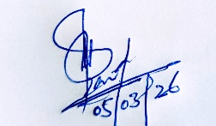  Ubaid Ullah  E&S Officer – PIU PHED
6 | Concept paper mitigation activity if any | Mitigation measures proposed
7 | Recommendations to the Design Engineer | Not Required

Annexures
Sub-Project Title: DWSS Wali khel Gul Wali
Land owner: Abdul Tawab

VLD/DUE DILIGENCE SCREENING CHECKLIST
Screening for Due Diligence | Yes | No | Remarks
Is the land in question free from any dispute on ownership or any other encumbrances? | Yes |  | The land is free from ownership disputes and encumbrances, as confirmed by community elders, political and religious representatives. This will further be verified during the VLD process by the Tehsildar and local government VC/NC representatives.
Has the land been jointly identified by the Revenue Department, beneficiary community and project representative? | Yes |  | The land has been collaboratively identified by the beneficiary community (community elders), PHED representative. This will further be verified during the VLD process by the Tehsildar and local government VC/NC representatives.
Has the Project team ensured that the land is appropriate for sub- project purposes and that the sub-project will not result in any adverse social or environmental impacts by using this land? | Yes |  | The project team and PHED representatives have assessed the site and confirmed its suitability for the sub-project, with no expected negative social or environmental impacts from its use.
Have the Titleholders or landowners donating land been made to understand that they will have equal access to the infrastructure built on the donated land like any other community member and that they cannot claim for any priority treatment? | Yes |  | Titleholder/ land owner has been fully informed and briefed during the VLD procedure that they will have equal access to the sub-project facility, with no special treatment or claims.
Is the land to be donated no more than 10% of the total land holding of the individual? | Yes |  | The donated land does not exceed 10% of the donors’ total landholding. This will further be verified during the VLD process by the Tehsildar and local government VC/NC representatives.
In case of communal land, has consent of 90% of land-owners through a consultative process been acquired? |  |  | N/A (Communal land is not involved in the sub-project)
Has it been ensured that the land titleholder/owner does not belong to vulnerable sections of society, unless he/she is a direct beneficiary of the subproject (i.e., donated parcel of land would result in net gains in that person’s livelihood)? Vulnerable sections are:  - households below the poverty line (with a valid government issued proof);  - Women headed households who may lose their shelter of livelihood due to land donation;  - Handicapped persons who may lose their shelter or livelihood due to land donation, | Yes |  | It has been confirmed by the community elders,  political representatives, religious leaders, VC Chairman/Secretary Local Government, project team and PHED staff that the landowner is not from a vulnerable group.
Has free and informed consent through meaningful consultations in good faith with all potential land donors been ensured? | Yes |  | Consent has been obtained through  genuine, informed, and good-faith consultations  with the land donor by the project team in the  presence of community elders, political representatives. This will further be verified during the VLD process by the Tehsildar and local government VC/NC representatives.
Have separate discussions been held with vulnerable donors such as women, elderly and orphans to facilitate meaningful participation and ensure there is no coercion by other land donors? |  |  | N/A.  No vulnerable donor involved.
Has it been verified that land is free from any encumbrances? | Yes |  | The land is free from any encumbrances, as confirmed by community elders, political and religious representatives. This will further be verified during the VLD process by the Tehsildar and local government VC/NC representatives.
Has it been verified that land donation will not displace tenants or labor, if any, from the land? | Yes |  | It has been ensured that no tenants or laborers are currently residing or working at the donated land. This will further be verified during the VLD process by the Tehsildar and local government VC/NC representatives.
Has it been verified that land donated is not land used traditionally or customarily for any religious or cultural practice? | Yes |  | The assessment confirms the land is not traditionally or customarily used for religious or cultural practices, preventing any potential community conflict.

Sub-project Map
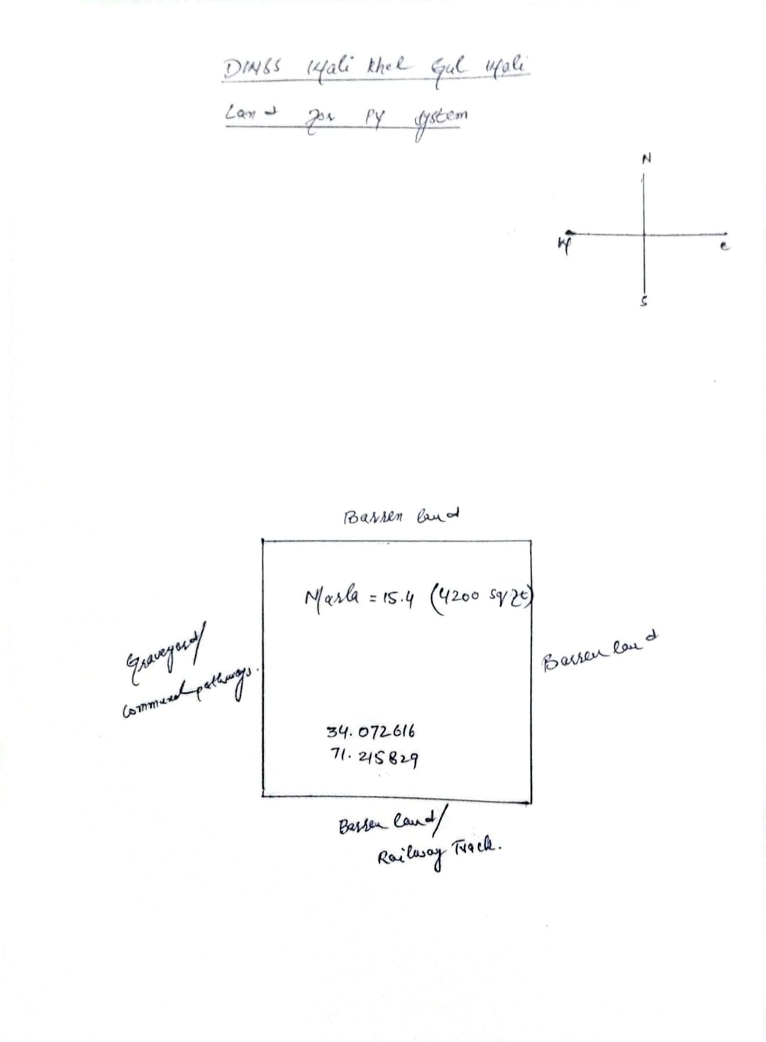

VLD Site Pictures:
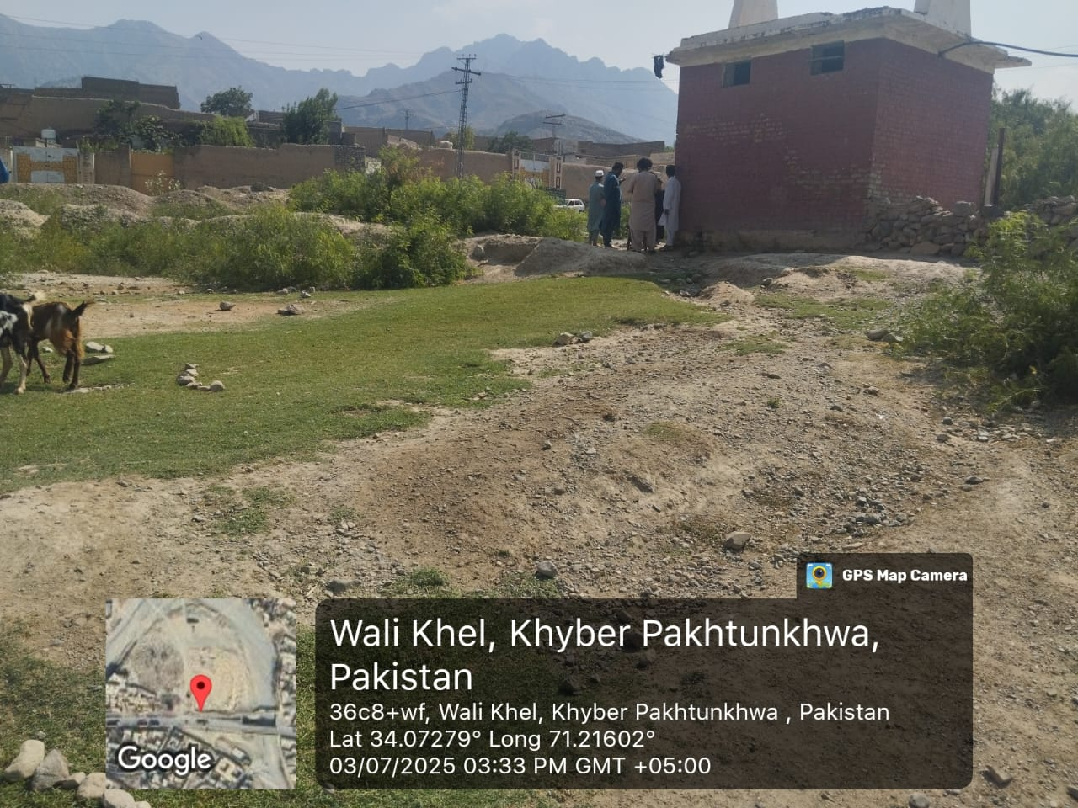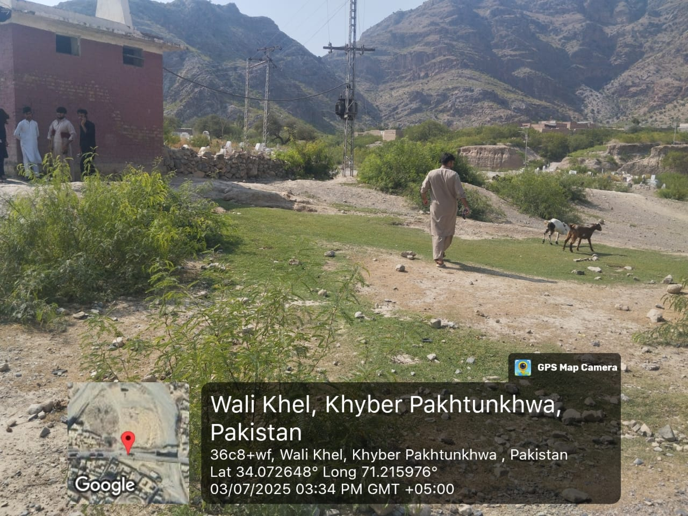
Picture 1 & 2: DWSS Wali khel Gul Wali, Khyber: Site assessment and proposed land for new PV system
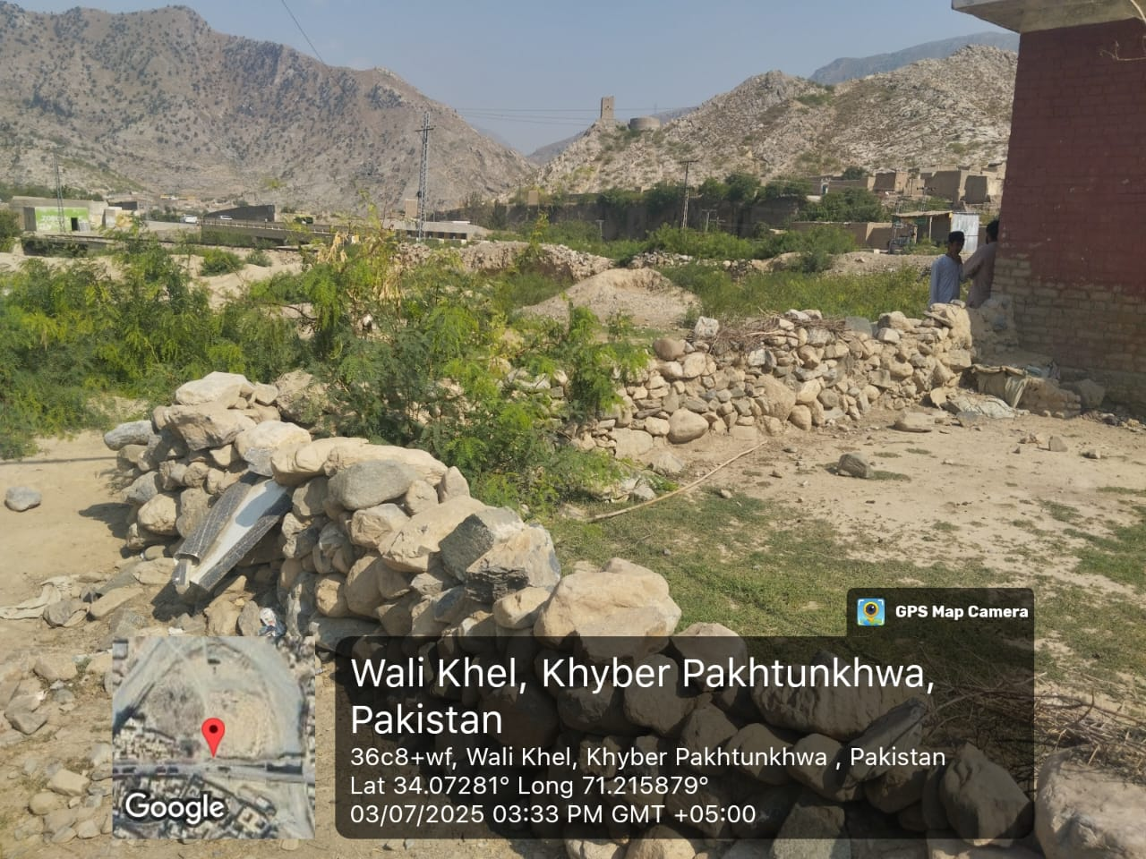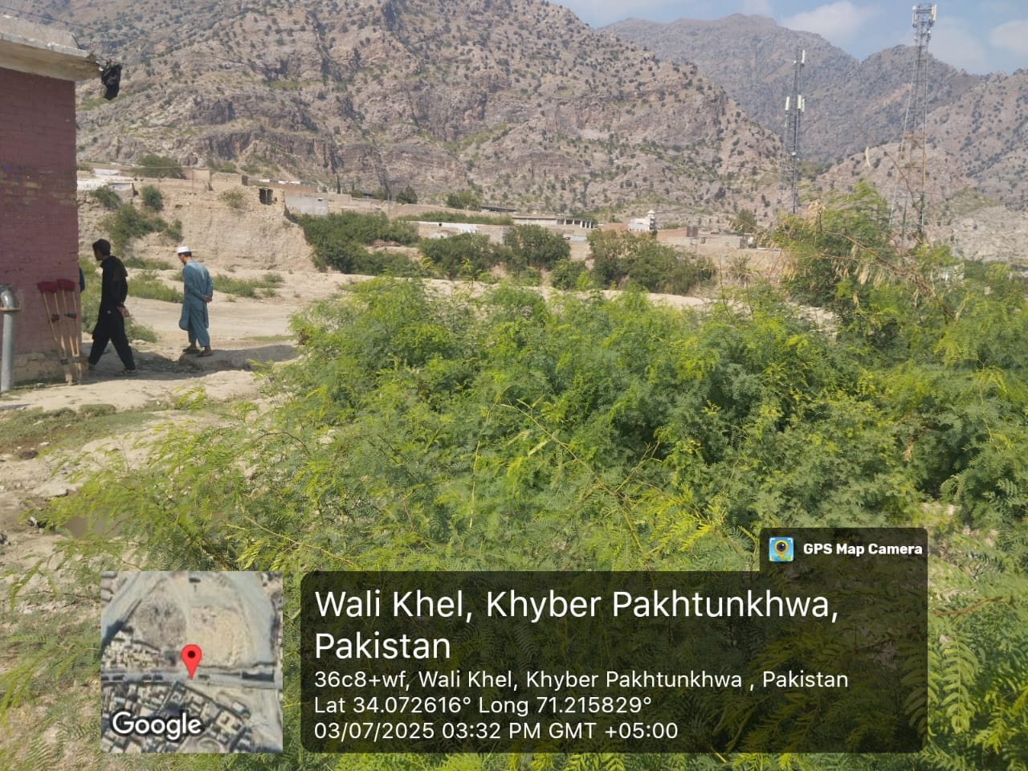
Picture 3 & 4: DWSS Wali khel Gul Wali, Khyber: Site assessment and proposed land for new PV system

VLD Agreement:
Filled VLD document (stamp paper) along with all the details of the sub-project site, signatures of Land owners, witnesses, union council officials has been submitted to the concerned PHED office for attestation by the concerned PHED official and signature of the concerned Tehsildar.

VLD Procedure & Owner Identification (Pictures):

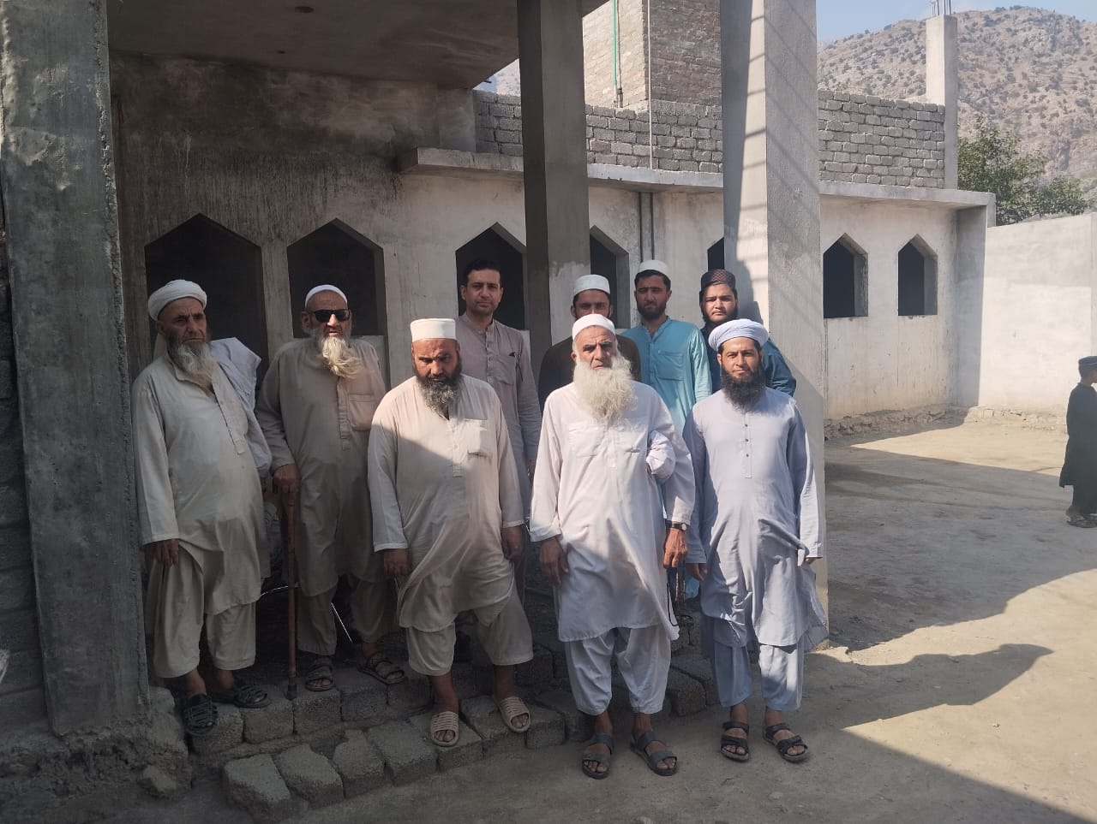
Picture 5: DWSS Wali khel Gul Wali, Khyber: Community consultation and VLD document signing being performed

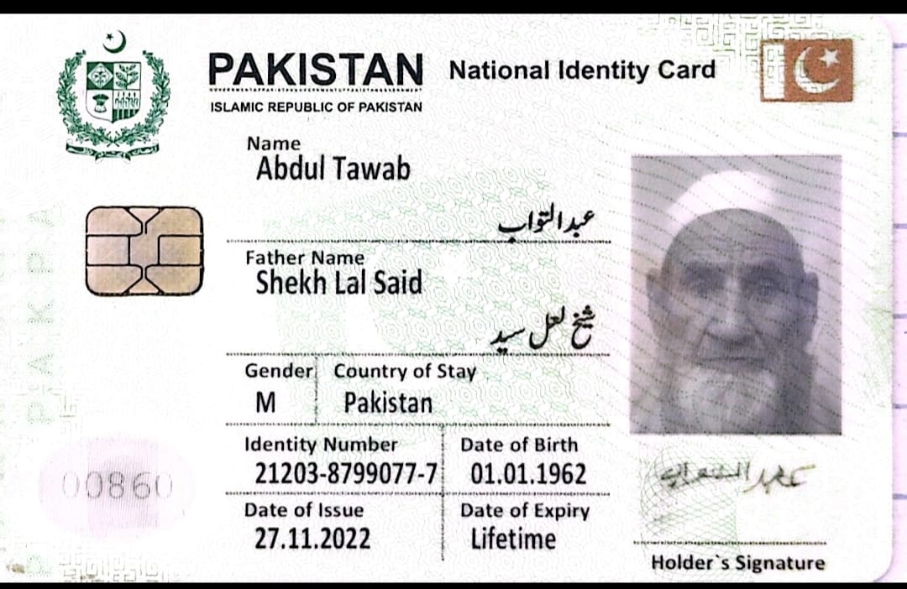
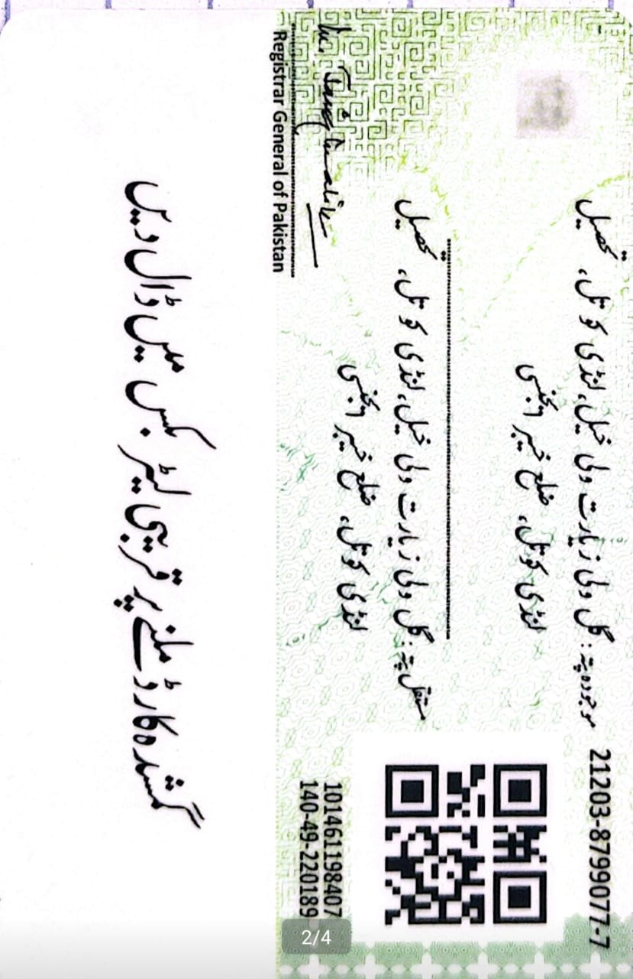

Picture 6 & 7: DWSS Wali khel Gul Wali, Khyber: Owner identification document for VLD procedure

Integrated Sanitation:

For the 11 sites of the integrated sanitation sub-project, separate E&S screening checklists have been filled for each site, for reference, one checklist has been attached in the ESMP, the remaining checklists have been shared separately to limit the number of pages of the ESMP.

Ghazi Tube well Nala MDK, Khyber
(Sanitation scheme)
ID of subproject | Ghazi Tube well Nala MDK, Khyber  (Sanitation scheme)
Proposing agency | PHE Department KP
Subproject location (with GPS coordinates) | 33.901146,71.371311
Subproject description | Sanitation scheme with proposed multiple (28) Septic Tanks (Communal)  - Construction of septic tank chambers and soakage pits  - Inlet/outlet piping  - Sewerage line (0.5 km)  VLD details:  Communal VLD
Estimated subproject cost | Rs. 19.09 million
Proposed date of commencement of sub-project | 22 June, 2026
Review status of technical details & specifications | In process.
Date of site visit/s to fill Checklist | 9th December, 2025.

Screening Questions |  | Yes | No | Remarks
A | Physical Environment
1 | Will the proposed subproject pose a risk of clearance of the vegetation (due to construction activities under subprojects, or related activities such as labor camp and storage site construction) that may result in an increased suspended solids washing into nearby water bodies? |  | No | There is no need of clearance of vegetation for the required construction works at the site and will not result in an increase in suspended solids washing into nearby water bodies.
2 | Will the proposed subproject pose a risk of contaminating drinking water sources due to construction activities? |  | No | There is very less chance of contamination of drinking water sources due to the required construction works, the water source is at a sufficient distance from the proposed subproject site. No drinking water source in 15 m radius of the site and ground water table is beyond the 2 m depth as required by The World Bank standards.
3 | Will the proposed subproject deplete groundwater due to water used during construction activities (e.g. For mixing, cooling, dust suppression etc.)? |  | No | The proposed subproject is not expected to significantly deplete groundwater resources, as the rehabilitation works will require only limited quantities of water for activities such as mixing, curing and dust suppression.
4 | Will the proposed subproject result in an increase in ambient air pollution, including chemical and particulate matter due to construction and operation of related machinery? | Yes |  | Due to involvement of excavation works at multiple sites, the proposed subproject is expected to cause a marginal impact on ambient air pollution particularly on particulate matter concentration.
5 | Will the proposed subproject result in an increase in ambient noise levels and vibrations due to the operation of construction or other machinery/vehicles? |  | No | The propose subproject activities will not require use of heavy machinery or repeated movement of vehicles hence very less chance of increase in noise pollution due to these sources.
6 | Will these ambient noise levels be beyond the specifications in the applicable NEQS? |  | No | Noise levels will not be beyond the specifications in the applicable NEQS due to very less use of heavy machinery or repeated movement of vehicles.
7 | Will the proposed subproject interventions be implemented in an area with high landslide risk? |  | No | Although the landscape of the area is generally hilly but the subproject site is predominantly plain, there is no history of landslides at the subproject site and the risk of landslides is considered negligible.
8 | Will the proposed subproject interventions generate hazardous and/or non-hazardous waste? |  | No | There is less chance of generating hazardous waste during the required works, while there will be significant quantity of non-hazardous waste generated. Waste Management plan will need to be implemented to ensure waste segregation and keep record of the generation, storage and disposal of waste.
9 | Will the proposed subproject interventions contribute to increased soil erosion, particularly impacting groundwater quality and downstream water supplies? |  | No | Site conditions are stable and construction activities will not result in excessive soil erosion and will not impact groundwater quality and downstream water supplies.
10 | Will the proposed subproject interventions potentially increase health risks for project workers and communities (e.g. COVID-19)? |  | No | The proposed subproject interventions will not potentially increase health risks for project workers and communities but standard health and safety protocols will be followed which will minimize any potential health risks to workers and communities.
11 | Will the proposed subproject (drinking water supply /sewerage /drainage) interventions impact or interfere with existing water infrastructure in the region? (e.g. Irrigation canals, wells etc.) | Yes |  | The proposed subproject interventions will positively impact the nearby drainage channel as the domestic waste water being discharged from the nearby communities’ houses will be treated at the sub-project.
12 | Is the proposed subproject being implemented in an area with a high risk of vector-borne diseases (e.g. Malaria and Dengue etc.)? |  | No | Vector-borne diseases in people and livestock were common in Khyber region in the past due to the limited use of vector control measures, however the implementation of disease control measures has decreased the risk of vector-borne diseases due to improved control measures such as insecticide spraying, the sub-project intervention will further decrease the risk due to improved sanitation facility in the region.
13 | Is the proposed subproject being implemented in an area with a high risk of natural hazard? (e.g. floods, earthquakes, landslides etc.) |  | No | The proposed subproject being implemented is not in an area with a high risk of natural hazard (e.g. floods, earthquakes, landslides etc.). Although the landscape of the area is generally hilly but the subproject site is predominantly plain, there is no history of landslides at the subproject site and the risk of landslides is considered negligible.

B | Ecological Environment
1 | Will the proposed subproject interventions potentially pose risks to any endangered species in the area under consideration? |  | No | No presence of endangered species found at the proposed subproject site under consideration, therefore, no risk to any endangered species.
2 | Will the proposed subproject interventions potentially cause any adverse impacts to habitats ecosystems and/or ecosystem services? |  | No | The proposed construction works will be confined to a designated site and will not cause any adverse impacts to habitats ecosystems and/or ecosystem services.
3 | Will the proposed subproject be located in areas that would promote the conversion of natural habitats? |  | No | No conversion of natural habitats expected at the subproject site due to the required construction works.
4 | Will any proposed subproject be located in or near sensitive environmental areas including parks and protected areas? |  | No | No parks or protected areas in or near the site.
5 | Are the proposed subproject likely to impact the paths of known migratory routes of wildlife? |  | No | The subproject site is not located in the path of wildlife migratory routes.
6 | Will the proposed subproject involve the introduction of any invasive species? (Invasive species are non-native (or alien) to the ecosystem under consideration and whose introduction causes or is likely to cause economic or environmental harm or harm to human health.) |  | No | The proposed subproject construction works will not involve the introduction of any invasive species, so no such risk involved.

C | Social Environment
1 | Will the proposed subproject involve land acquisition or involuntary resettlement? If yes, filling up of following is mandatory:  - Involuntary resettlement screening checklist for civil works  - VLD/Due diligence screening checklist (for all project-related civil works requiring land acquisition in areas WITH existing land records.)  - Qaumi Commission screening checklist (for all project-related civil works requiring land acquisition in areas WITHOUT existing land records.) | Yes |  | The proposed subproject does not require any land acquisition, as the septic tanks will be constructed within the revenue paths i.e., along existing community pathways and (unpaved) kacha tracks. The septic tanks are relatively small in size, ranging from 68 square feet to 150 square feet, and can therefore be easily accommodated within the revenue paths. This approach ensures that the sanitation scheme utilizes communal space without affecting private landownership, also minimizing resettlement risks and facilitating community access to improved sanitation infrastructure.  However, to encourage community participation and mitigate future complications, a communal VLD will be performed for septic tanks placed in communal pathways, hence VLD/Due diligence screening checklist has been filled and attached.  Involuntary resettlement screening checklist and Qaumi Commission screening checklist are not required.
2 | If there is any land requirement, has it been verified that the land being acquired is free from any dispute on ownership or any other encumbrances? | Yes |  | The land (communal pathway) is free from ownership disputes and encumbrances, as confirmed by community elders, political and religious leaders.
3 | Has it been ensured that the land is not being acquired through force or coercion? | Yes |  | The community members has expressed their willingness to provide land (communal pathway) for septic tanks, it will further be ensured that the land is not being acquired through force or coercion during the VLD process, signed by the community representative and members, community elders/witnesses, VC/NC representatives.
4 | Are there any forced labor or child labor risks associated with contractors or other third parties involved in implementing the proposed subproject? |  | No | Considering the inflation rate and the economic conditions of the region, there is a possibility of child labor.  However, in accordance with  national laws and the KP Child  Protection and Welfare Act, 2010, no child or forced labor will be permitted. Only worker above the age of 18 years will be allowed to work at site.
5 | Is labor influx expected during the implementation of the proposed subproject? Please estimate the strength of the anticipated outside labor force. |  | No | During the implementation of the proposed subproject, skilled labor is available in local community and as per the project policy, local labor will be preferred, there would be less possibility of hiring of outside labor force.
6 | Will local labor be used for the proposed subproject activities? | Yes |  | As per the project policy and World  Bank guidelines, both skilled and unskilled labors from local community will be preferred in hiring.
7 | Will there be any temporary or permanent physical or economic displacement as a result of the proposed subproject activities? |  | No | There is no chance of temporary or permanent physical and economical displacement (involuntary resettlement), resulting from the proposed subproject activities.
8 | Will the proposed subproject interventions likely to have impacts on important religious/cultural heritage sites? |  | No | There are no cultural heritage sites located within the subproject area.  However, two religious sites (mosques) are present in the vicinity of subproject area. While the subproject activities are not expected to have any direct impact on the mosque, special care should be taken during construction activities to ensure that it remain unaffected.
9 | Have there been any past security-related issues at the proposed subproject site? | Yes |  | The security situation in district Khyber was historically peaceful until the late 2000s when the merged district (tribal areas) became a significant conflict zone due to the spillover of militancy from neighboring areas and  Afghanistan. However, in the past few months, specifically in the subproject area there are no direct security risks or conflicts reported.
10 | Has stakeholder engagement taken place in the proposed subproject area? | Yes |  | During the E&S screening, the E&S  team has met with the stakeholders  particularly the District  Administration, Local government  representatives at the village level  i,e., VC Chairman/Secretary, community elders/representatives, religious representatives, PHED staff, vulnerable groups i,e., women and persons with disability.  The stakeholders were briefed regarding the project overview and details and objectives of the sub project and the beneficiaries. The stakeholders showed positive response regarding the project objective and ensured their cooperation during the construction and operation phases.
11 | Have there been any potential security risks and conflicts related to the proposed subproject area under consideration? |  | No | The proposed subproject site is safe. There are no direct security risks or conflicts that have been reported at or near the site in the past few months and rehabilitation activities can be carried out without major concerns.
12 | Will there be enough measures against the potential security risks, taken to ensure project staff and beneficiary safety? | Yes |  | The safety of project staff and beneficiaries will be ensured through the implementation of a standard security management plan (SMP).  The security situation will be closely monitored, and necessary precautionary measures will be taken throughout the project cycle.
13 | Will the subproject conduct community awareness-raising activities related to the proposed subproject? (if any) e.g. links between human health and access to appropriate water supply and sanitation facilities. | Yes |  | During the E&S screening, community people/elders, vulnerable groups and political and religious representatives were sensitized on key aspects of the subproject.  Furthermore, awareness-raising  activities are planned to be conducted both prior to and throughout the construction phase to enhance community awareness, particularly regarding the links between human health and access to safe water supply and sanitation facilities.
14 | Will the proposed subproject consider ensuring equitable access to sanitation facilities for all beneficiaries, especially in areas with higher water scarcity or vulnerable populations? | Yes |  | The subproject will ensure fair and equitable access to sanitation services for all beneficiaries especially to vulnerable population. It will adopt a participatory approach and engage community elders and local government representatives to help ensure that in providing the sanitation services the needs of the most vulnerable are not overlooked.
15 | Will the proposed subproject address the social impacts of morbidity and mortality, particularly among vulnerable populations? | Yes |  | While the proposed subproject does not directly address mortality, by reducing illness and improving hygiene conditions, it indirectly supports better health outcomes and lowers the risks that can lead to severe health consequences.  The subproject will significantly contribute to reducing the social impacts of morbidity, particularly among vulnerable populations, by reducing the risk of water borne diseases due to treatment of the discharged domestic waste water.  This sub-project will significantly help lower the risk of water borne and vector borne diseases in the community.
16 | Will the proposed subproject interventions empower women to benefit? | Yes |  | The proposed interventions will particularly empower women by providing safe and hygienic sanitation facilities, thereby enhancing their dignity, health and security.
17 | Were vulnerable groups contacted or remain involved during stakeholder consultations? (e.g. women, minorities, economically disadvantaged individuals, etc.) | Yes |  | Vulnerable groups especially women, children and elderly groups were randomly identified and consulted/engaged as key stakeholders. Discussions regarding the issues related to sanitation facilities in their areas and the recommendations to overcome those issues.

RISK CLASSIFICATION
D | Steps | Recommendations/Findings
1 | Risk category identification | Low  Moderate  Substantial  High
2 | Recommendation on type of E&S instruments required | E&S Checklist with Mitigation Measures  ESMP  Others
3 | Summary of screening findings | Moderate risk to Environment and Social aspects identified during the screening and therefore E&S instrument recommended is ESMP
4 | Name of person conducting screening |   Muhammad Ahmad  Environmental Specialist  Dated: - 09-12-2025
5 | Name of the person endorsing the E&S screening findings | 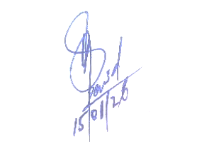  Ubaid Ullah  E&S Officer – PIU PHED
6 | Concept paper mitigation activity if any | Mitigation measures proposed
7 | Recommendations to the Design Engineer | Not Required

Annexures
E&S Screening and Community Consultation (Pictures):
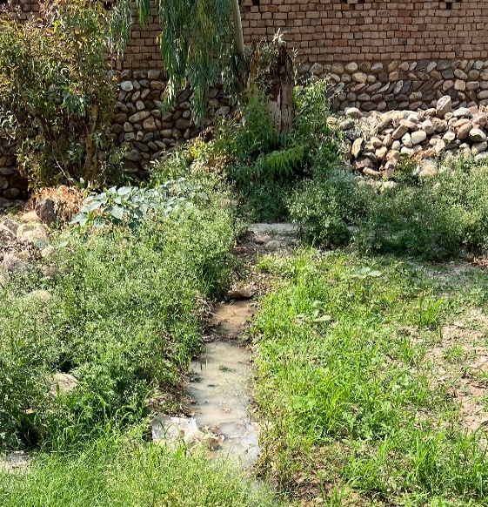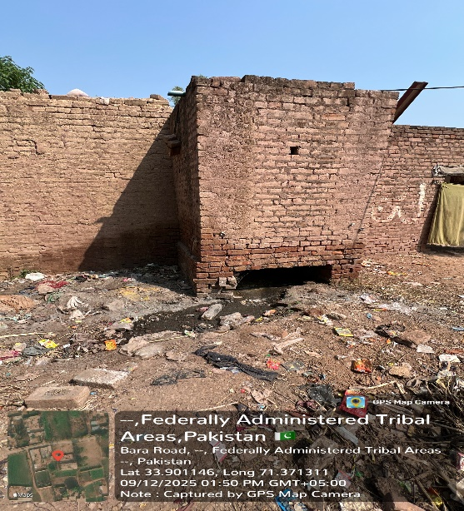
Picture 1 & 2: Ghazi Tube well Nala MDK, Khyber (Sanitation scheme): Current sanitation situation

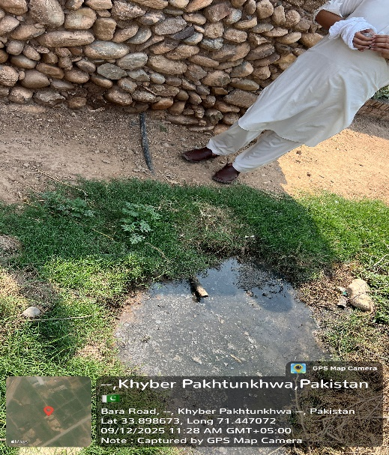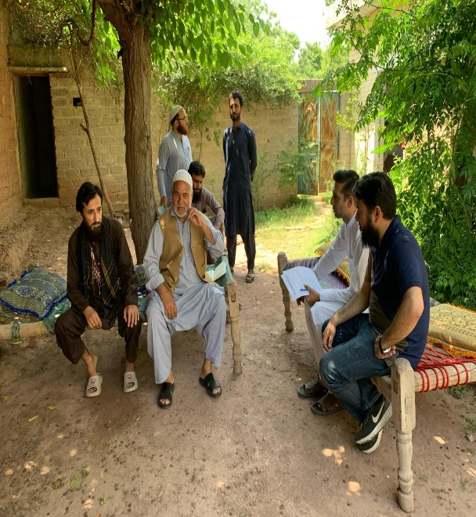
Picture 3 & 4: Ghazi Tube well Nala MDK, Khyber (Sanitation scheme): Current sanitation situation and consultation with community members during E&S screening

VLD/DUE DILIGENCE SCREENING CHECKLIST
Screening for Due Diligence | Yes | No | Remarks
Is the land in question free from any dispute on ownership or any other encumbrances? | Yes |  | The land (communal pathway) is free from ownership disputes and encumbrances, as confirmed by community elders, political and religious representatives. This will further be verified during the VLD process by the local government VC/NC representatives.
Has the land been jointly identified by the Revenue Department, beneficiary community and project representative? | Yes |  | The land (communal pathway) has been collaboratively identified by the consultant team, beneficiary community (community elders) and PHED representative. This will further be verified during the VLD process by the local government VC/NC representatives.
Has the Project team ensured that the land is appropriate for sub- project purposes and that the sub-project will not result in any adverse social or environmental impacts by using this land? | Yes |  | The project team and PHED representatives have assessed the site and confirmed its suitability for the sub-project (ST’s), with no expected negative social or environmental impacts from its use.
Have the Titleholders or landowners donating land been made to understand that they will have equal access to the infrastructure built on the donated land like any other community member and that they cannot claim for any priority treatment? | Yes |  | Titleholder/ land owner (community members) have been fully informed and briefed during the VLD procedure that they will have equal access to the sub-project facility, with no special treatment or claims.
Is the land to be donated no more than 10% of the total land holding of the individual? | Yes |  | The donated land (communal pathway) does not exceed 10% of the donors (community members) total landholding. This will further be verified during the VLD process by the local government VC/NC representatives.
In case of communal land, has consent of 90% of land-owners through a consultative process been acquired? | Yes |  | Consent of 90% has been obtained from community members through a consultative process for the use of communal pathways for the installation of septic tanks.
Has it been ensured that the land titleholder/owner does not belong to vulnerable sections of society, unless he/she is a direct beneficiary of the subproject (i.e., donated parcel of land would result in net gains in that person’s livelihood)? Vulnerable sections are:  - households below the poverty line (with a valid government issued proof);  - Women headed households who may lose their shelter of livelihood due to land donation;  - Handicapped persons who may lose their shelter or livelihood due to land donation, | Yes |  | It has been confirmed by the community elders, political representatives, religious leaders, VC Chairman/Secretary Local Government, project team and PHED staff that the communal pathway is a shared land and is not from a vulnerable group.
Has free and informed consent through meaningful consultations in good faith with all potential land donors been ensured? | Yes |  | Consent has been obtained through genuine, informed, and good-faith consultations with the community members by the project team in the presence of community elders, political representatives. This will further be verified during the VLD process by the local government VC/NC representatives.
Have separate discussions been held with vulnerable donors such as women, elderly and orphans to facilitate meaningful participation and ensure there is no coercion by other land donors? |  |  | N/A.  No vulnerable donor involved.
Has it been verified that land is free from any encumbrances? | Yes |  | The land (communal pathway) is free from any encumbrances, as confirmed by community elders, political and religious representatives. This will further be verified during the VLD process by the local government VC/NC representatives.
Has it been verified that land donation will not displace tenants or labor, if any, from the land? | Yes |  | It has been verified during the assessment that the placement of septic tanks on communal pathways will not result in the displacement of any tenants or labor, as communal pathways are not occupied or used for tenancy or labor activities.
Has it been verified that land donated is not land used traditionally or customarily for any religious or cultural practice? | Yes |  | The assessment confirms the land (communal pathway) is not traditionally or customarily used for religious or cultural practices, preventing any potential community conflict.

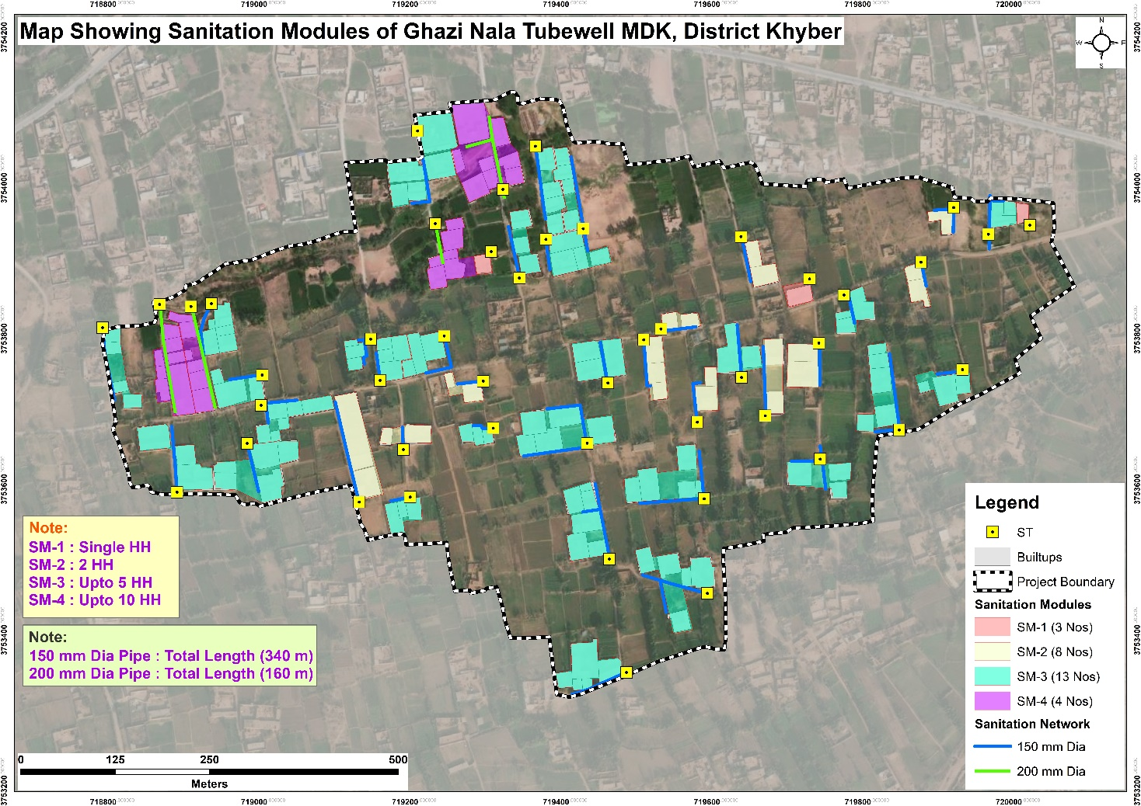

Annex 2. Labor Management Procedures (LMP)

1. Introduction:
All labor management activities under this project shall strictly follow this Labor Management Procedures (LMP). No worker, contractor, subcontractor, or agency shall deviate from these procedures. This LMP applies to all project labor – including direct hires, contract workers, temporary laborers, community-based workers, and volunteers engaged in any project-related activity. The LMP covers are all the important aspects linked to the labor management of the project.

2. Terms & Conditions of Employment
- Written Agreements: Every worker shall receive a written employment agreement in Urdu/Pashto detailing: wages (daily/monthly), working hours (max 8 hours/day, 48 hours/week, with 1 day rest), overtime rates (double normal wage), leave entitlements (annual, sick, emergency), and termination notice period (7–30 days based on tenure).
- Minimum Wage: Wages shall not be less than the officially notified minimum wage for unskilled/skilled labor in KP.
- Payment: Wages paid weekly or bi-weekly via bank transfer or wage slip with acknowledgment; no payment in kind or delayed beyond 7 days.
- Accommodation: If workers are non-local, the employer provides safe, gender-segregated accommodation with clean water, sanitation, and first aid. Local workers are prioritized.
- Working Conditions: Personal protective equipment (PPE – helmets, gloves, boots, masks) provided free of cost. Provision of safe drinking water and hygienic toilet facilities ensured at worksites.
3. Prohibition of Child & Forced Labor
- Absolute Prohibition: No person under 18 years shall be employed in hazardous work (e.g., excavation, machinery, chemical handling). No person under 14 years or below the legal working age (currently for non-hazardous under KP laws) shall be employed for any project activity.
- Forced Labor: No bonded labor, prison labor, debt labor, or any form of compulsory work. All work is voluntary, with right to leave after giving notice. No retention of identity documents, no deposits, no penalties for resignation.
- Verification: Employers must maintain age verification (CNIC/B-form copy). Random site inspections shall be conducted by the client and SC Environmental & Social (E&S) teams.
- Remediation: If child labor is found, child shall be removed immediately, enrolled in catch-up schooling (project to fund), and family provided with financial support to replace lost income.
4. Worker Code of Conduct (Enforceable)
Every worker and supervisor must sign the required Code of Conduct (attached as annex 9). Violation leads to disciplinary action up to termination and legal reporting.
Enforcement: Contractors shall maintain a disciplinary log. First offense: written warning; second: fine (1 day wage) + suspension; third: termination. Severe offenses (assault, theft, child labor) lead to immediate termination and police filing.

5. Worker Grievance Mechanism (Separate from Community Grievance)
A separate, safe, and confidential grievance mechanism exists exclusively for workers. It is accessible to all workers – including daily wagers and subcontractor staff.

Composition of Worker’s GRC (PIU PHED):

Designation/Organization | GRC Members
PD PIU PHED | Head/convener of GRC
E&S officer PIU PHED | Secretary of GRC
Assistant Resident Engineer (SC) | Member
Contractor Project Manager | Member
Environment/Social/Gender Specialist, Supervision Consultant, PIU PHED | Member
Co-opted/Invited member(s)  E.g. complainant, lawyer, relevant govt. Official, etc. | Member/Observer

Grievance Registration and Resolution Process
Submission: Complainants can lodge grievances through:
  - Focal Person: Environment & Social Officer, PIU PHED, KP-RIISP
  - Phone: +92 91 9217303
  - Email: piuphedgrm@gmail.com
  - In person/letter: Office of the Project Director, KP-RIISP, Plot No. 40, Sector B-II, Phase-V, Hayatabad, Peshawar.
  - Complaint Box/Registers at site offices
Procedure:
- Step 1 – Filing: Grievance recorded within 24 hours. Worker receives unique ID number.
- Step 2 – Acknowledgment: Within 48 hours (SMS/notice board).
- Step 3 – Resolution Time:
  - Minor (wage error, leave denial) → 7 days
  - Major (harassment, safety violation, retaliation) → 14 days with investigation
- Step 4 – Appeal: If unsatisfied, worker can escalate to Senior Social Development Specialist (PCMU), then to KP Ombudsperson for Labor.
- Step 5 – Closure: Written resolution given to worker. No retaliation permitted.
Non-retaliation clause: Any supervisor punishing a worker for filing a grievance shall be terminated immediately.
6. Management & Contractual Obligations
- Primary Responsibility: PIU ensures all contractors/subcontractors prepare and submit the LMP
- Contractor’s Duty: Before mobilization, contractor must submit a Labor Management Plan (including list of workers, wage rates, grievance log, and Code of Conduct acknowledgment forms).
7. Monitoring & Reporting
- Daily: Site supervisor checks attendance, wage slips, grievance box.
- Monthly: E&S Officer conducts random worker interviews (20% of workforce) – anonymous survey on working conditions, payment timeliness, harassment.
- Quarterly: Detailed report: number of workers, grievances filed/resolved, any child/forced labor cases, code of conduct violations.
8. Effective Date & Dissemination
This LMP becomes effective upon award of contract to the contractor. Copies shall be:
- Displayed (in Urdu/Pashto) at every worksite notice board.
- Explained during weekly toolbox talks.
- Provided to every sub-contractor, and worker.
All project-related labor management must follow this LMP. Any deviation is a breach of ESMP and grounds for contract termination.

Annex 3. Maps and Architectural Drawings
Figure 1: Location of Selected Schemes for Rehabilitation-Integrated Sanitation, District Khyber
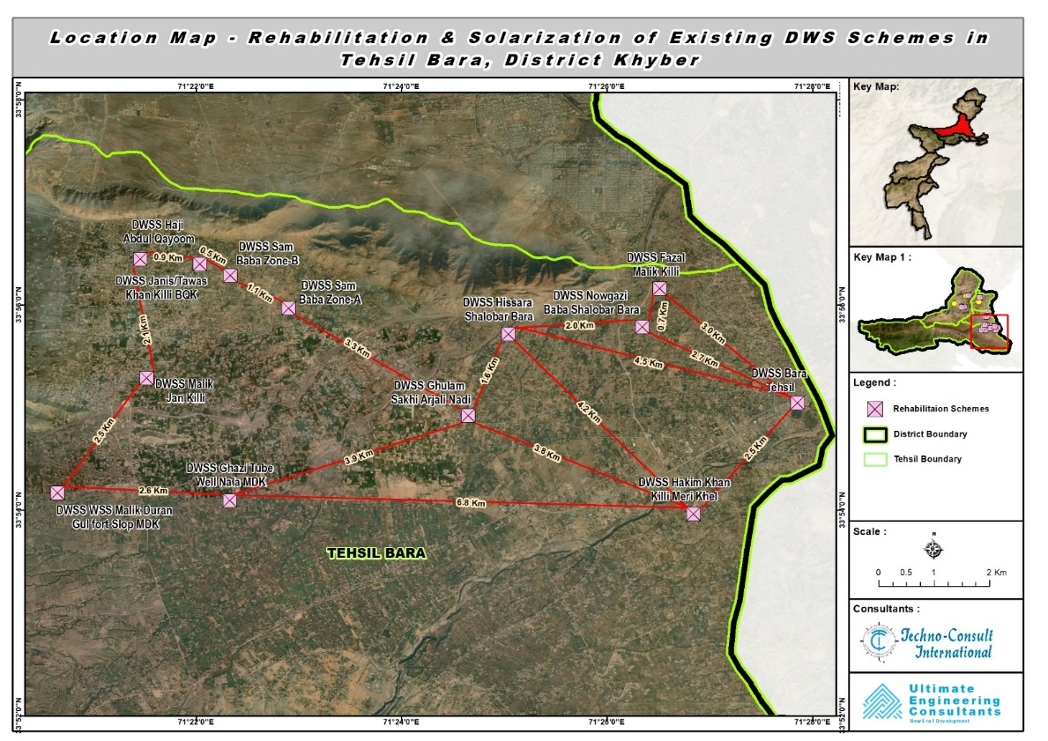
Figure 2: Location of Selected Schemes (13) for Rehabilitation-Integrated Sanitation in Tehsil Bara, District Khyber

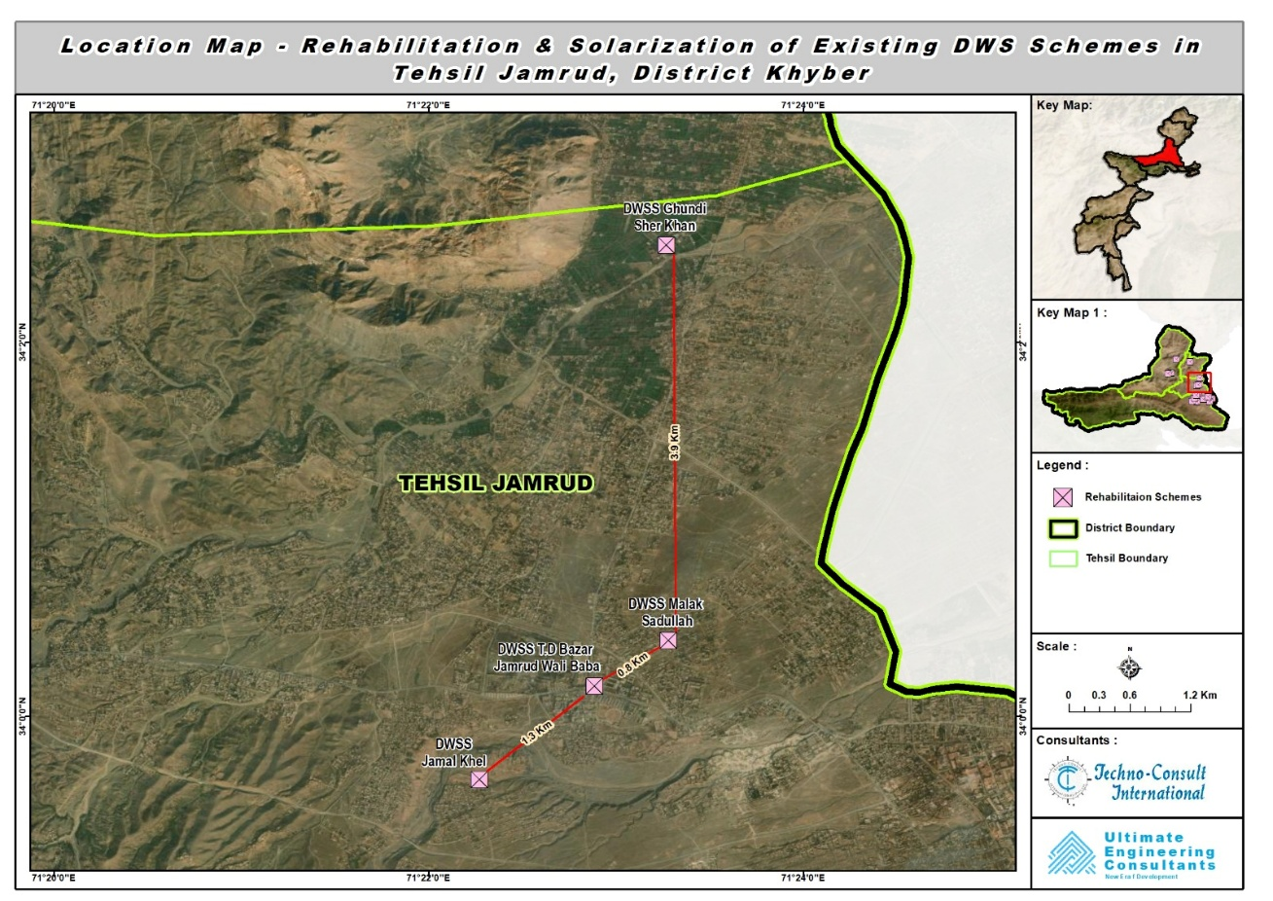
Figure 3: Location of Selected Schemes (4) for Rehabilitation-Integrated Sanitation in Tehsil Jamrud, District Khyber
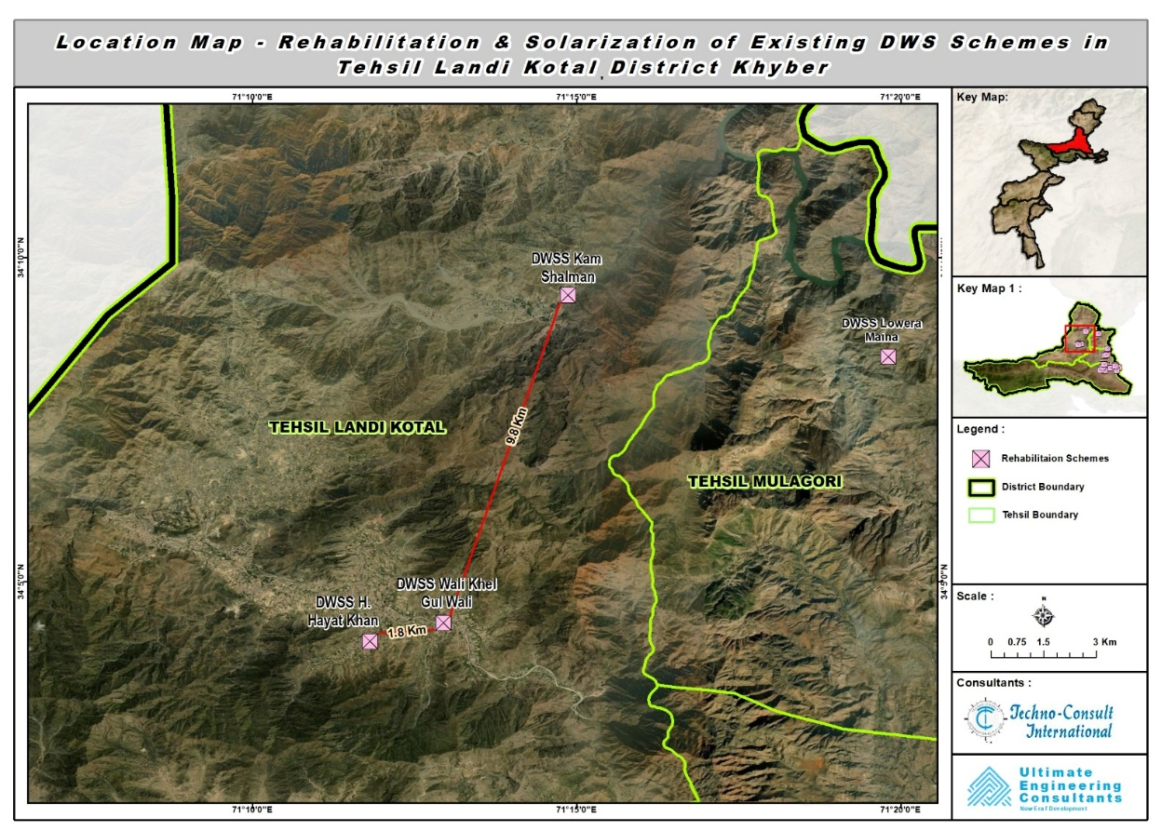
Figure 4: Location of Selected Schemes (3) for Rehabilitation-Integrated Sanitation in Tehsil Landi Kotal, District Khyber
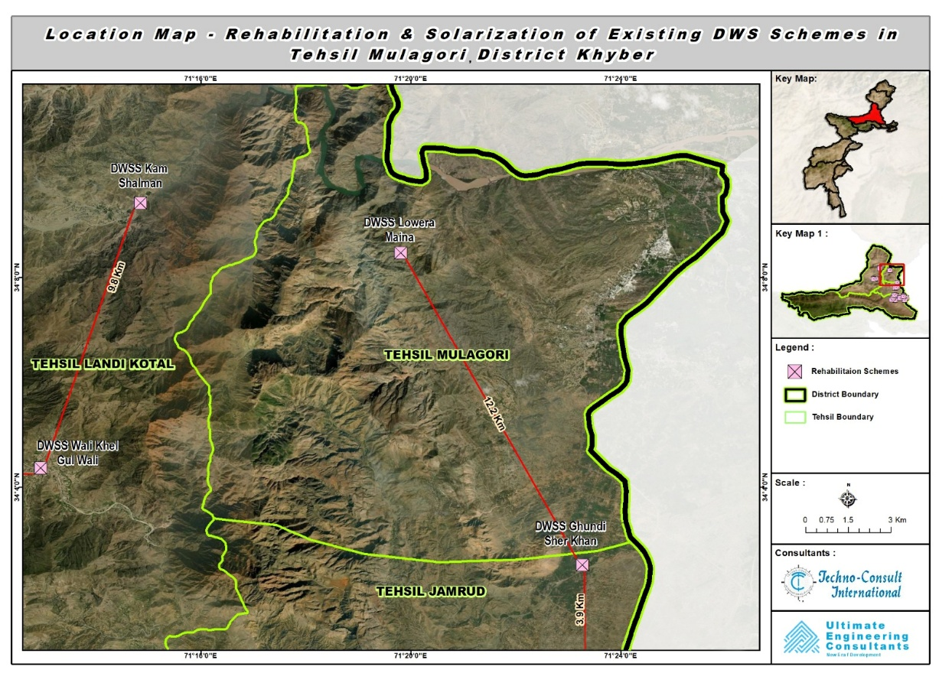
Figure 5: Location of Selected Scheme (1) for Rehabilitation-Integrated Sanitation in Tehsil Mula Gori, District Khyber
- Maps and Architectural Drawings (Rehabilitation and Solarization Component):
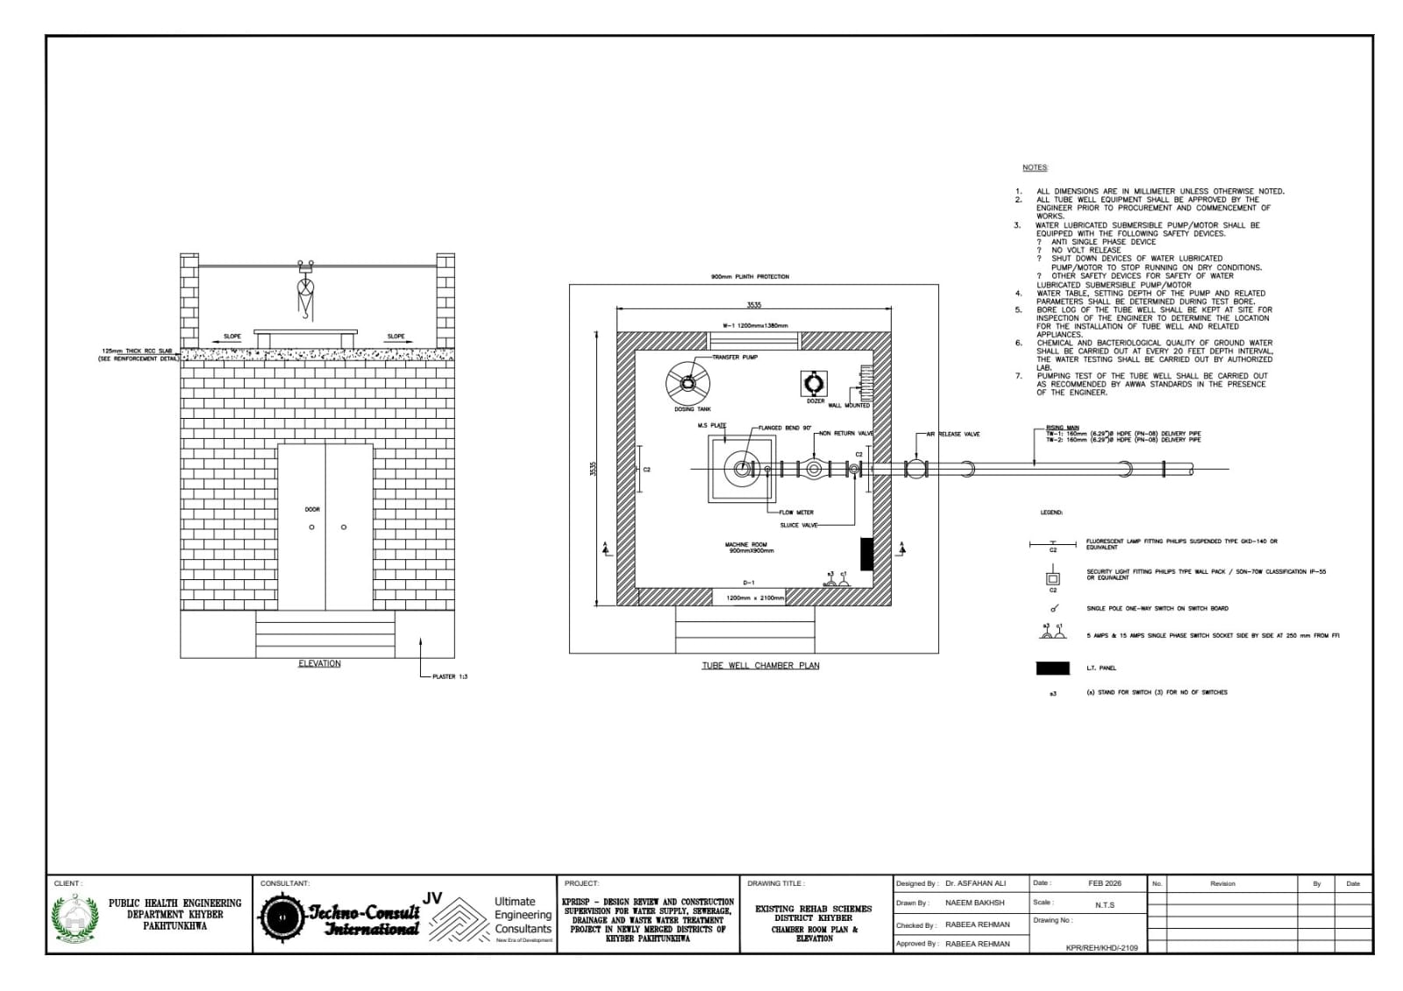
Figure 6: Pump room drawing, District Khyber

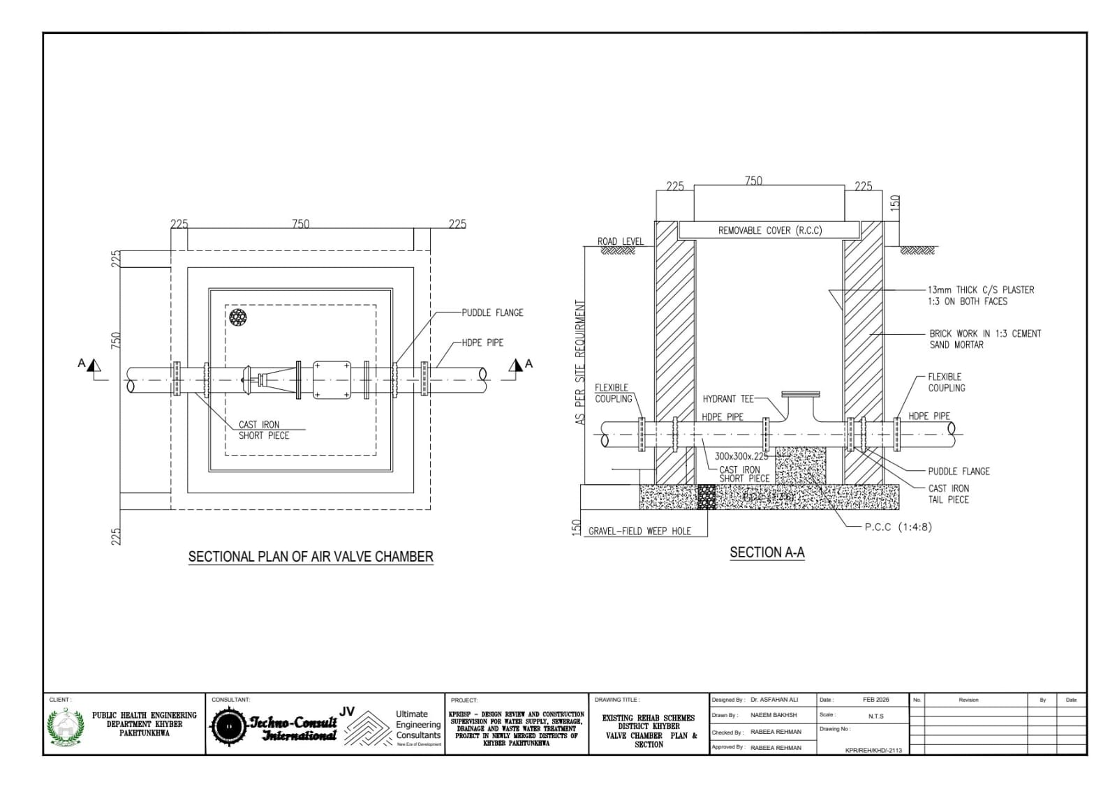
Figure 7: Valve chamber drawing, District Khyber
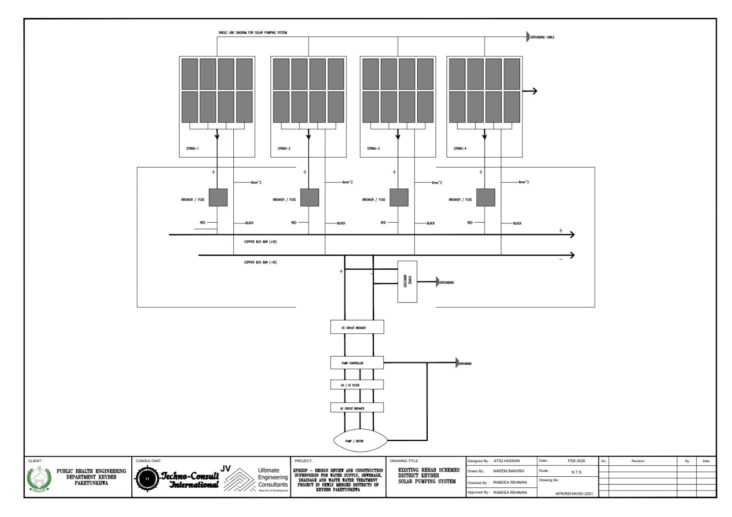
Figure 8: New PV System drawing, District Khyber
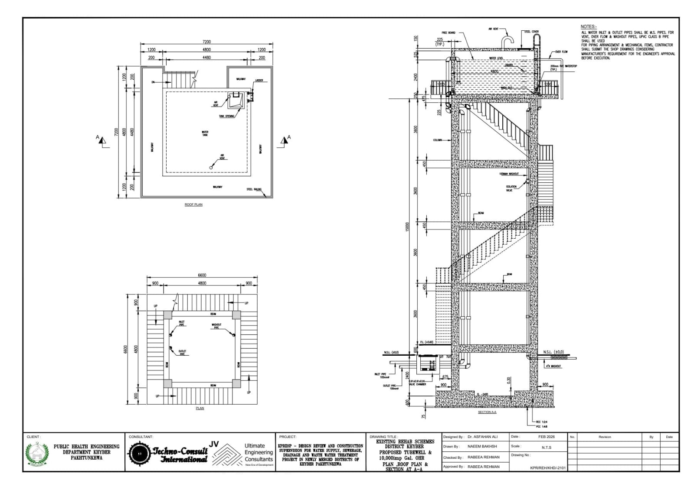
Figure 9: Overhead Reservoir (OHR) drawing, District Khyber
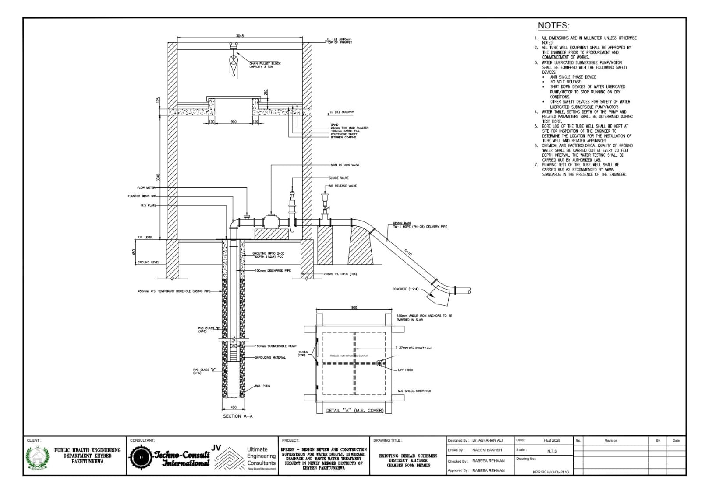
Figure 10: Chamber room and borehole section drawing, District Khyber
- Distribution Network Layout Maps (Rehabilitation and Solarization Component): 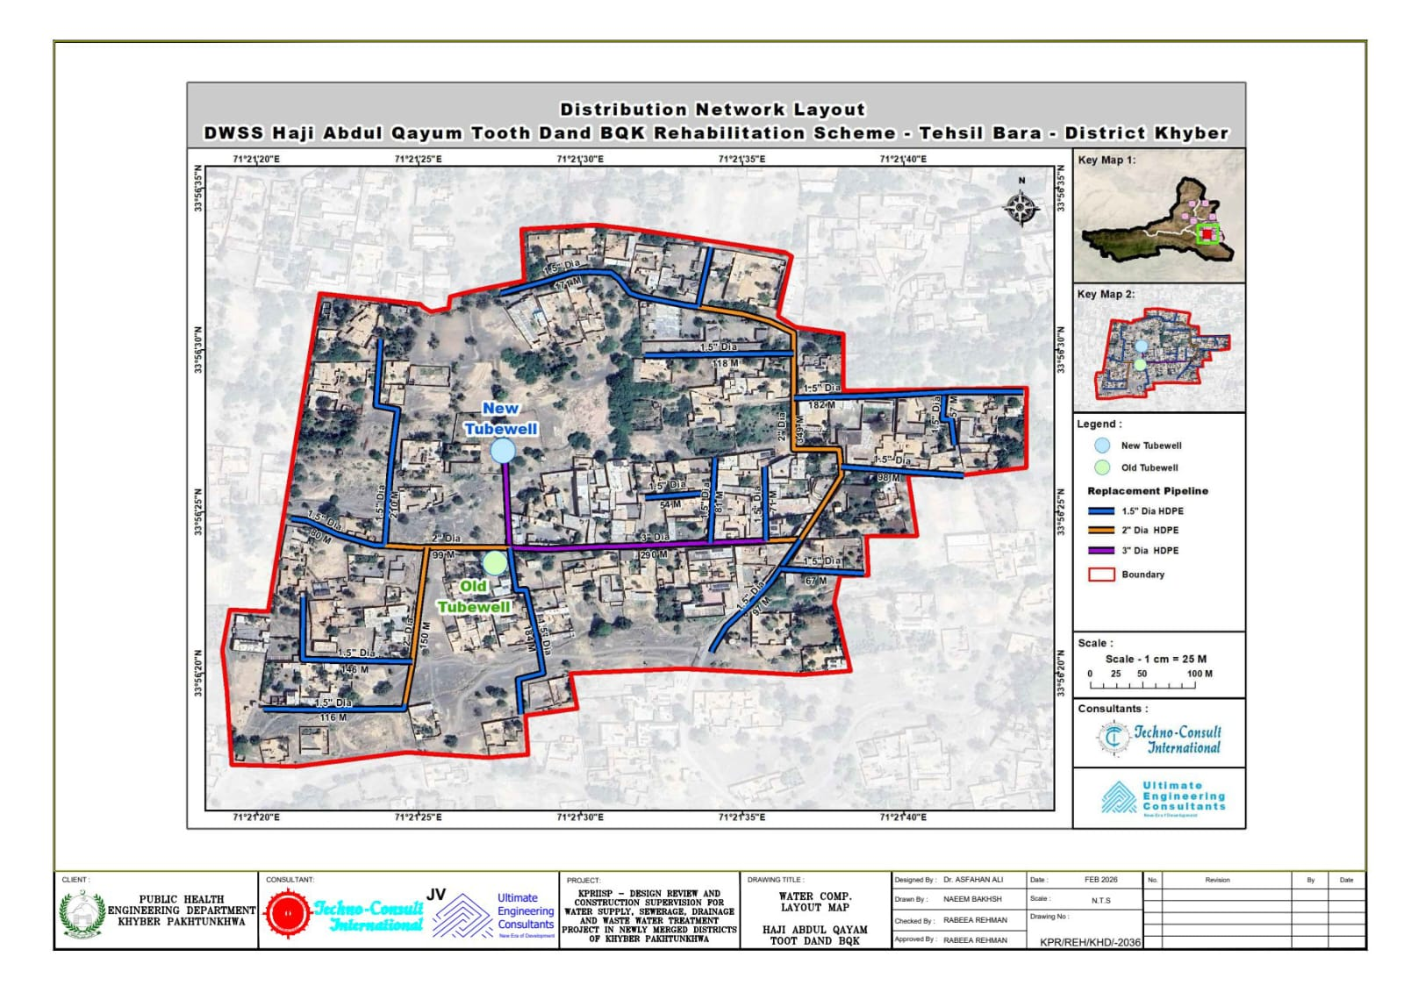
Figure 11: DWS Haji Abdul Qayum Toot Dand BQK, District Khyber: Water Distribution Network Layout
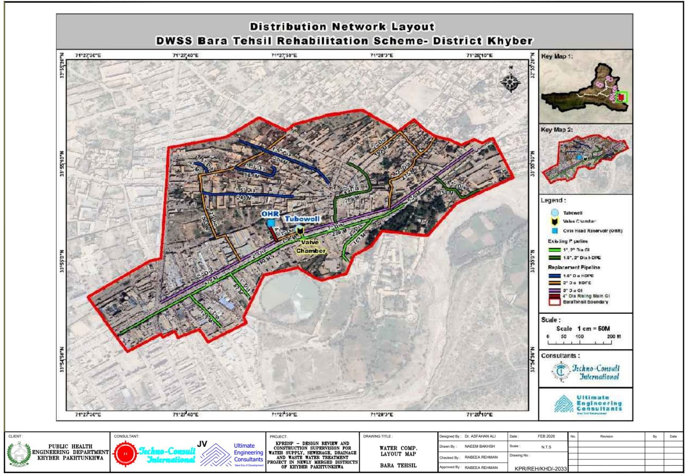
Figure 12: DWS Bara Tehsil, District Khyber: Water Distribution Network Layout
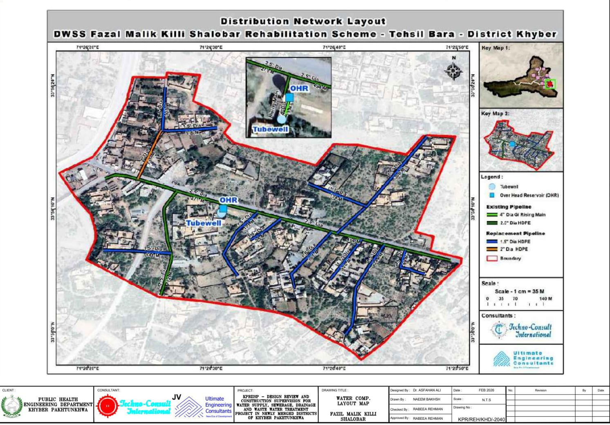
Figure 13: DWS Fazal Malik Killi Shalobar, District Khyber: Water Distribution Network Layout
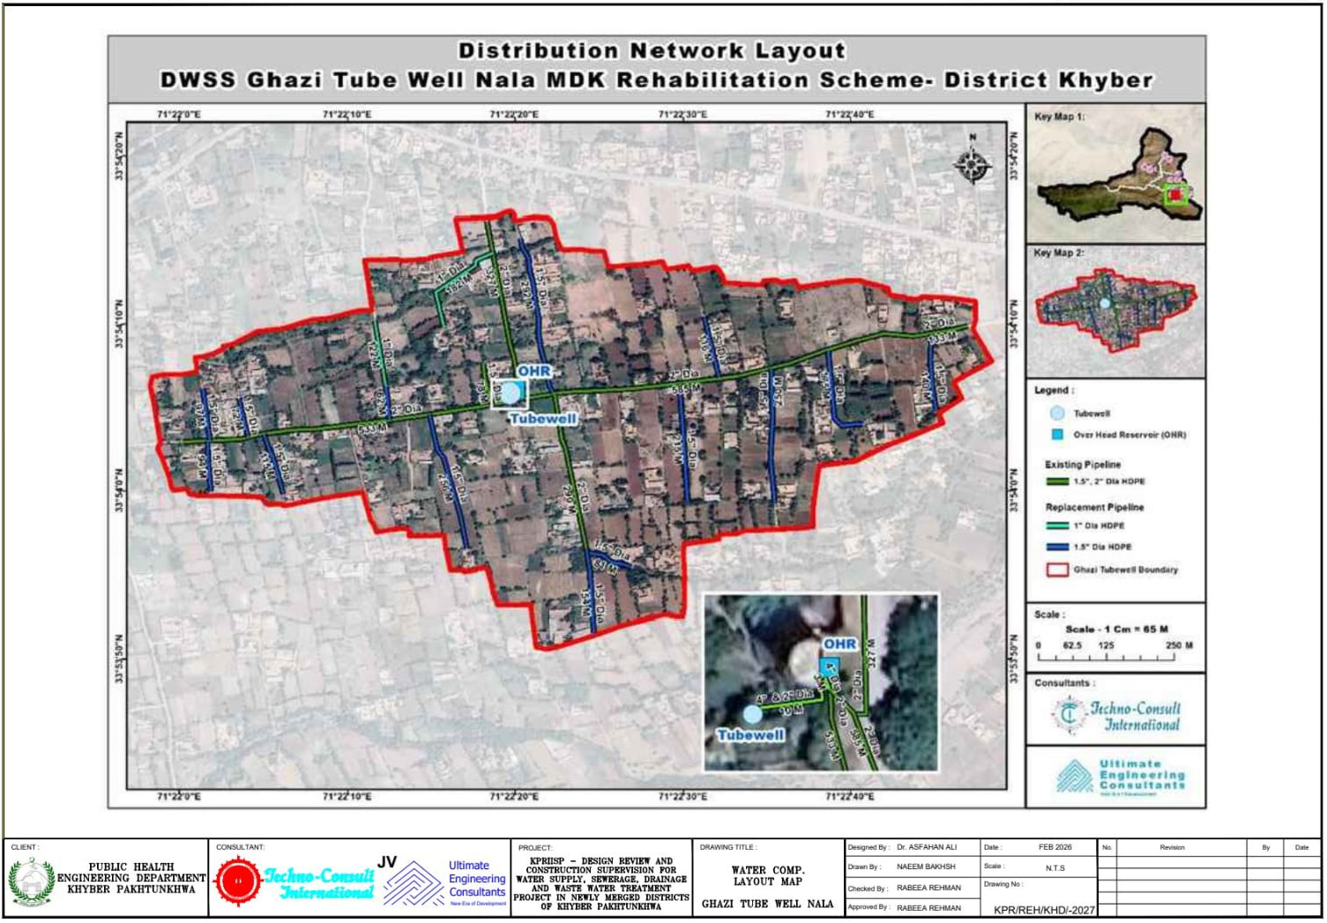
Figure 14: DWS Ghazi Tubewell Nala MDK, District Khyber: Water Distribution Network Layout
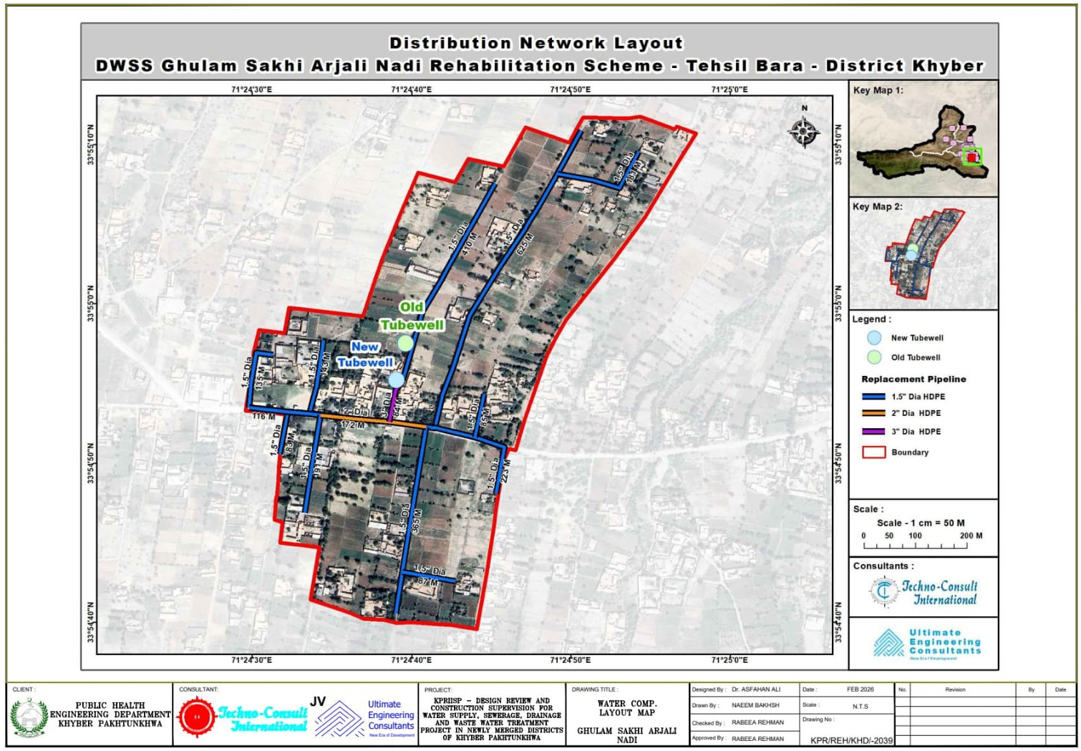
Figure 15: DWS Ghulam Sakhi Arjali Nadi, District Khyber: Water Distribution Network Layout
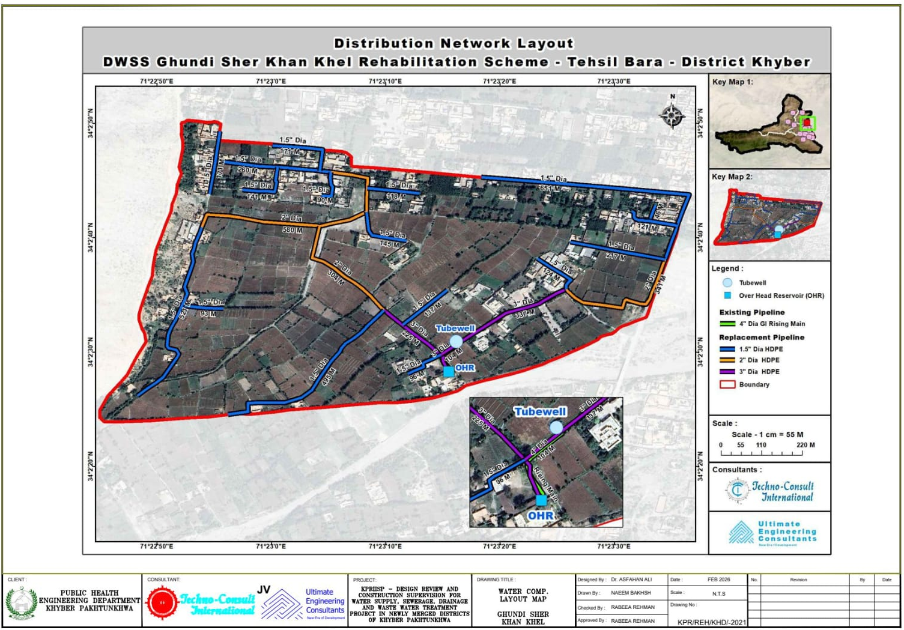
Figure 16: DWS Ghundi Sher Khan Khel, District Khyber: Water Distribution Network Layout
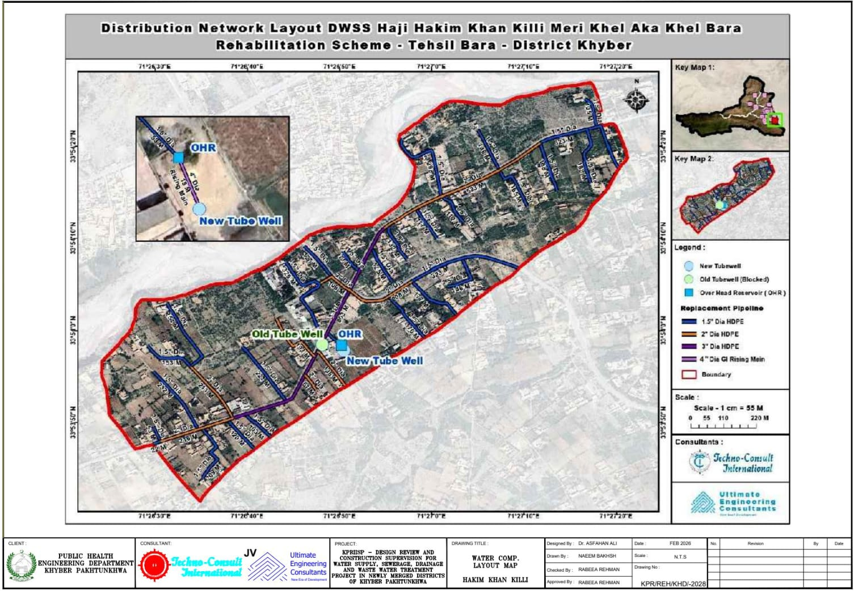
Figure 17: DWS Hakim Khan Killi, District Khyber: Water Distribution Network Layout
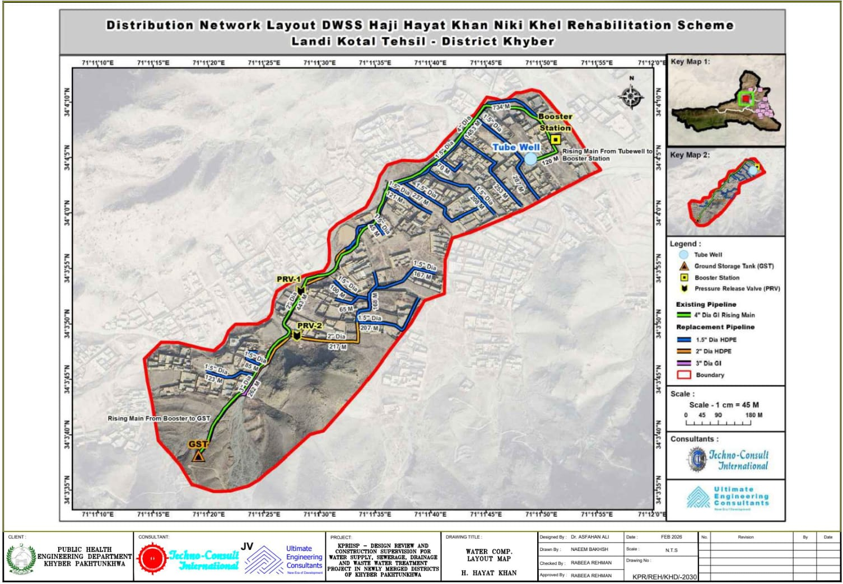
Figure 18: DWS H. Hayat Niki Khel, District Khyber: Water Distribution Network Layout
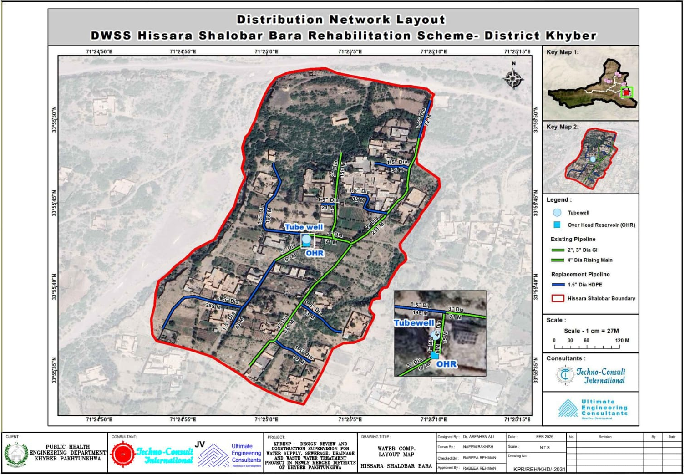
Figure 19: DWS Hissara Shalobar, District Khyber: Water Distribution Network Layout
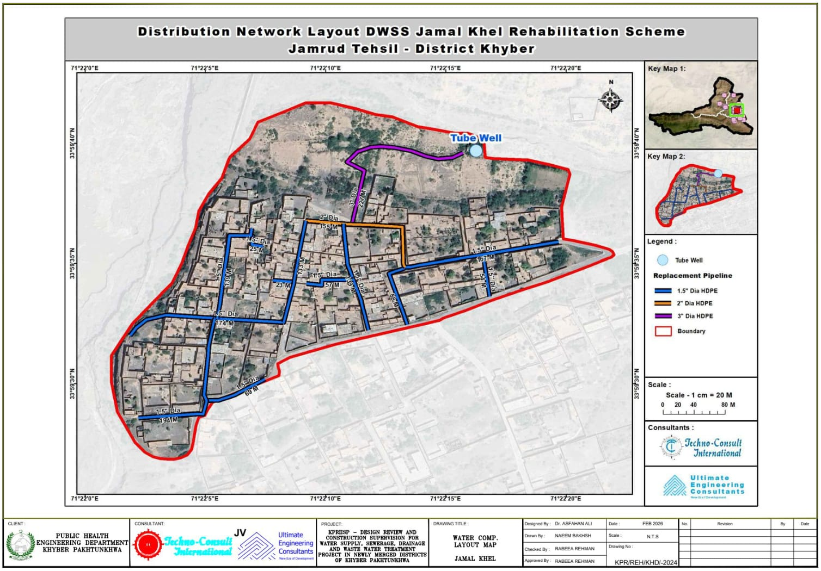
Figure 20: DWS Jamal Khel, District Khyber: Water Distribution Network Layout
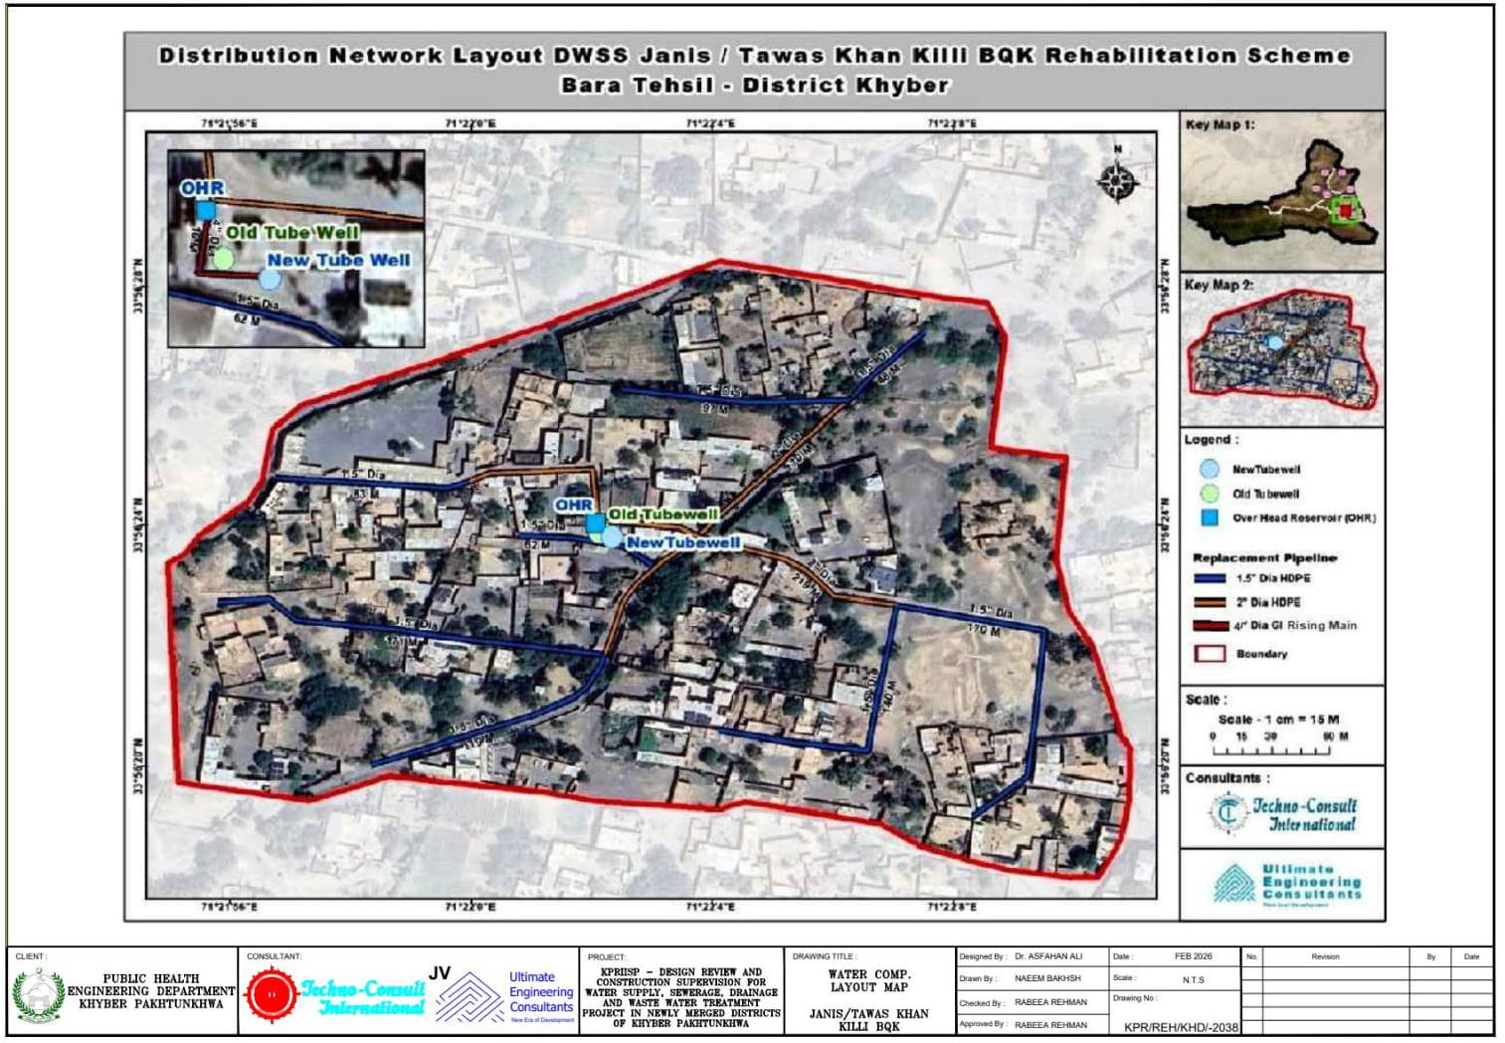
Figure 21: DWS Janis/Tawas Khan, District Khyber: Water Distribution Network Layout
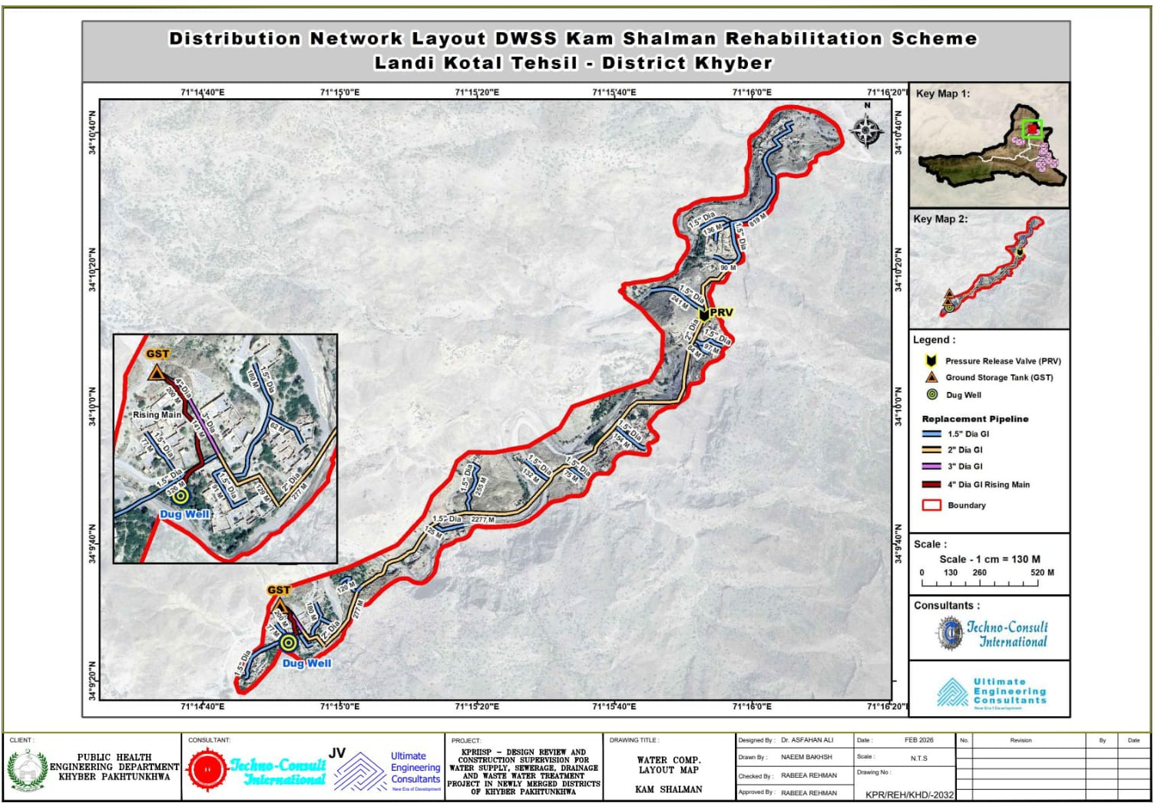
Figure 22: DWS Kam Shalman, District Khyber: Water Distribution Network Layout
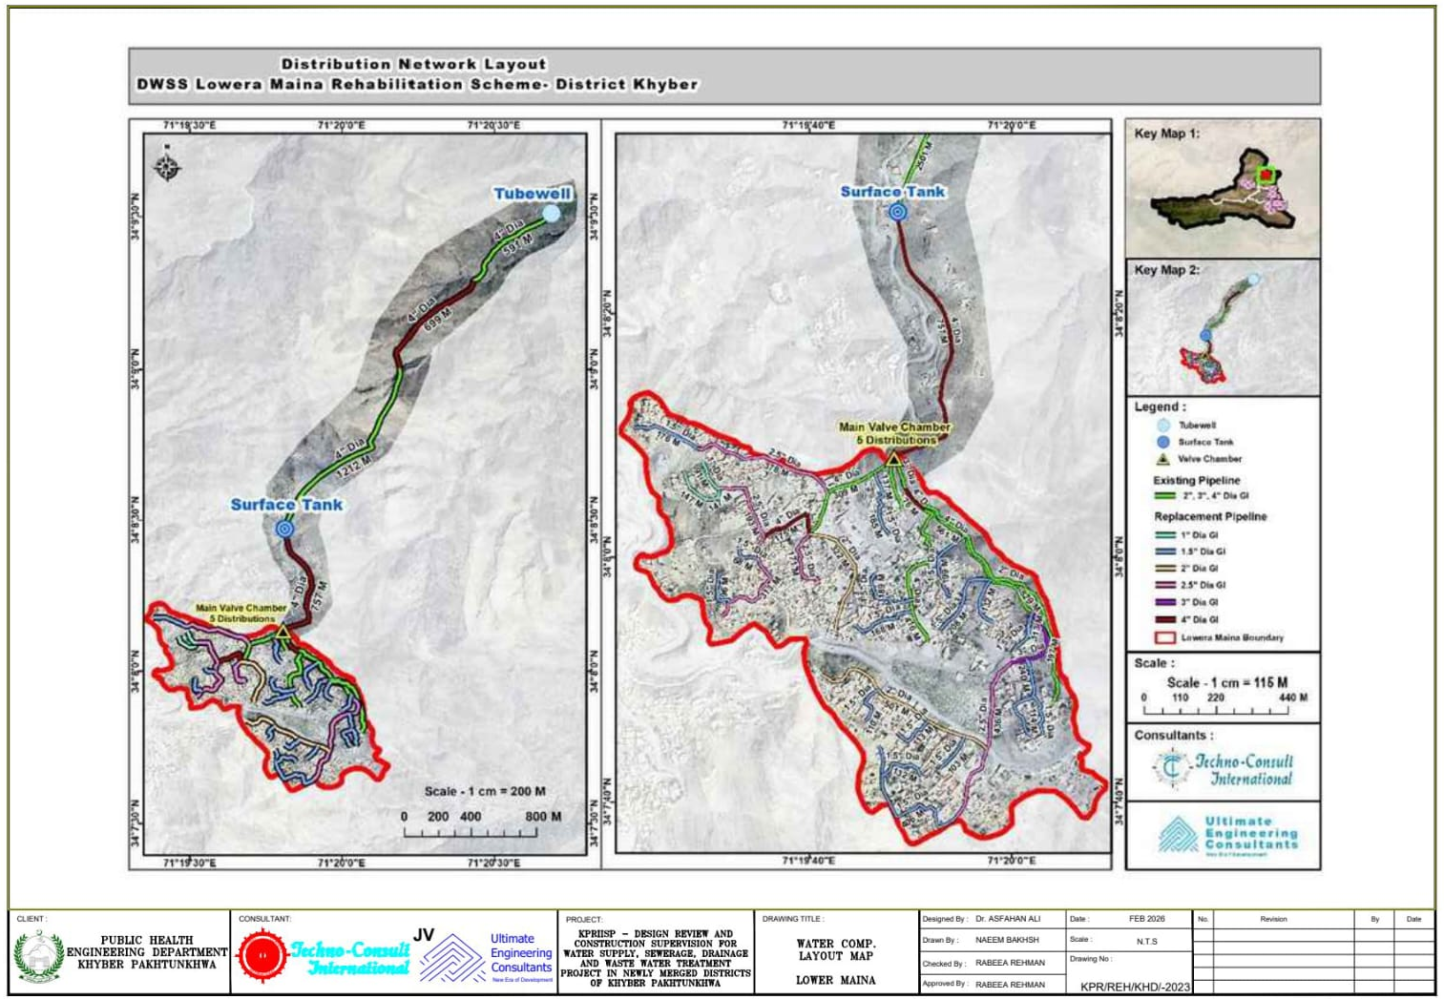
Figure 23: DWS Lowera Maina, District Khyber: Water Distribution Network Layout
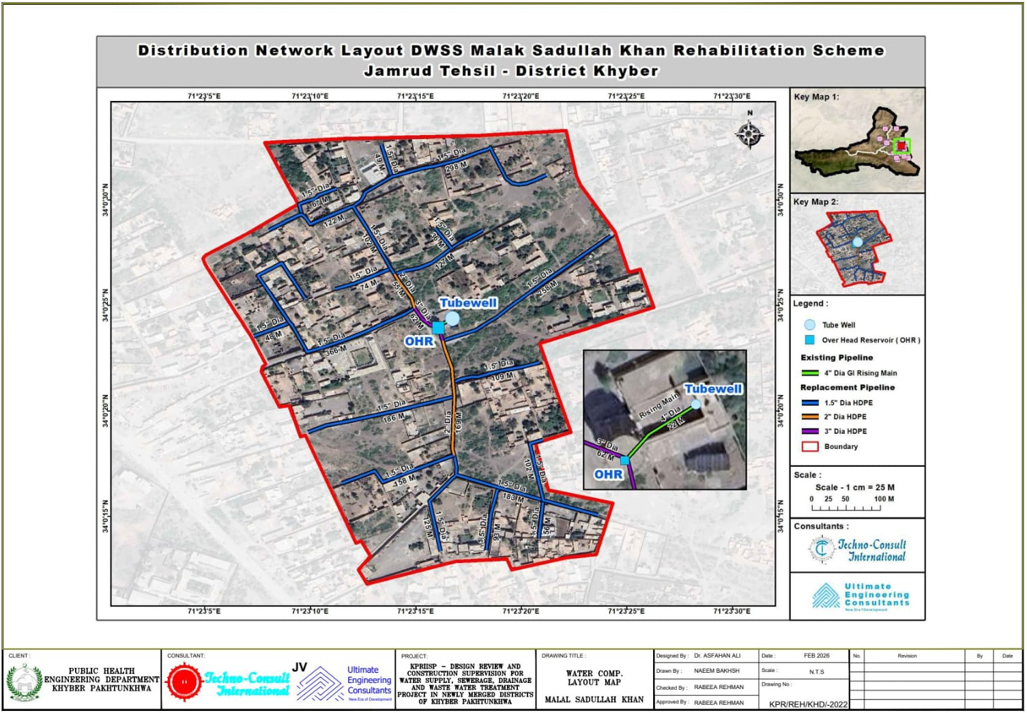
Figure 24: DWS Malak Saadullah, District Khyber: Water Distribution Network Layout
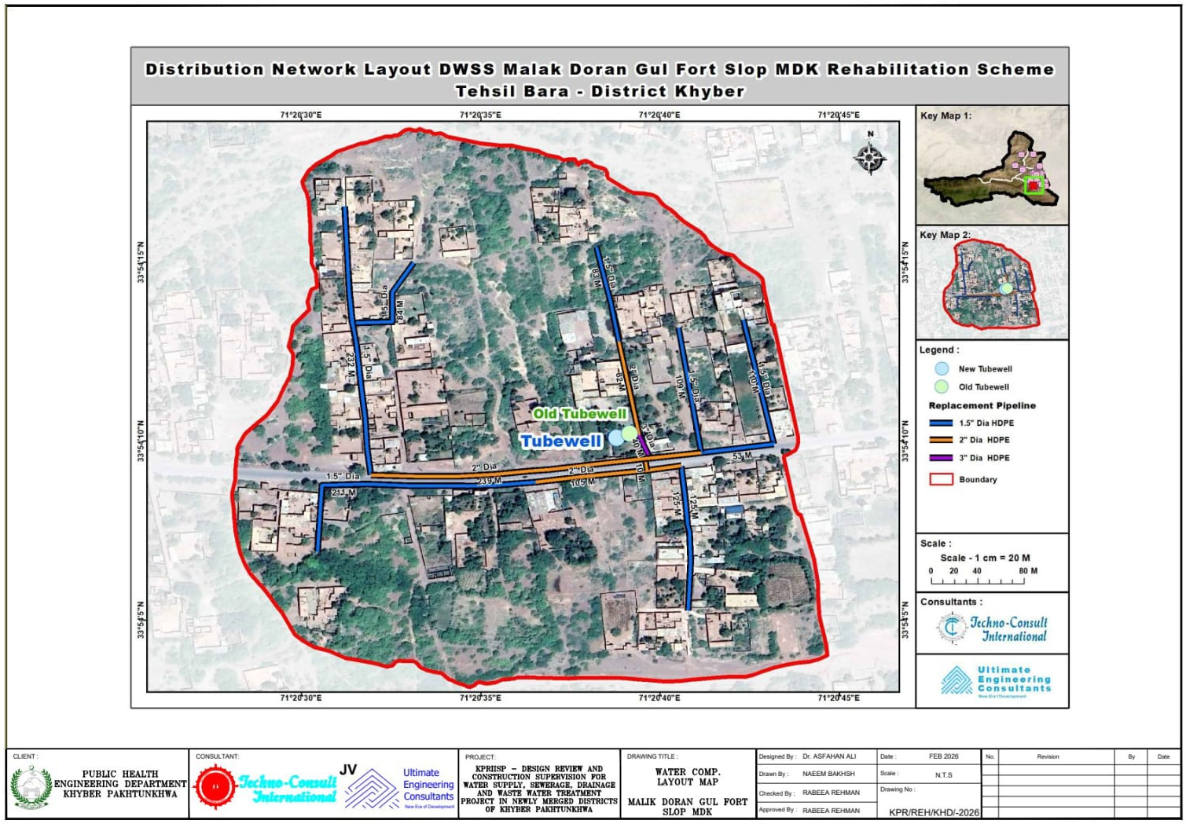
Figure 25: DWS Malik Doran Gul Fort, District Khyber: Water Distribution Network Layout
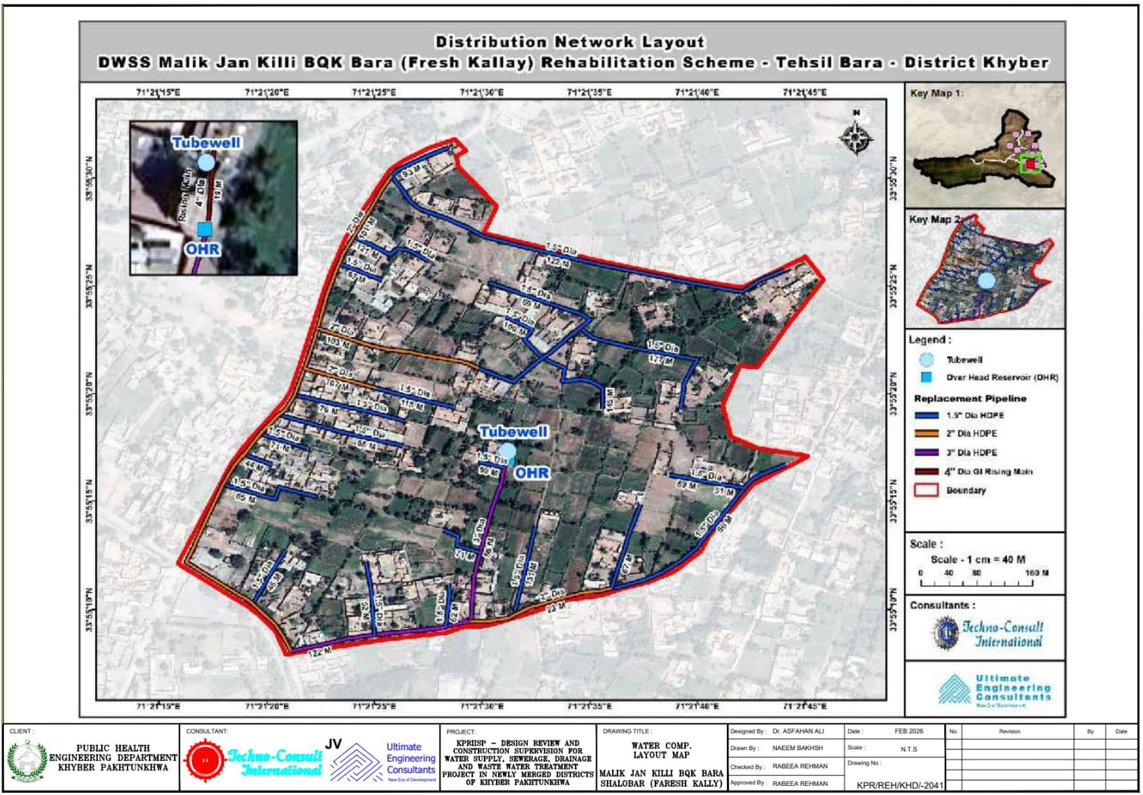
Figure 26: DWS Malik Jan Killi, District Khyber: Water Distribution Network Layout
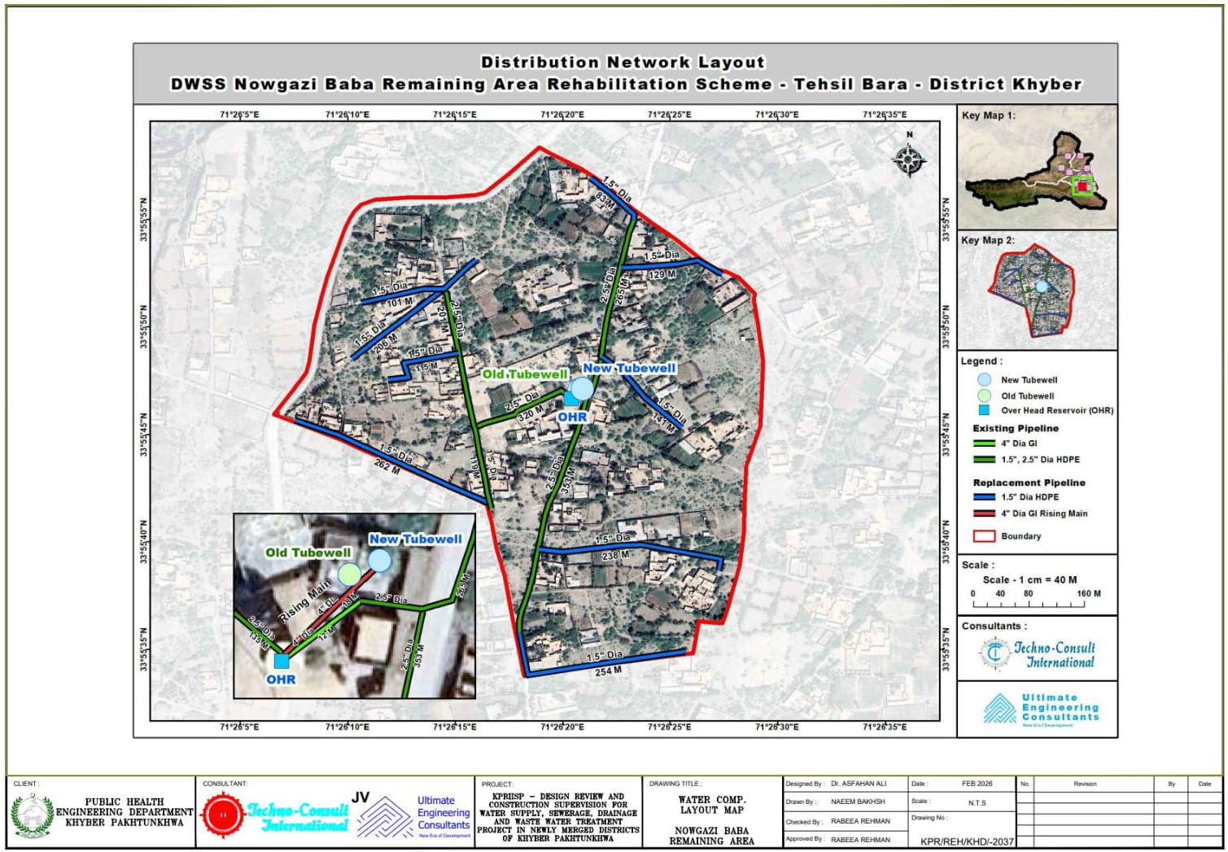
Figure 27: DWS Nowgazi Baba Remaining Area, District Khyber: Water Distribution Network Layout
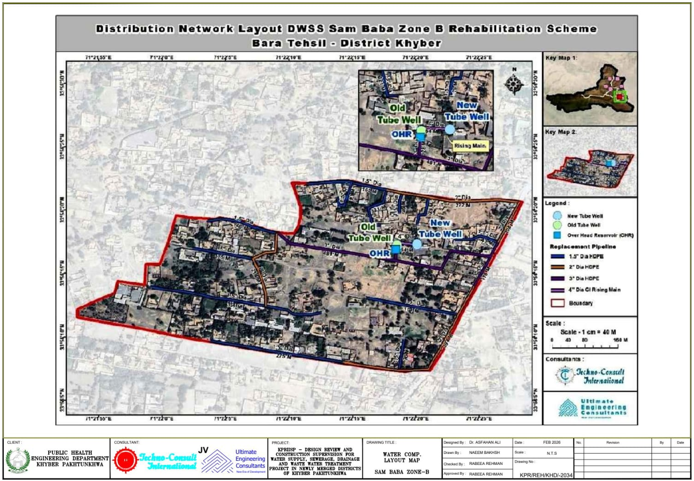
Figure 28: DWS Sam Baba Zone-B, District Khyber: Water Distribution Network Layout
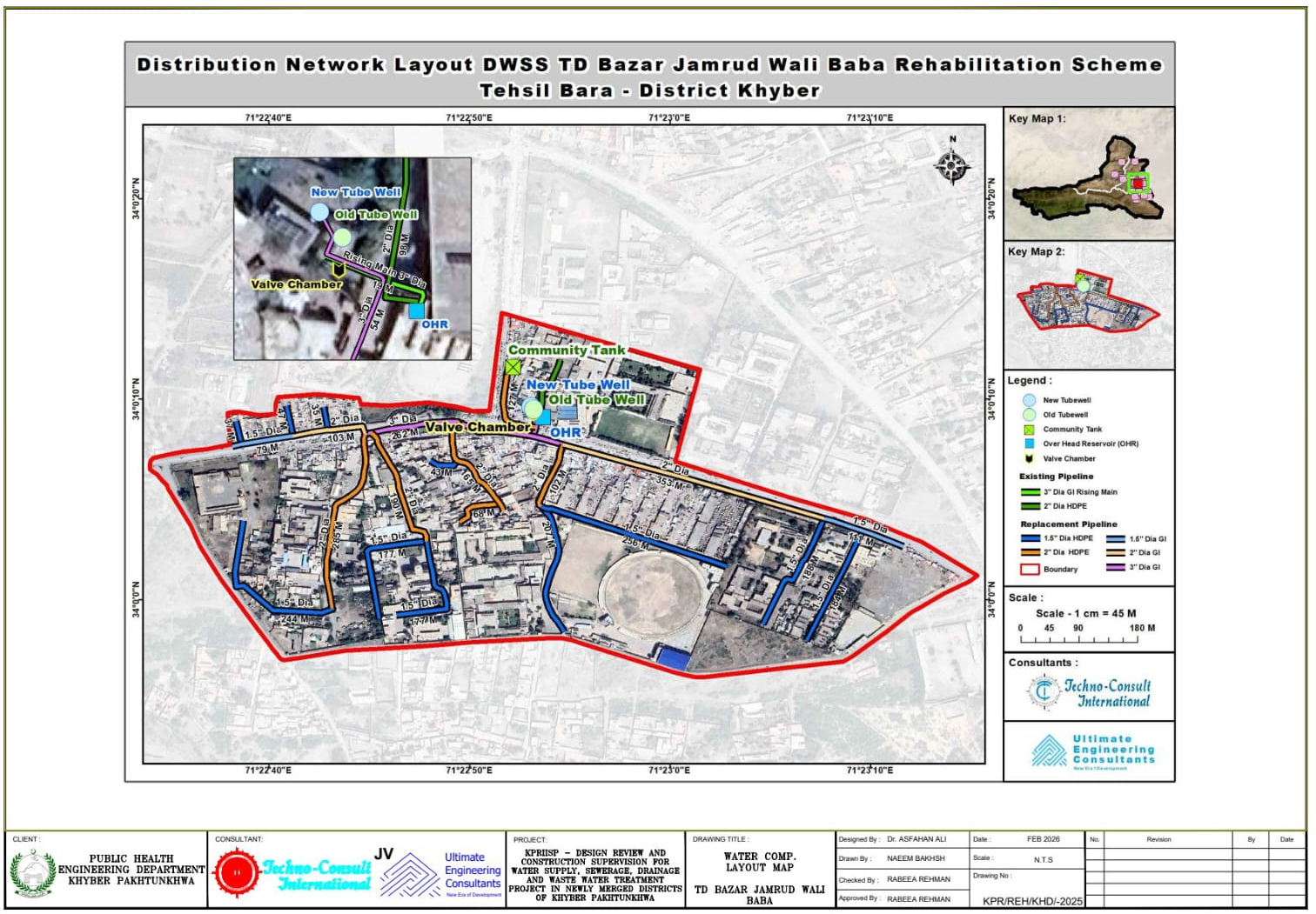
Figure 29: DWS TD Bazar Jamrud Wali Baba, District Khyber: Water Distribution Network Layout
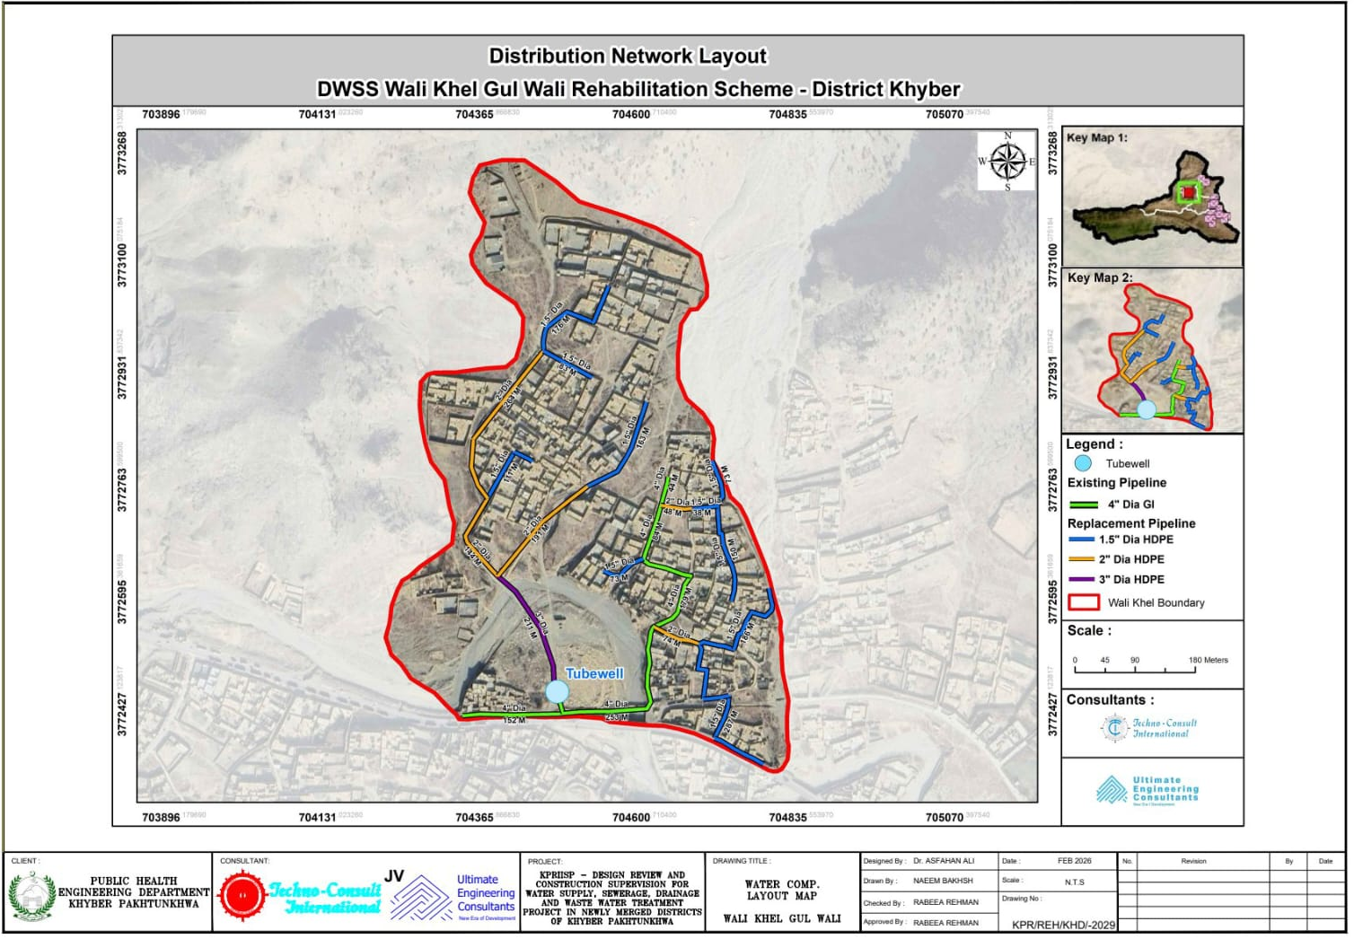
Figure 30: DWS Wali Khel Gul Wali, District Khyber: Water Distribution Network Layout
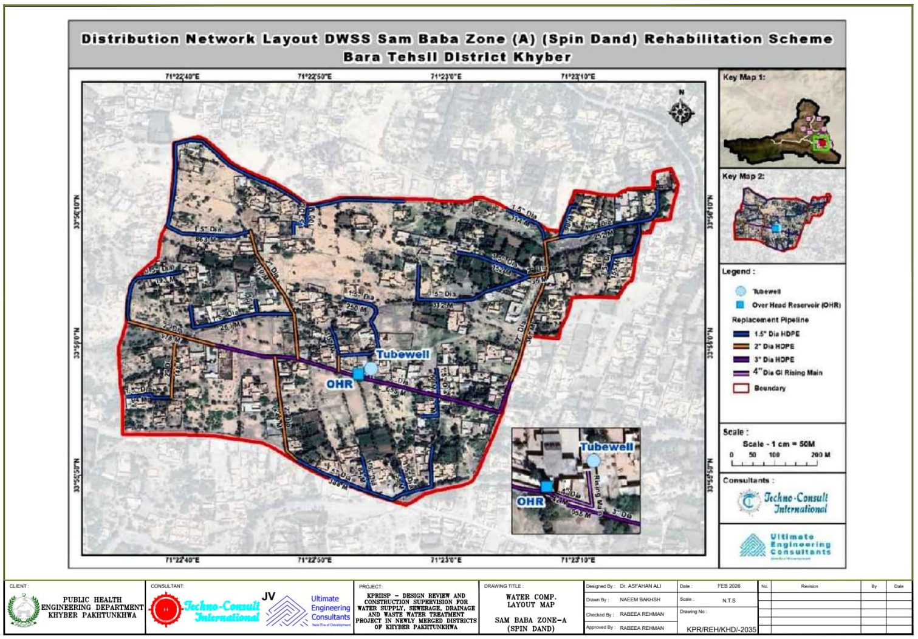
Figure 31: DWS Sam Baba Zone-B, District Khyber: Water Distribution Network Layout

- Maps for Identification of Sensitive Receptors in the Surrounding Areas of the Scheme(s):

DWSS Bara Tehsil

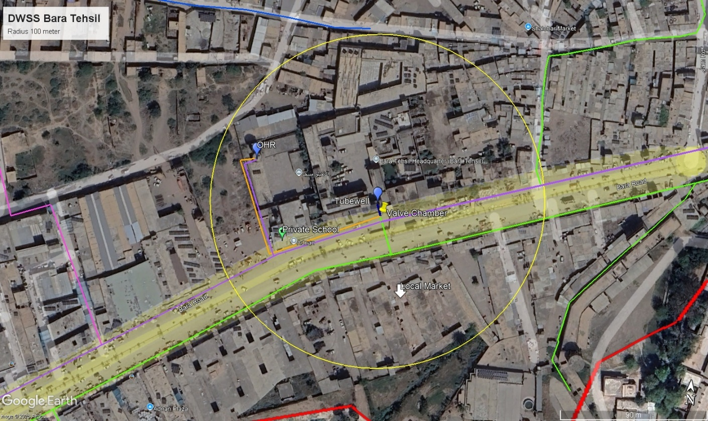
Figure 32: DWSS Bara Tehsil, District Khyber: Private school and Mosque identified as sensitive receptor
DWSS Fazal Malik Killi
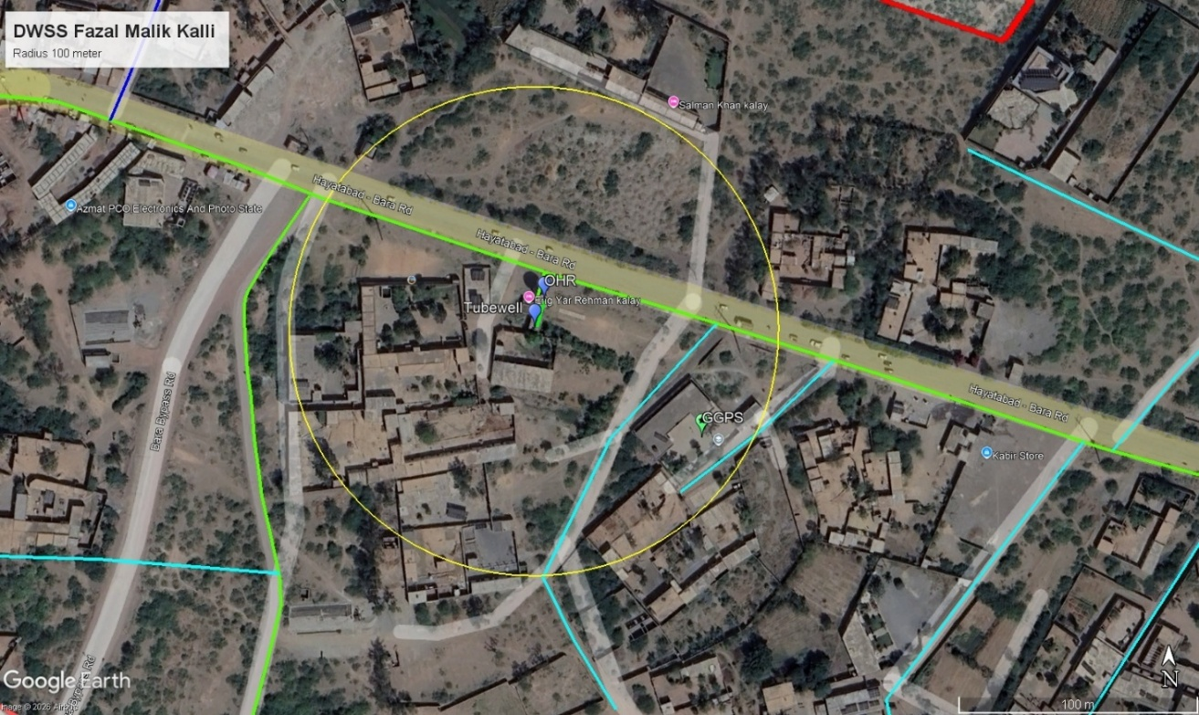
Figure 33: DWSS Fazal Malik Killi, District Khyber: Government school identified as sensitive receptor
DWSS Ghundi Sher Khan Khel
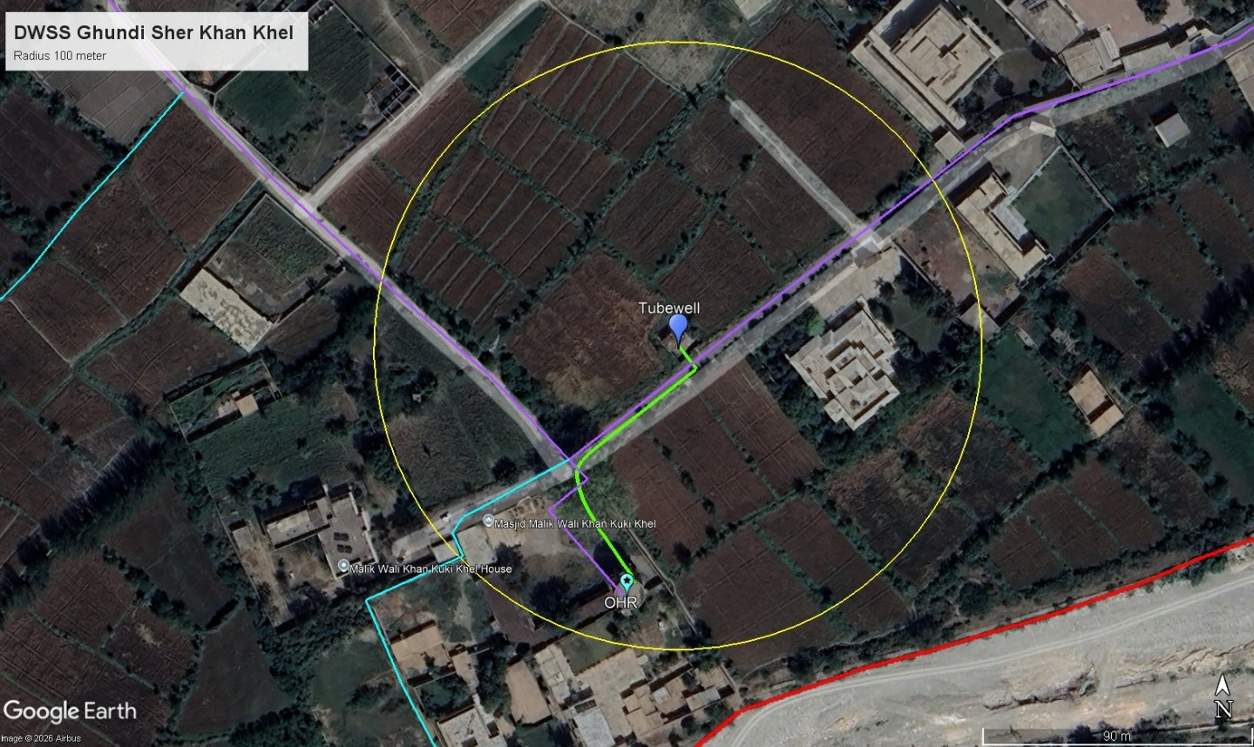
Figure 34: DWSS Ghundi Sher Khan Khel, District Khyber: Local Mosque identified as a sensitive receptor
DWSS Janis/Tawas Khan
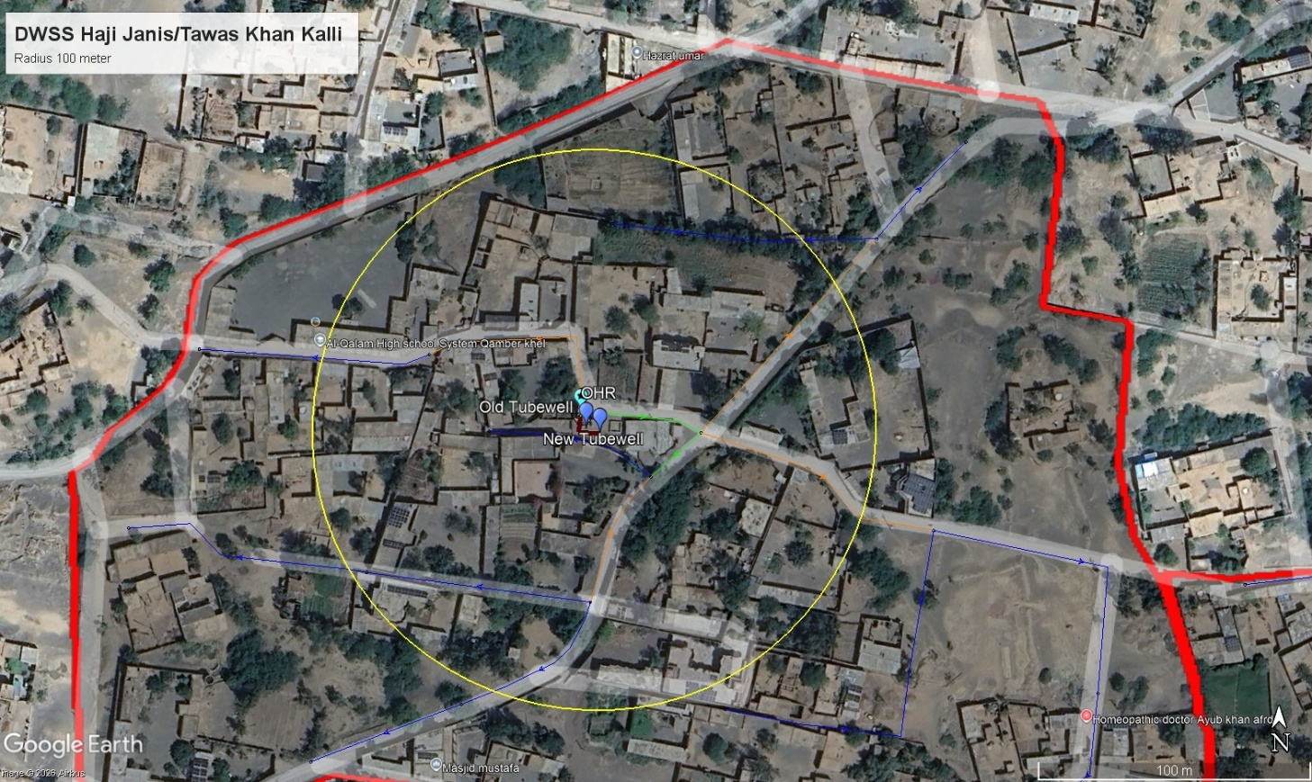
Figure 35: DWSS Janis/Tawas Khan, District Khyber: Private school identified as a sensitive receptor

DWSS Malik Doran Gul Fort
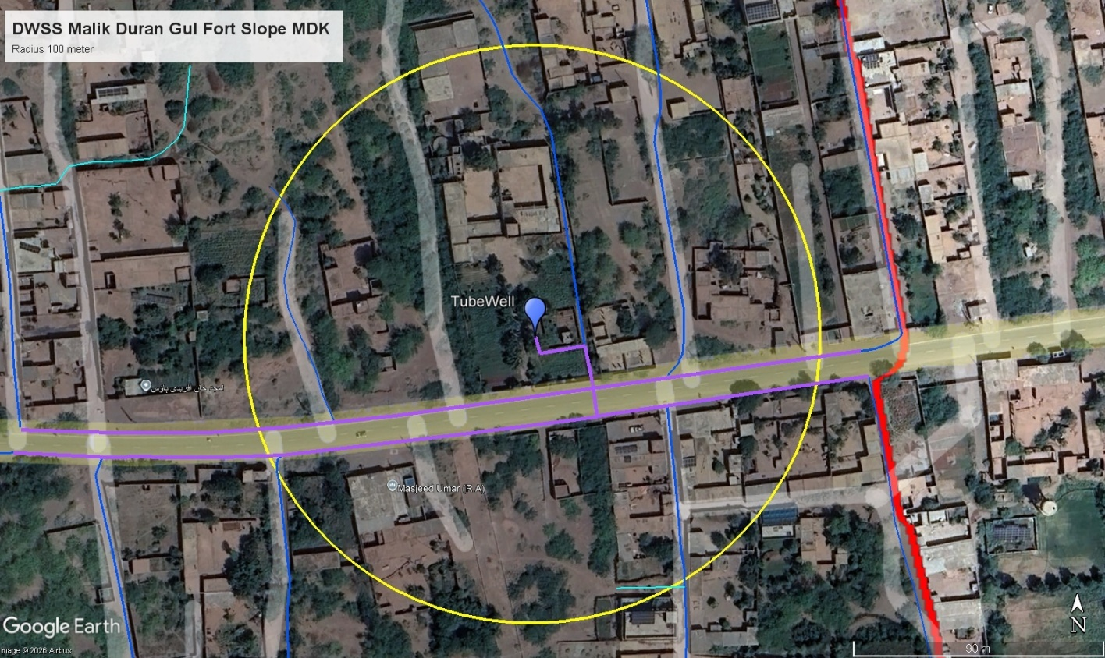
Figure 36: DWSS Malik Doran Gul Fort, District Khyber: Local Mosque identified as a sensitive receptor
DWSS TD Bazar
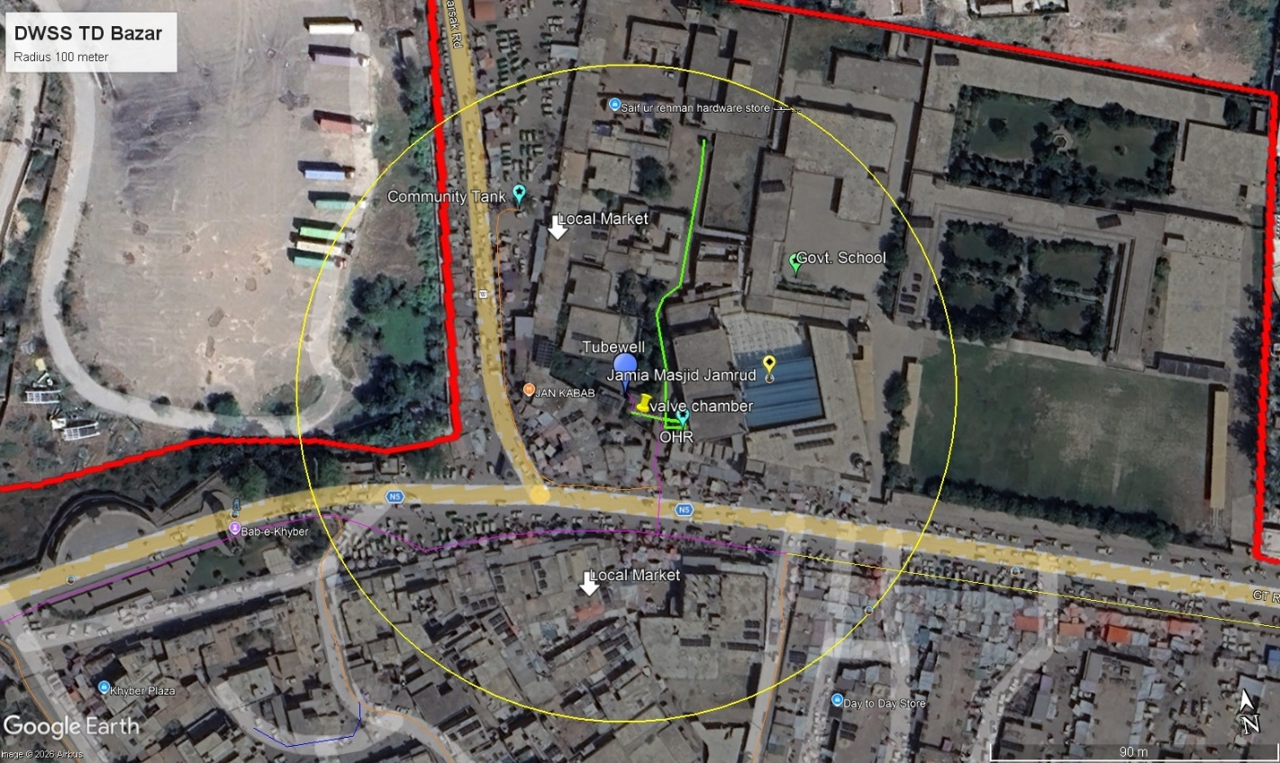
Figure 37: DWSS TD Bazar, District Khyber: Government school and local mosque identified as a sensitive receptor

- Maps and Architectural Drawings (Integrated Sanitation Component):

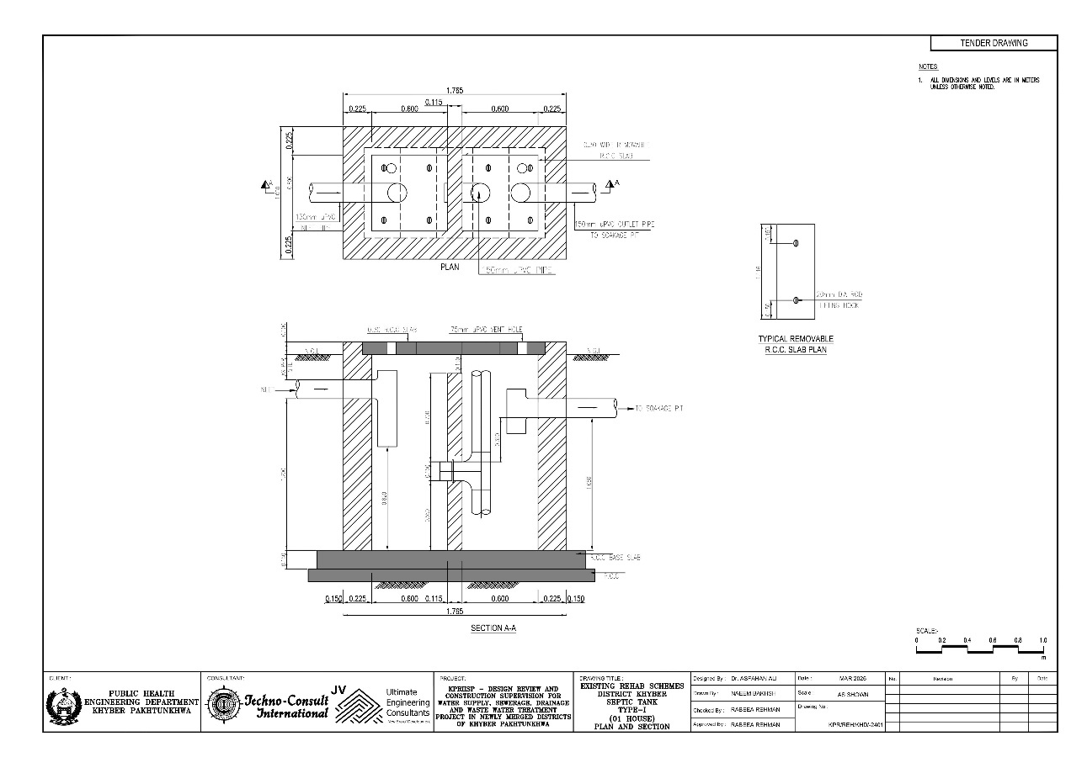
Figure 08: Integrated Sanitation Scheme, Khyber: Architectural Drawing for Septic Tank (Type-1)
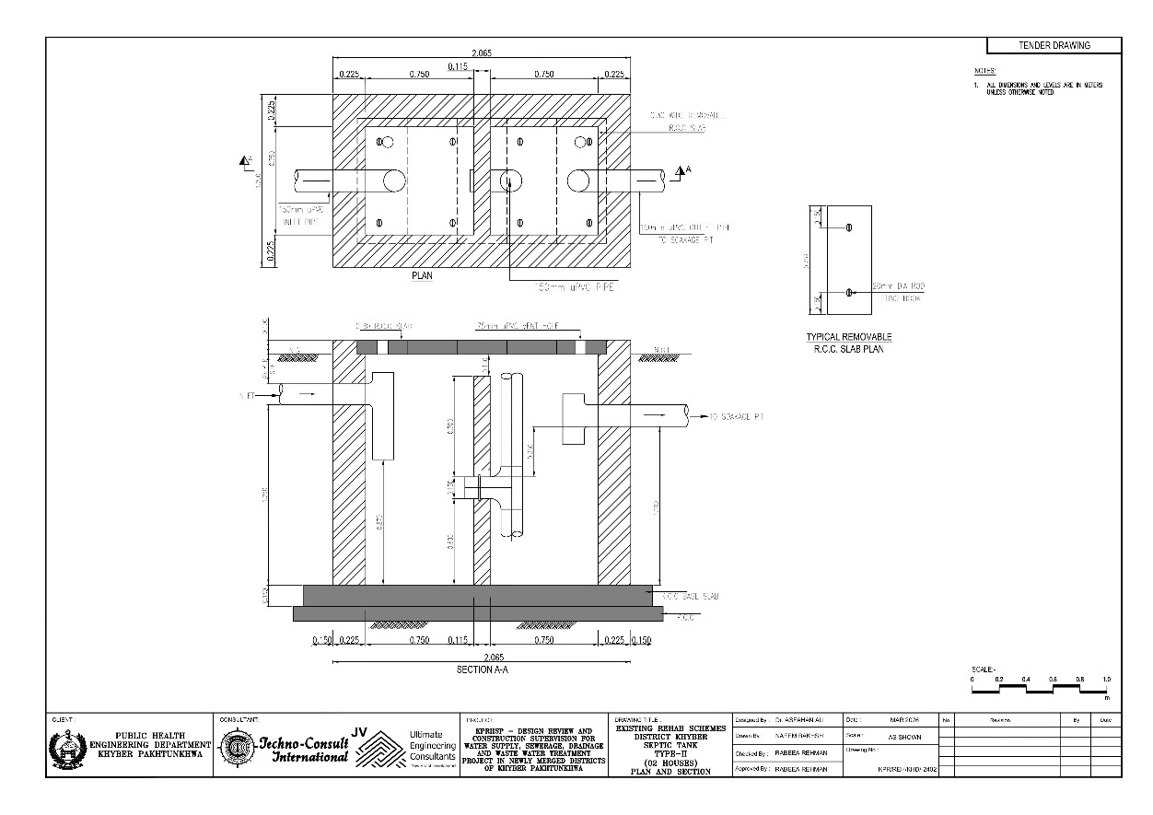
Figure 09: Integrated Sanitation Scheme, Khyber: Architectural Drawing for Septic Tank (Type-2)
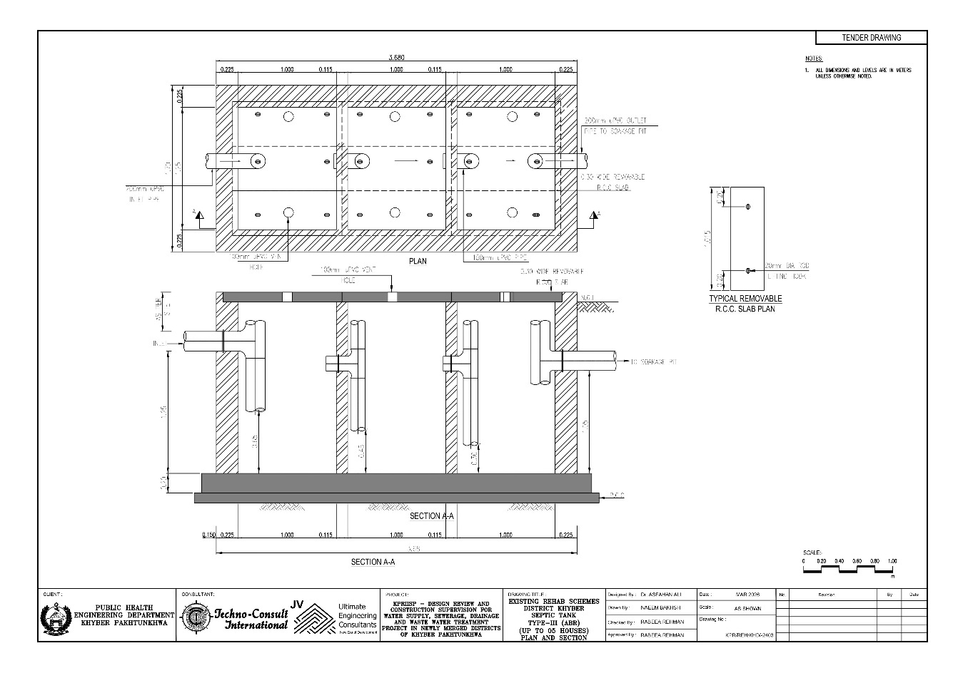

Figure 40: Integrated Sanitation Scheme, Khyber: Architectural Drawing for Septic Tank (Type-3)
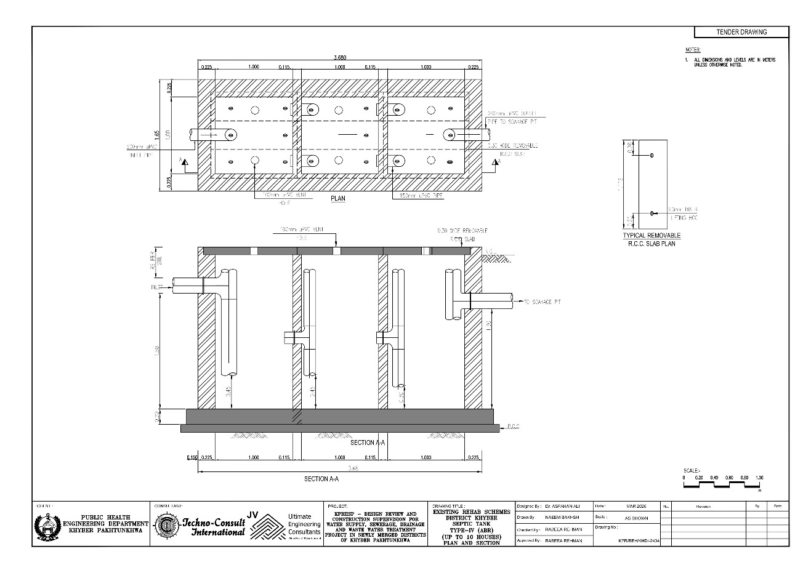
Figure 41: Integrated Sanitation Scheme, Khyber: Architectural Drawing for Septic Tank (Type-4)
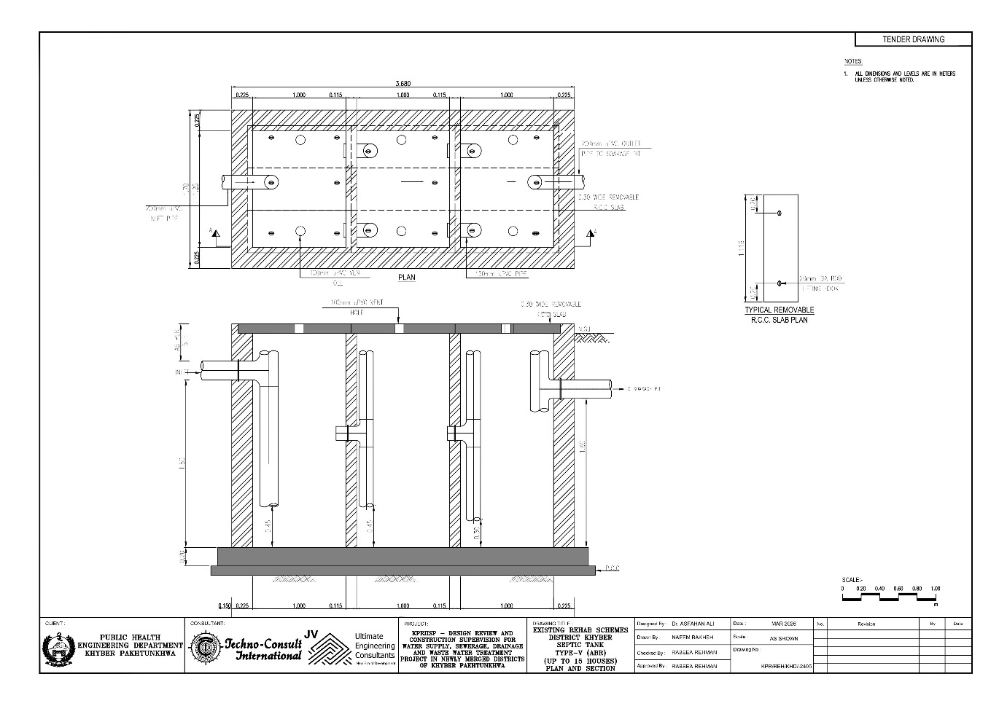
Figure 42: Integrated Sanitation Scheme, Khyber: Architectural Drawing for Septic Tank (Type-5)
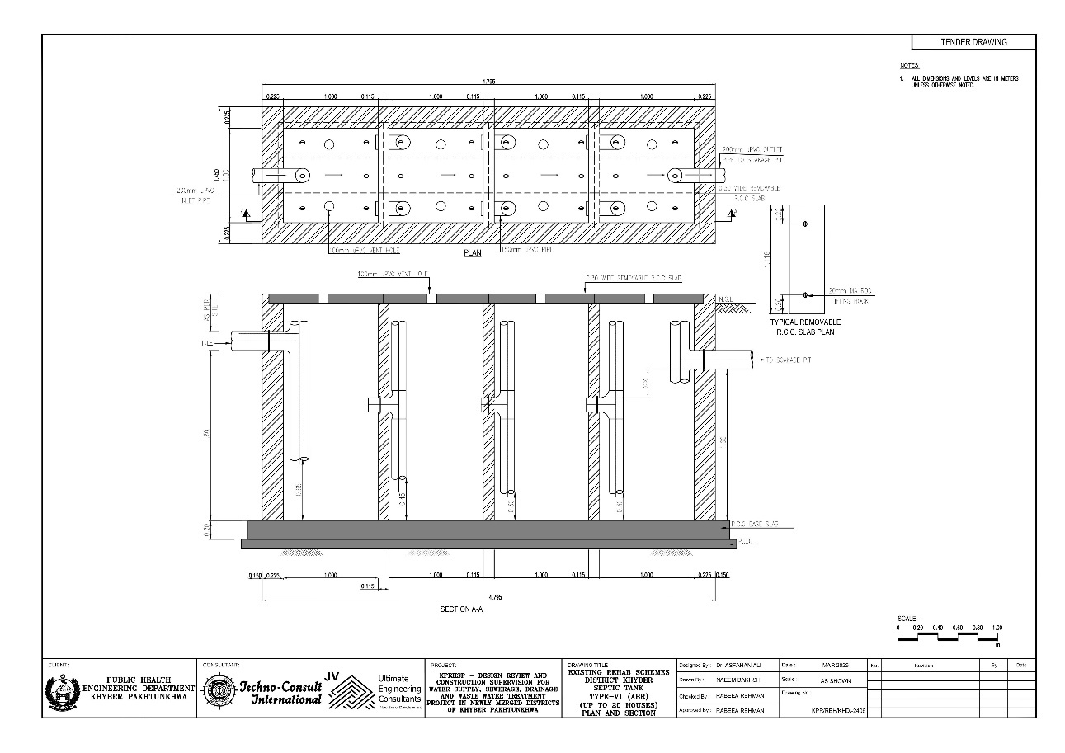
Figure 43: Integrated Sanitation Scheme, Khyber: Architectural Drawing for Septic Tank (Type-6)
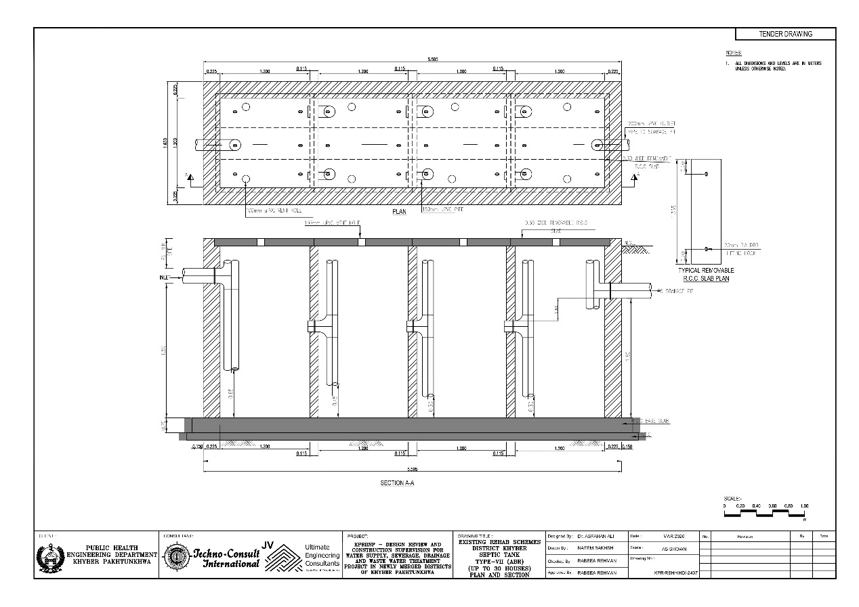
Figure 44: Integrated Sanitation Scheme, Khyber: Architectural Drawing for Septic Tank (Type-7)

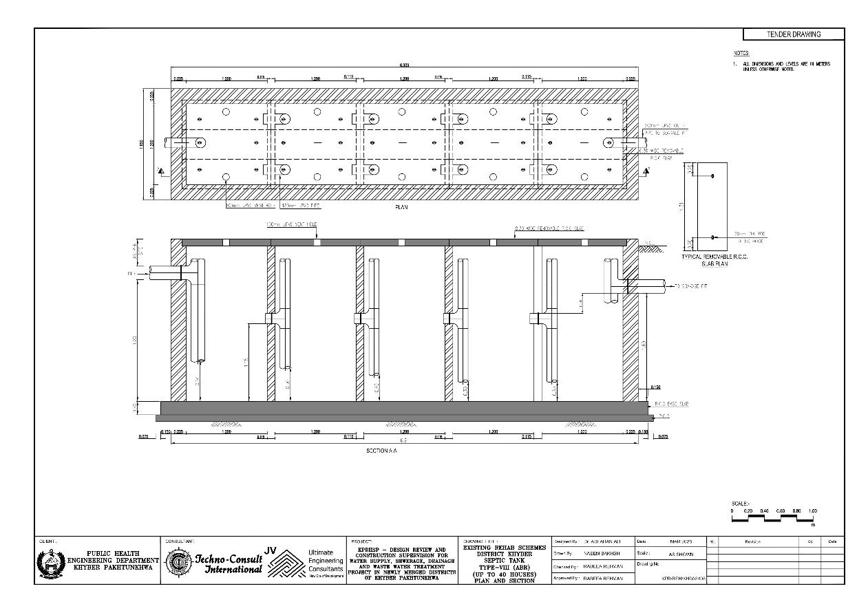
Figure 45: Integrated Sanitation Scheme, Khyber: Architectural Drawing for Septic Tank (Type-8)

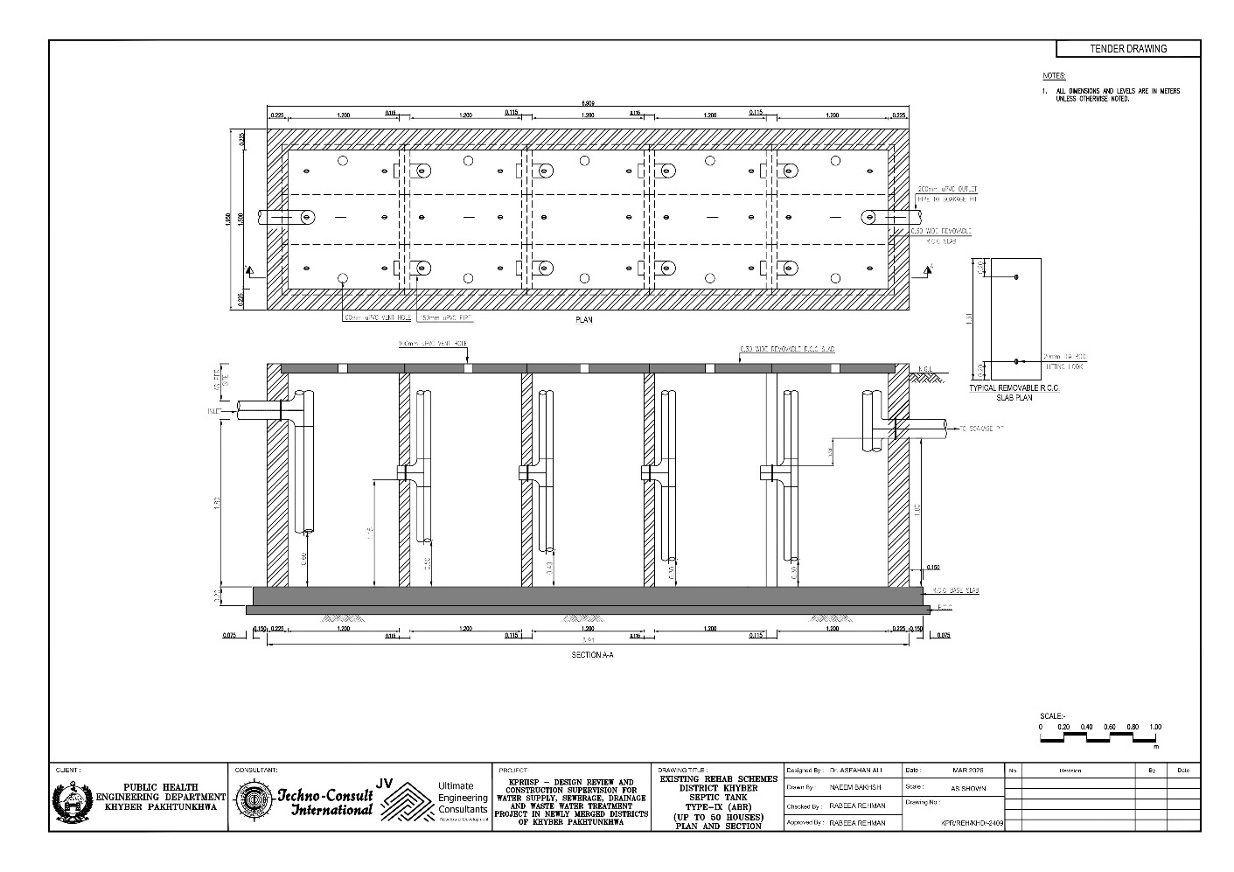

Figure 46: Integrated Sanitation Scheme, Khyber: Architectural Drawing for Septic Tank (Type-9)

- Scheme wise Sanitation Modules maps for each scheme:

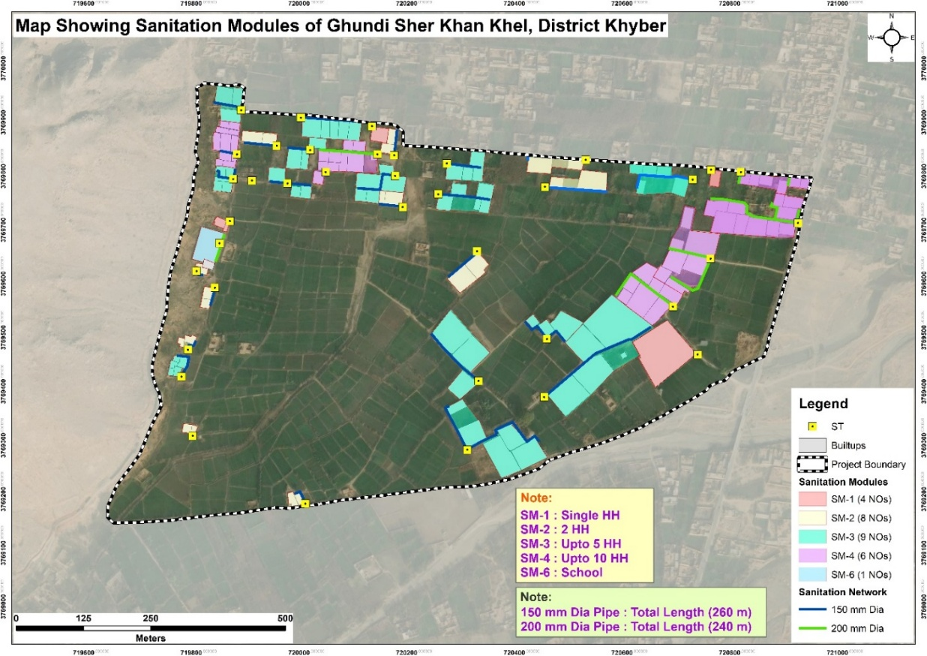
Figure 47: Map Showing Sanitation Modules for DWSS Ghundi Sher Khan Khel.
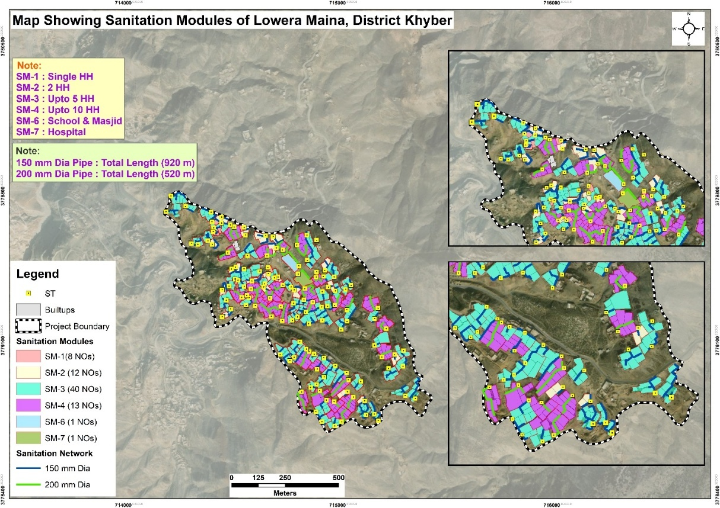
Figure 48: Map Showing Sanitation Modules for DWSS Lowera Maina

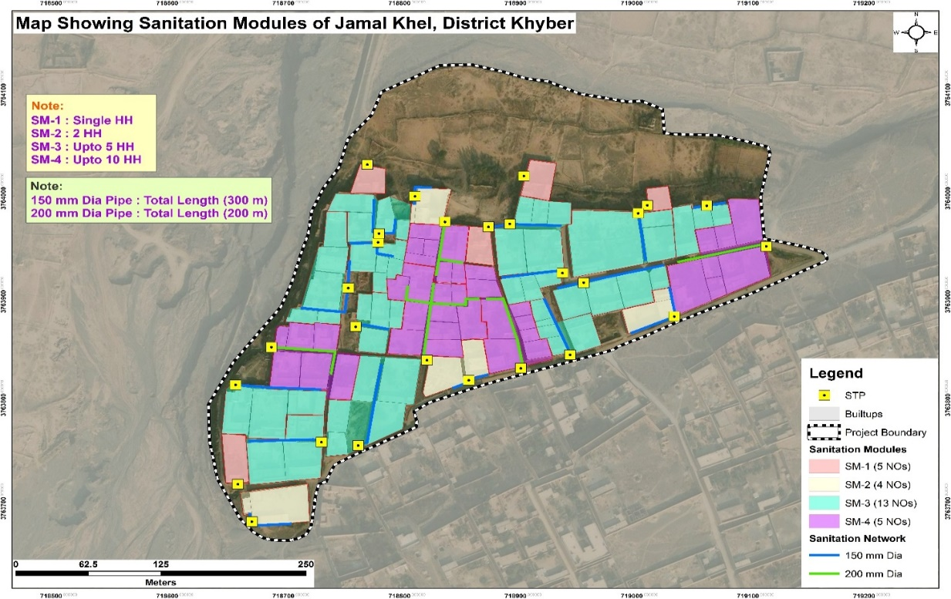
Figure 49: Map Showing Sanitation Modules for DWSS Jamal Khel.

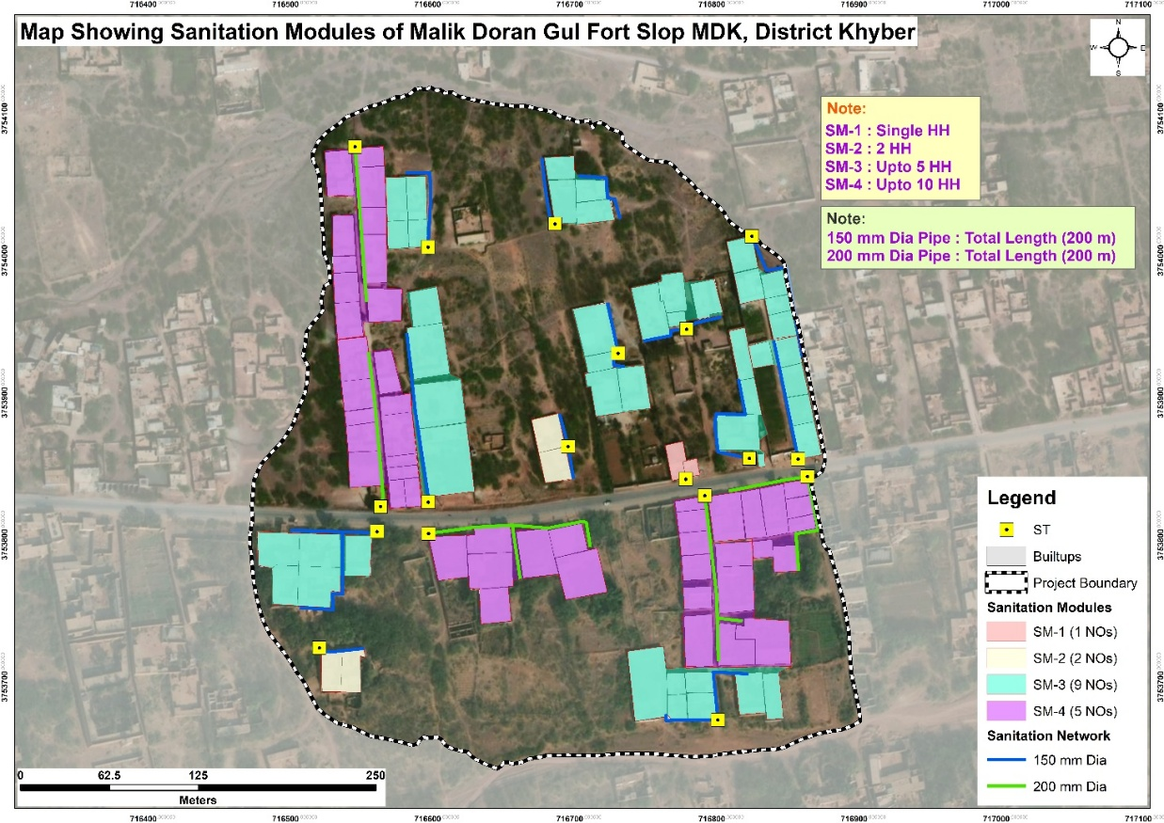
Figure 50: Map Showing Sanitation Modules for DWSS Malik Doran Gul Fort Slop MDK

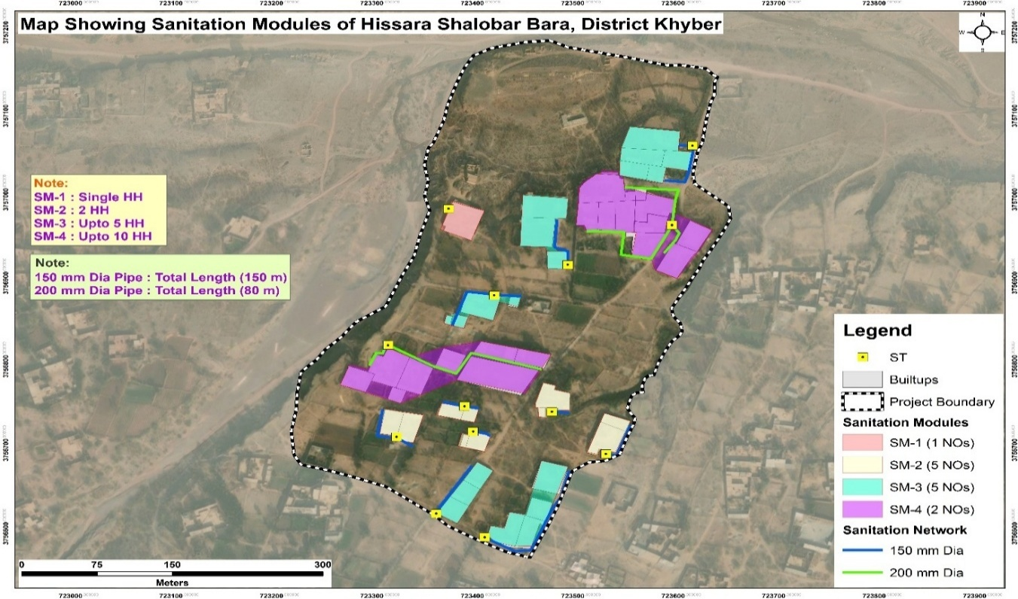
Figure 51: Map Showing Sanitation Modules for DWSS Hissara Shalobar Bara.

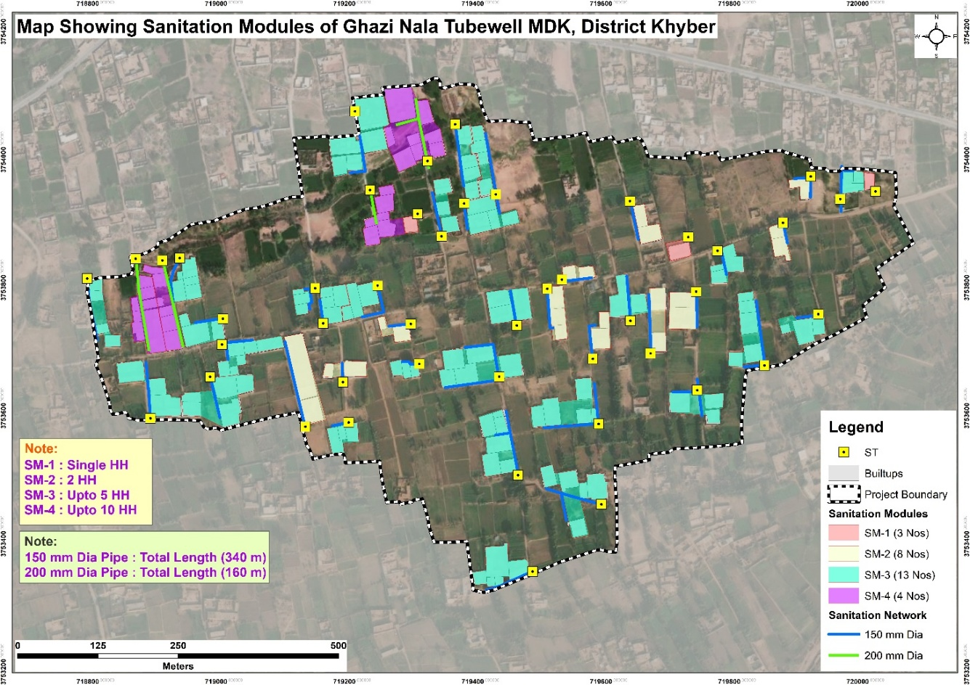
Figure 52: Map Showing Sanitation Modules for DWSS Ghazi Tubewell Nala MDK
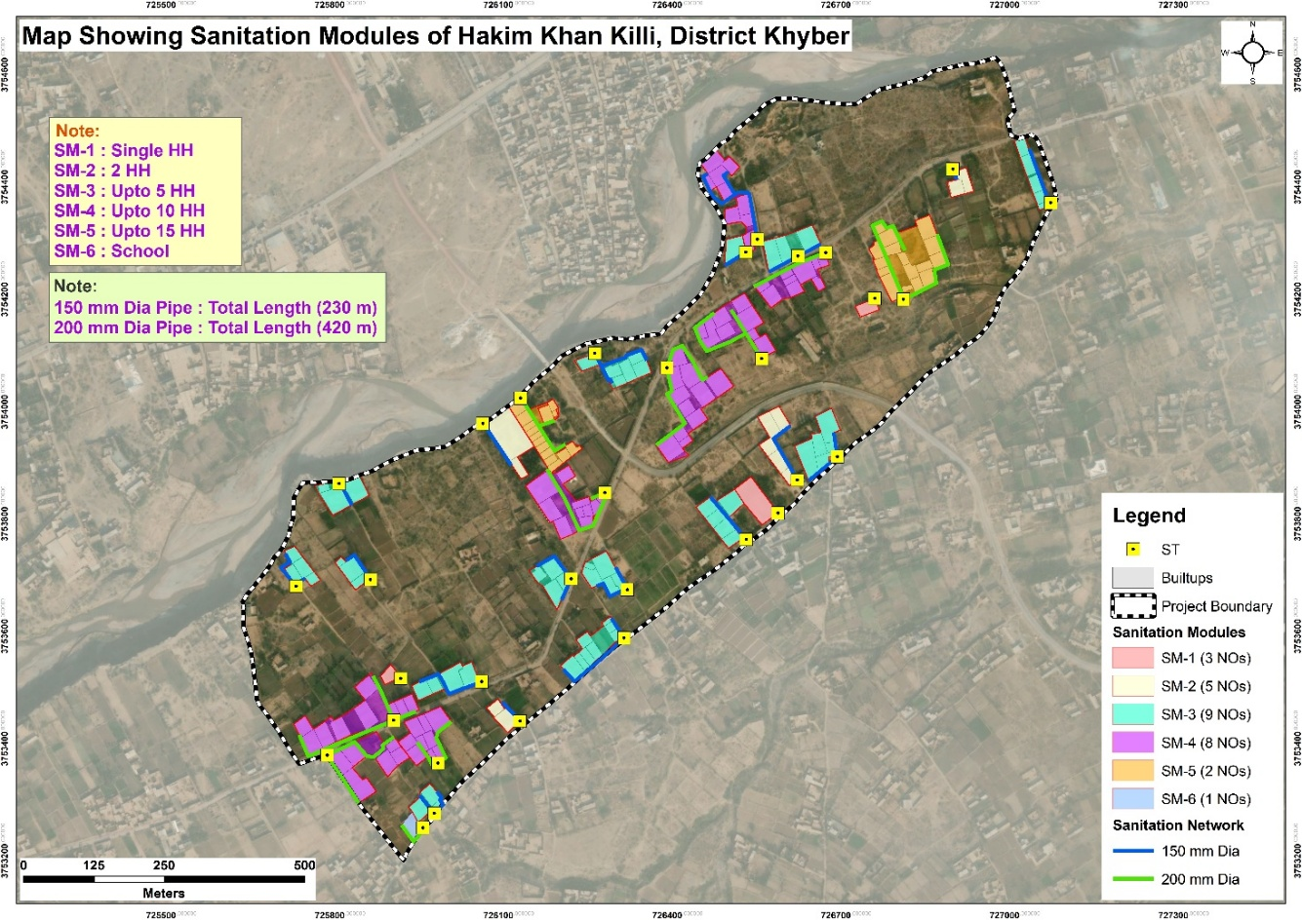
Figure 53: Map Showing Sanitation Modules for DWSS Hakim Khan Killi Meri Khel Aka Khel Bara

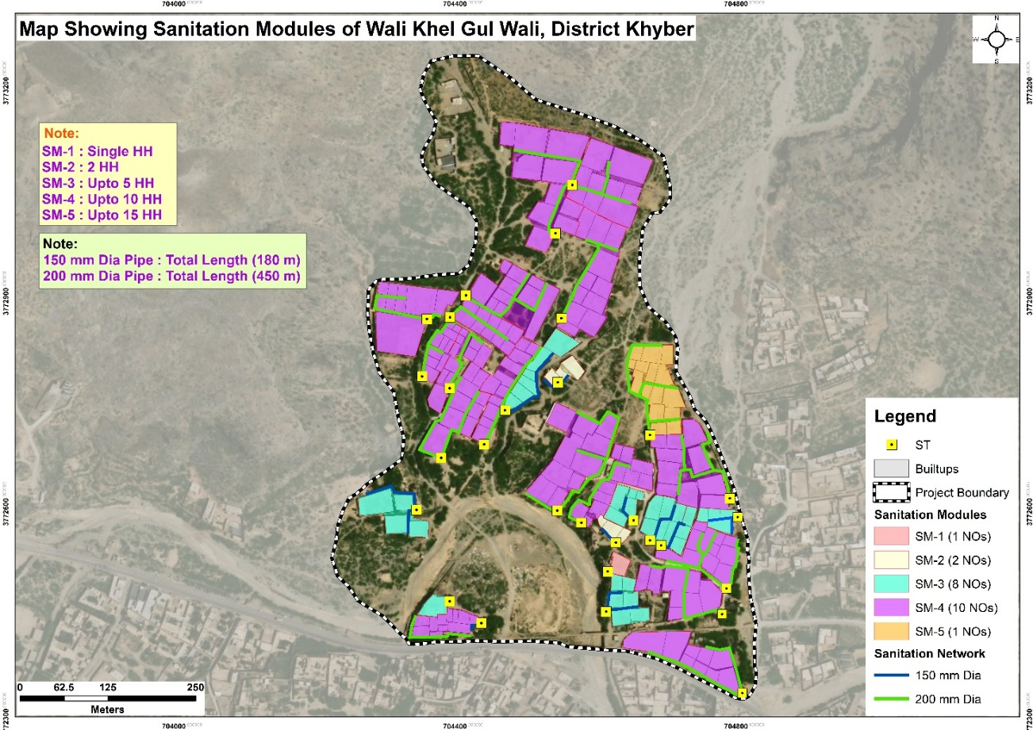
Figure 54: Map Showing Sanitation Modules for DWSS Wali Khel Gul Wali
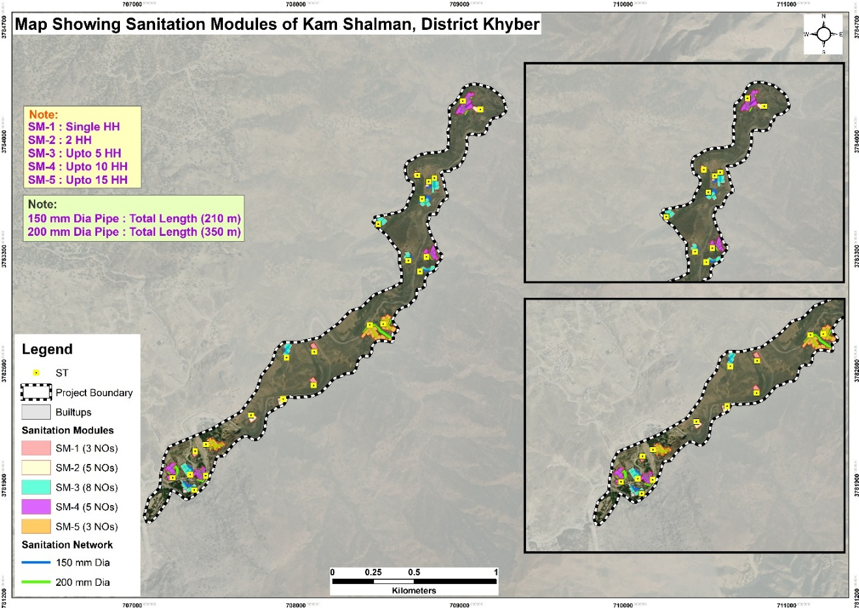
Figure 55: Map Showing Sanitation Modules for DWSS Kam Shalman
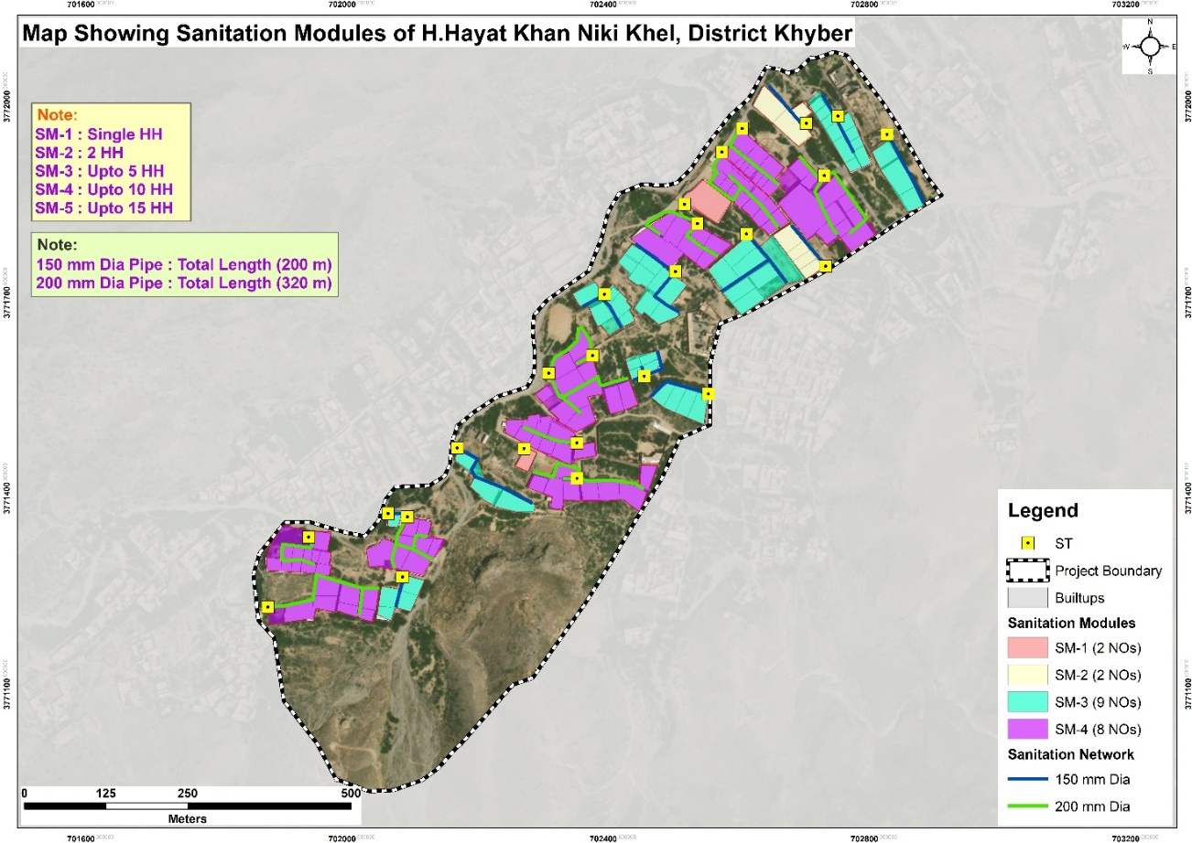
Figure 56: Map Showing Sanitation Modules for DWSS H. Hayat Khan Niki Khel
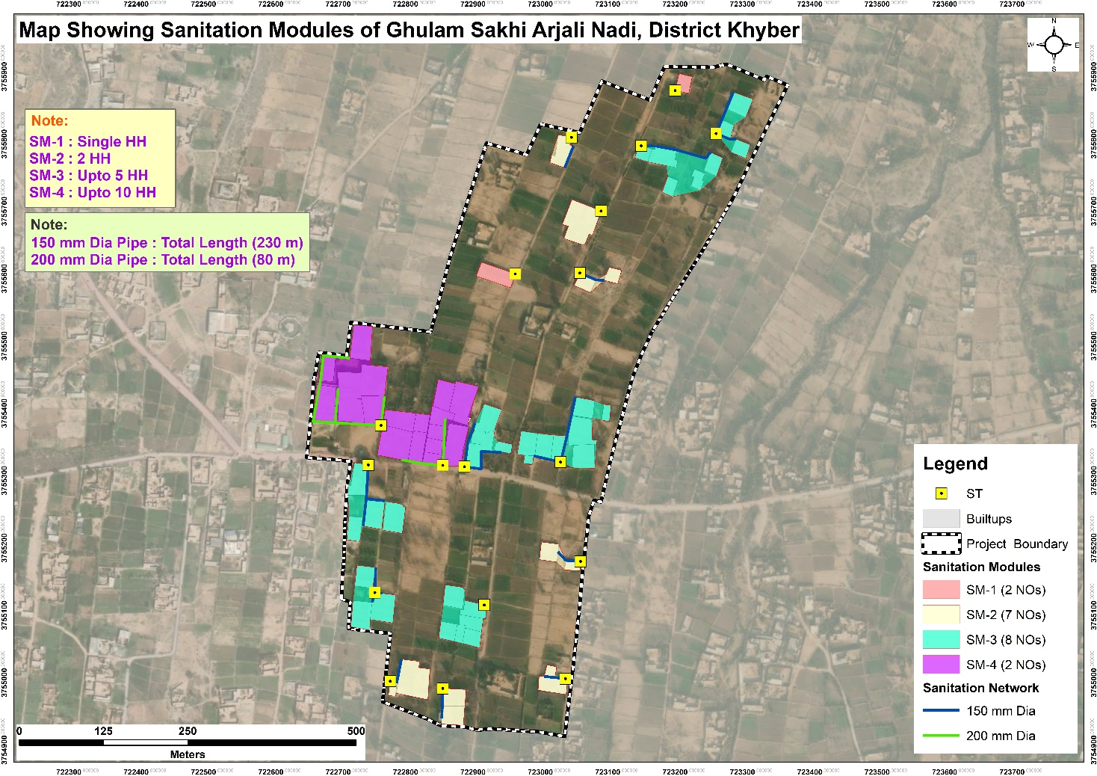
Figure 57: Map Showing Sanitation Modules for DWSS Ghulam Sakhi Arjali Nadi

Annex 4. EPA Environmental Assessment Rules

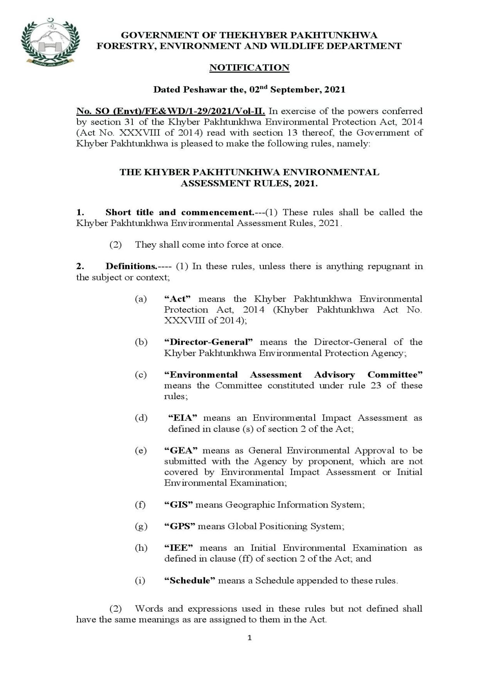

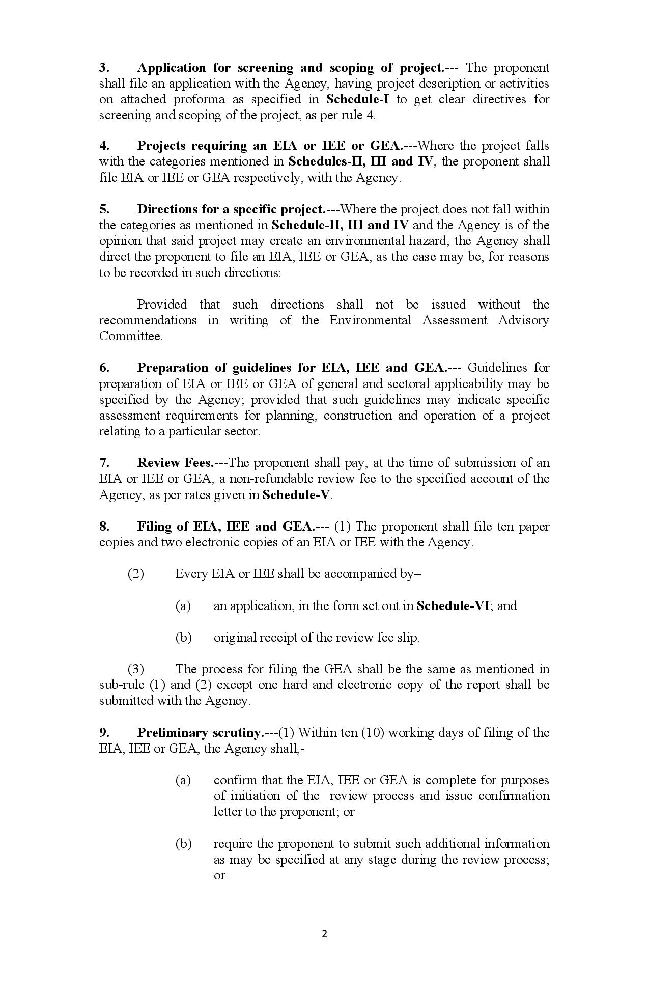

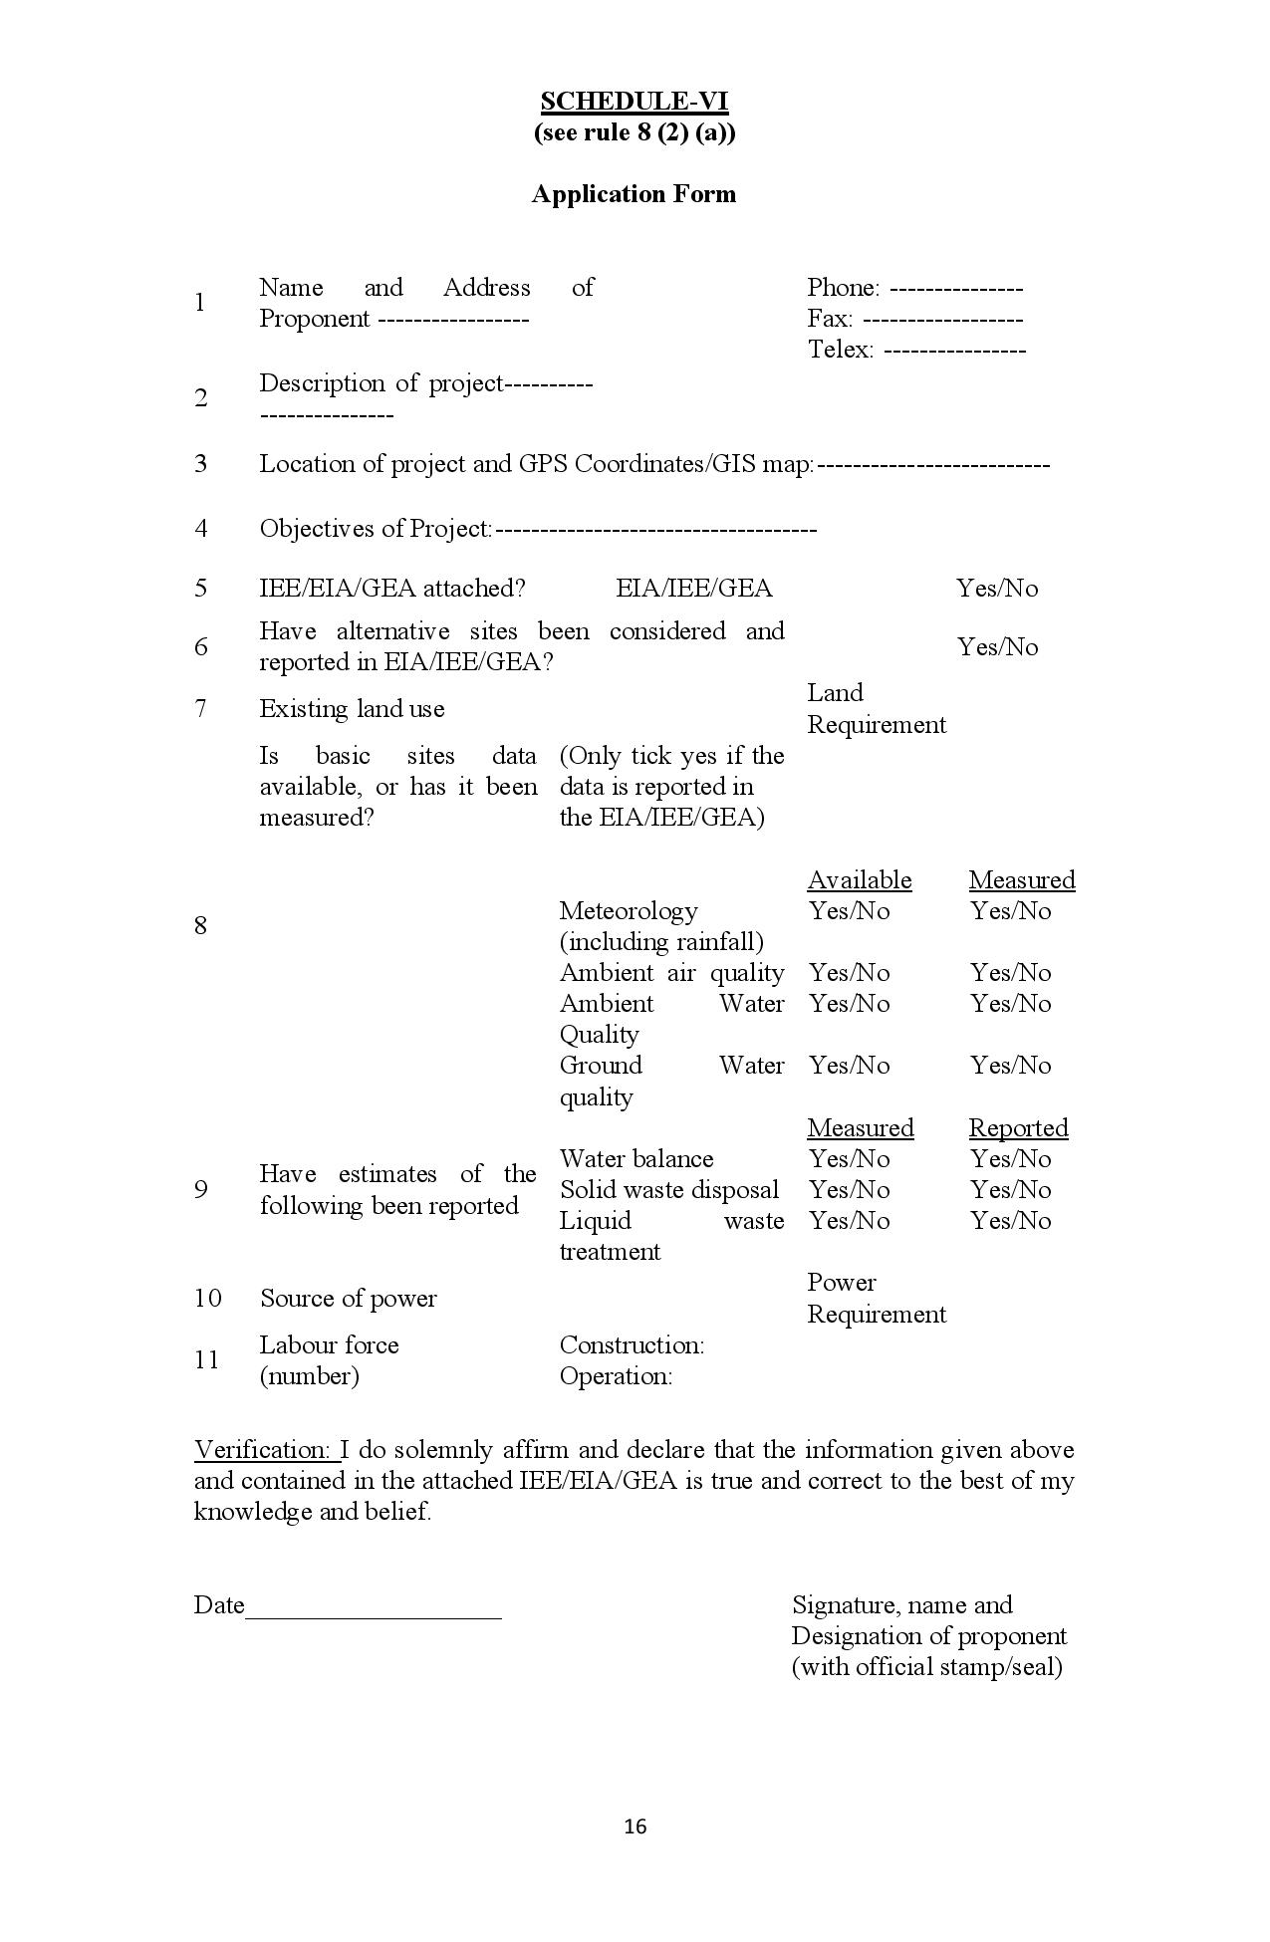

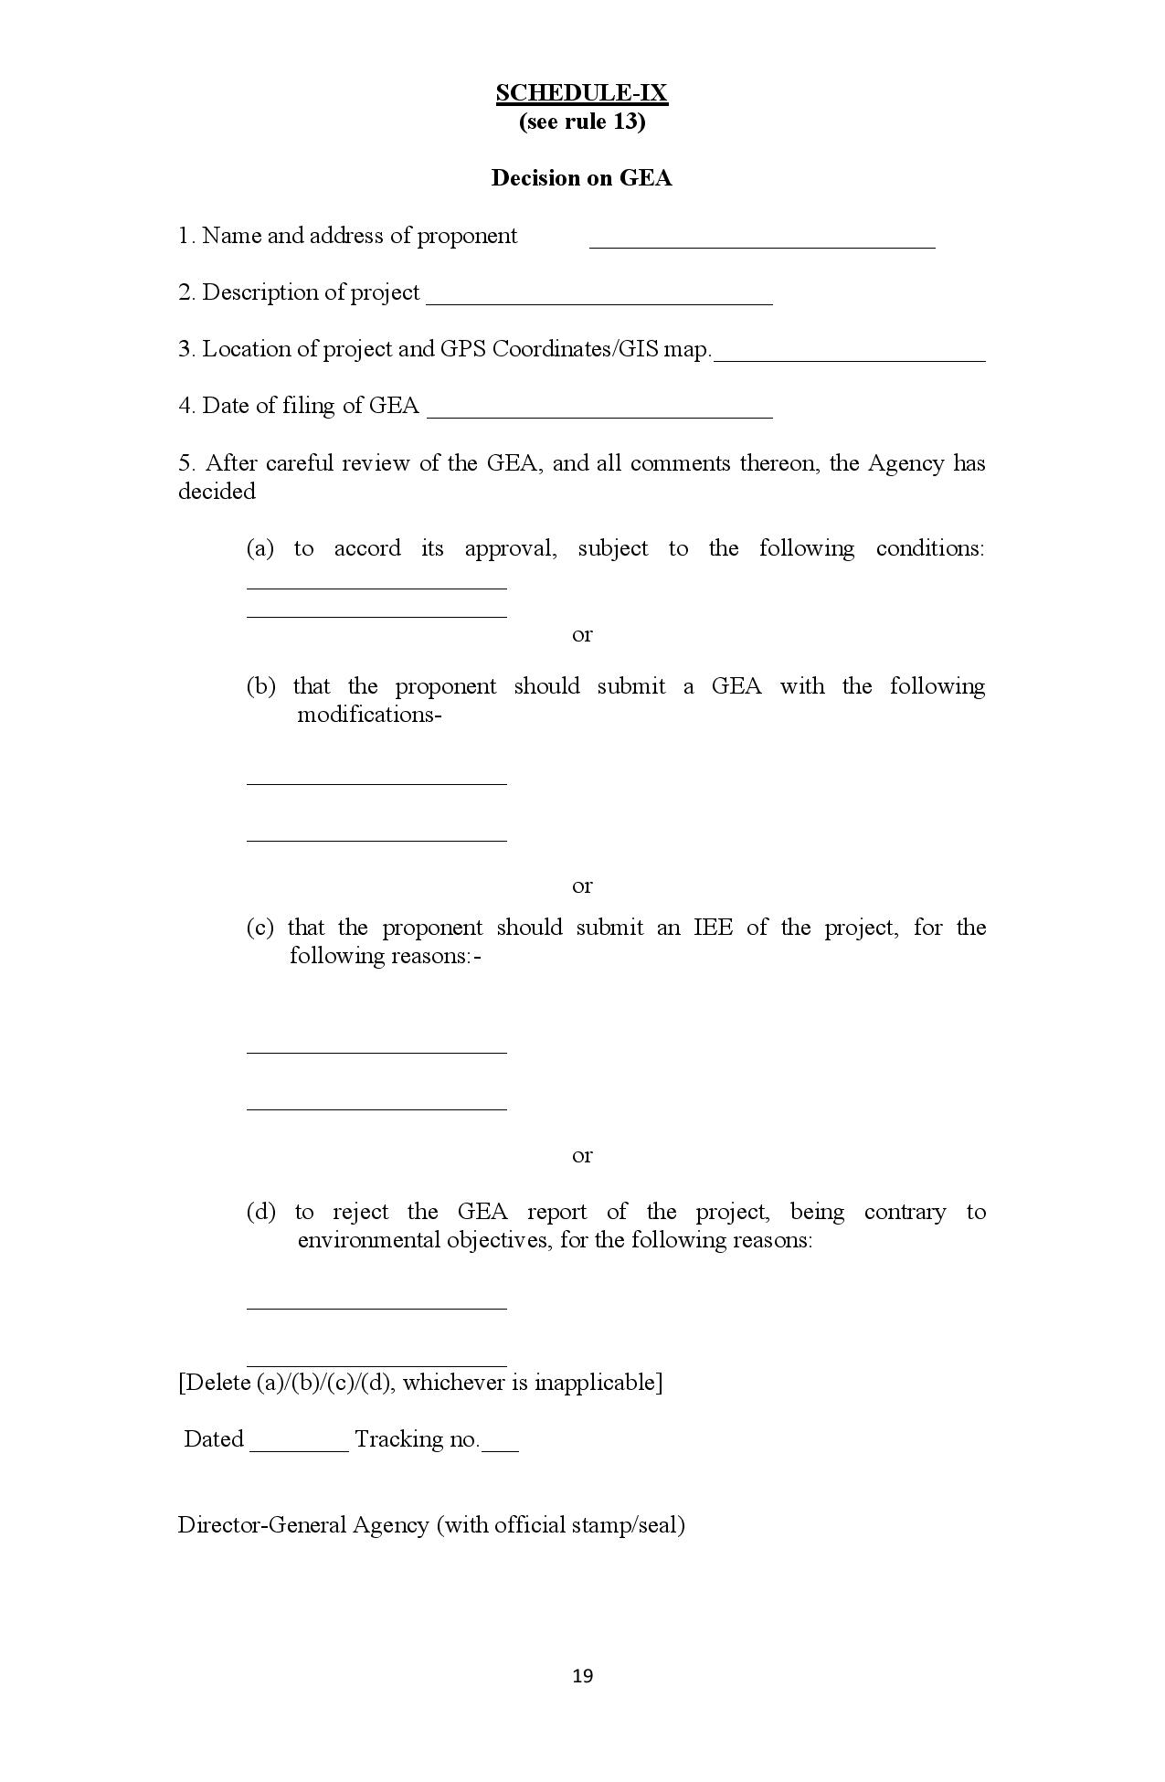

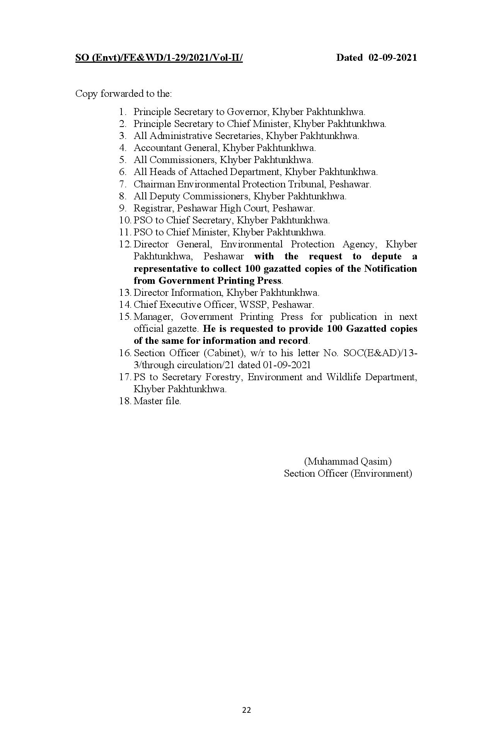

Annex 5. Water Quality Test Reports

DWSS Bara Tehsil
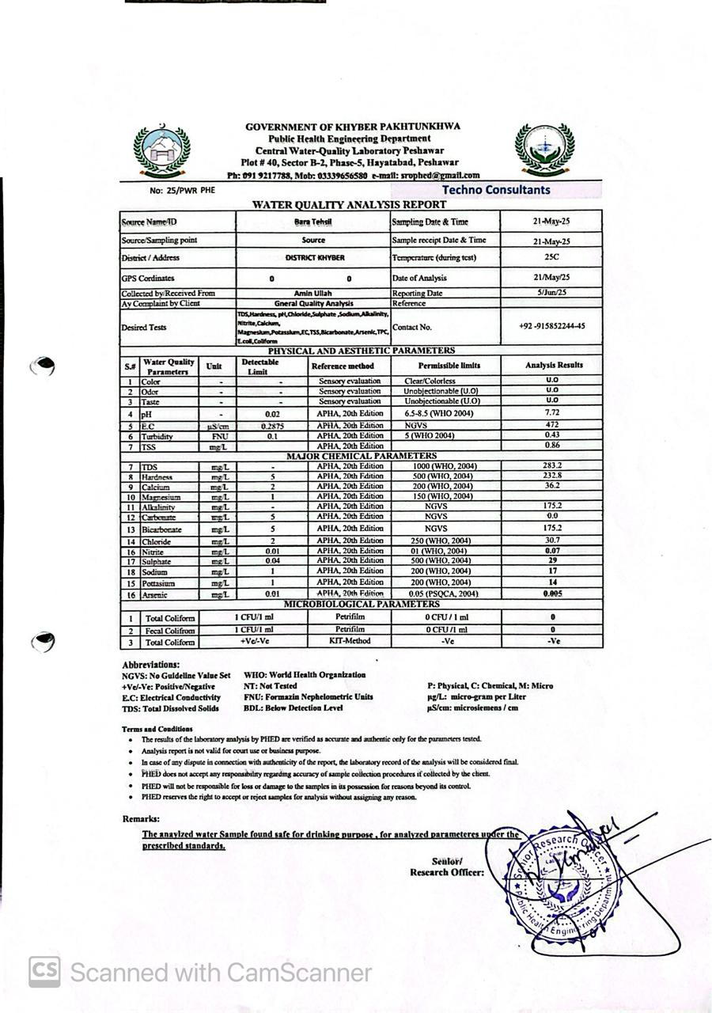

DWSS Ghundi Sher Khan

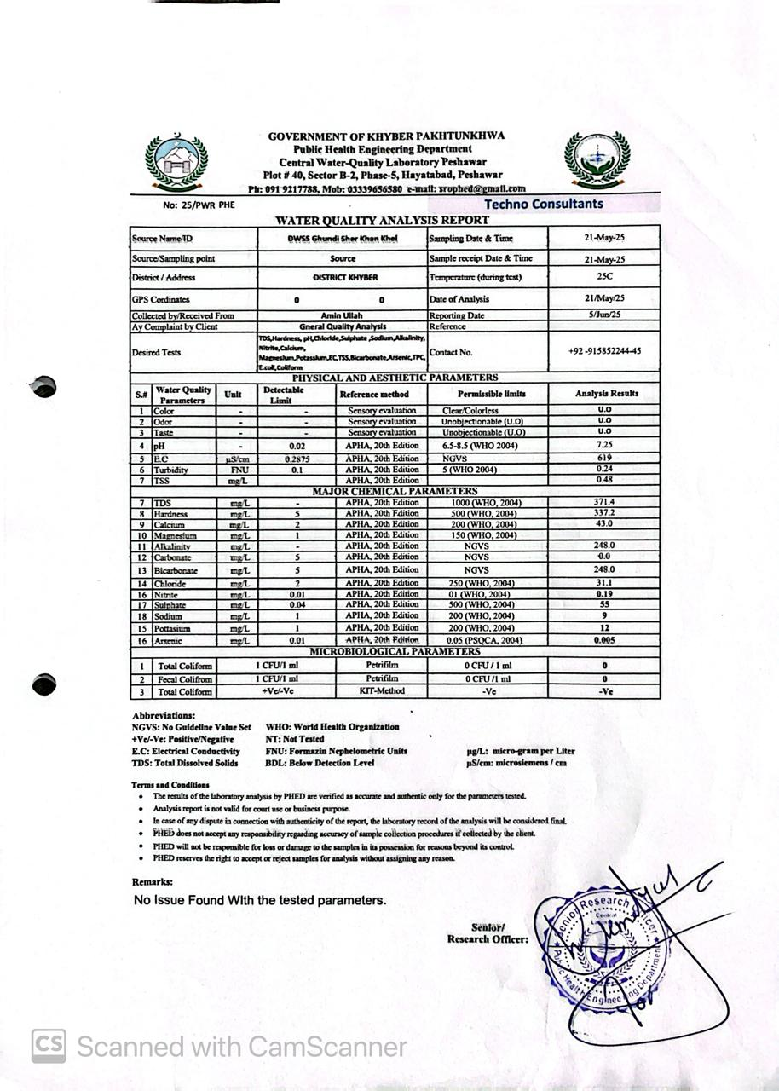

DWSS Kam Shalman

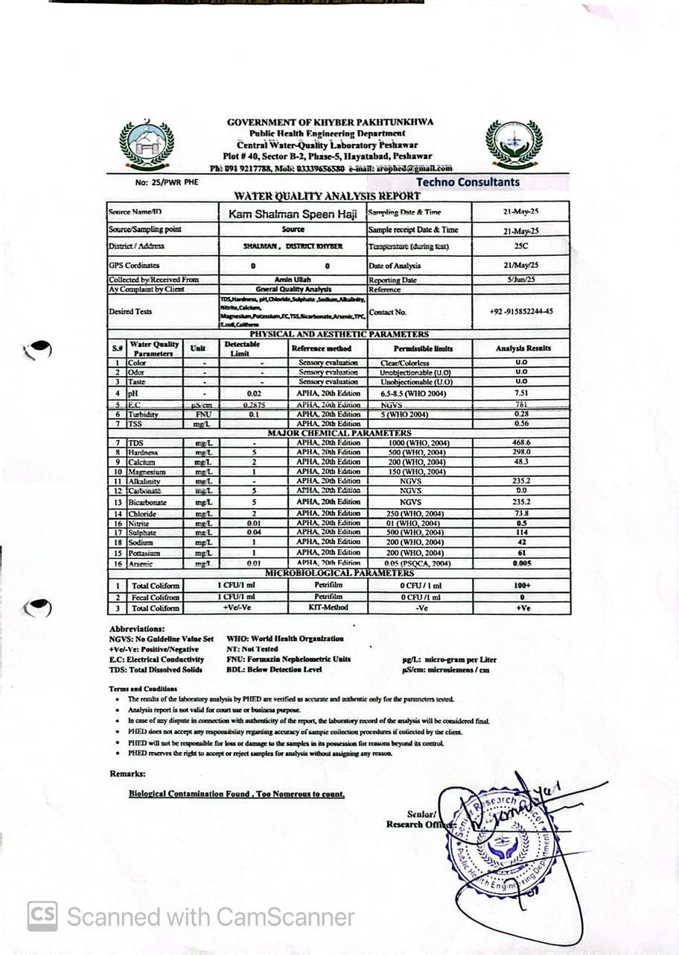

DWSS Hayat Khan

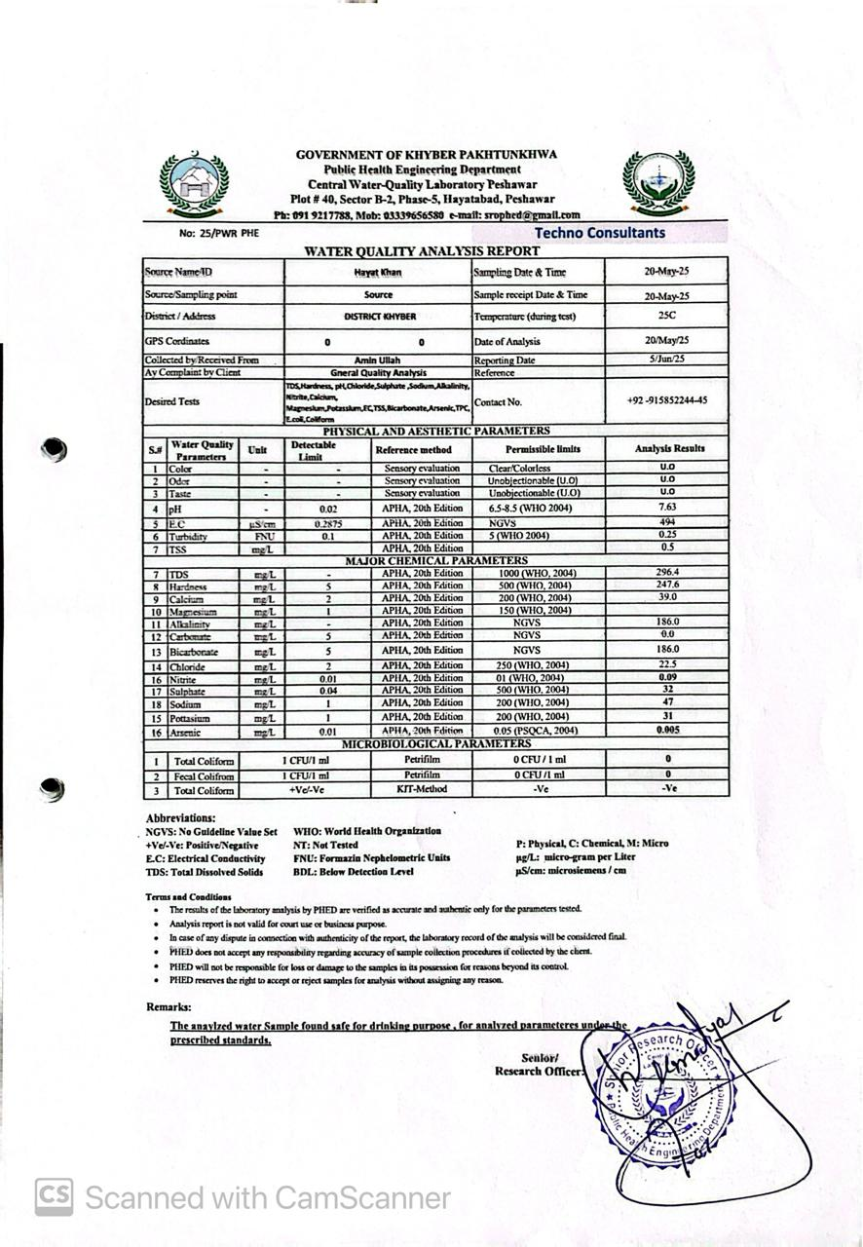

DWSS Hissara Shalobar
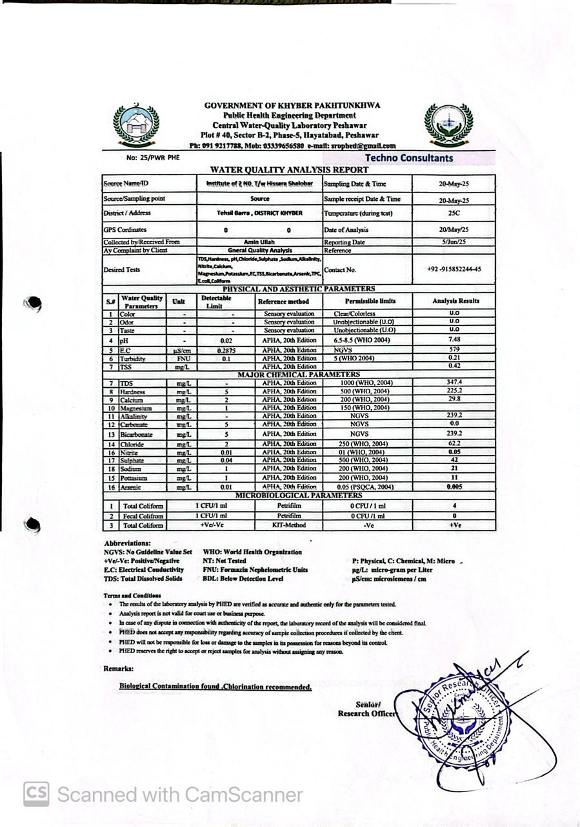

DWSS Jamal Khel
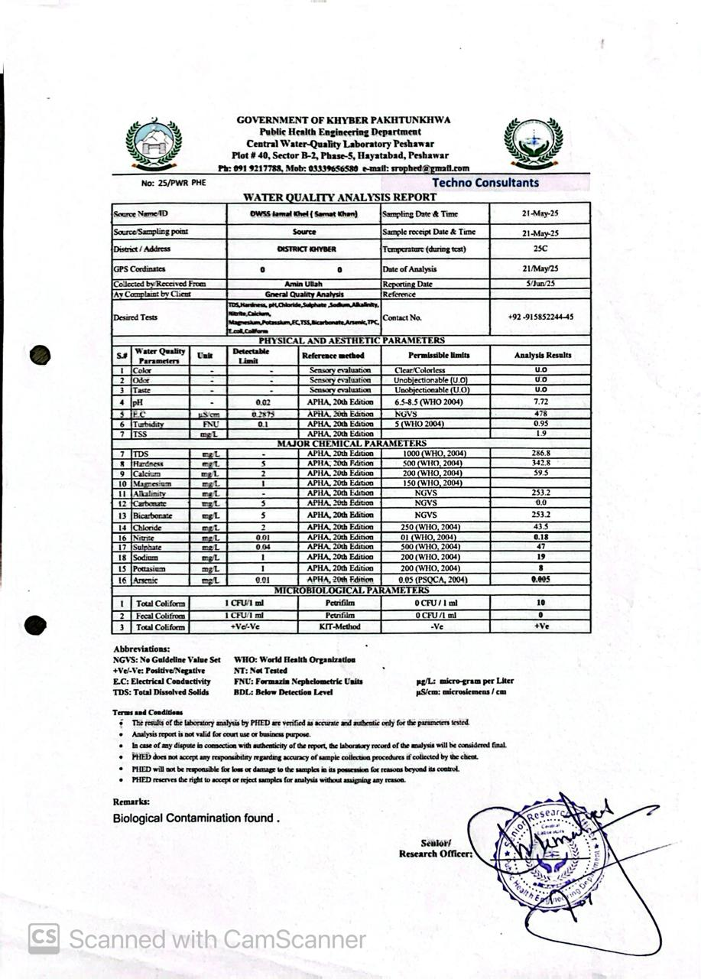

DWSS Wali Khel Gul Wali
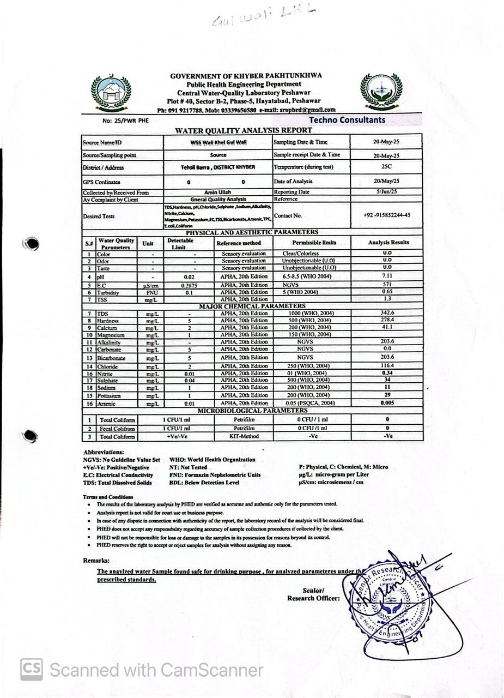

DWSS Malak Saadullah
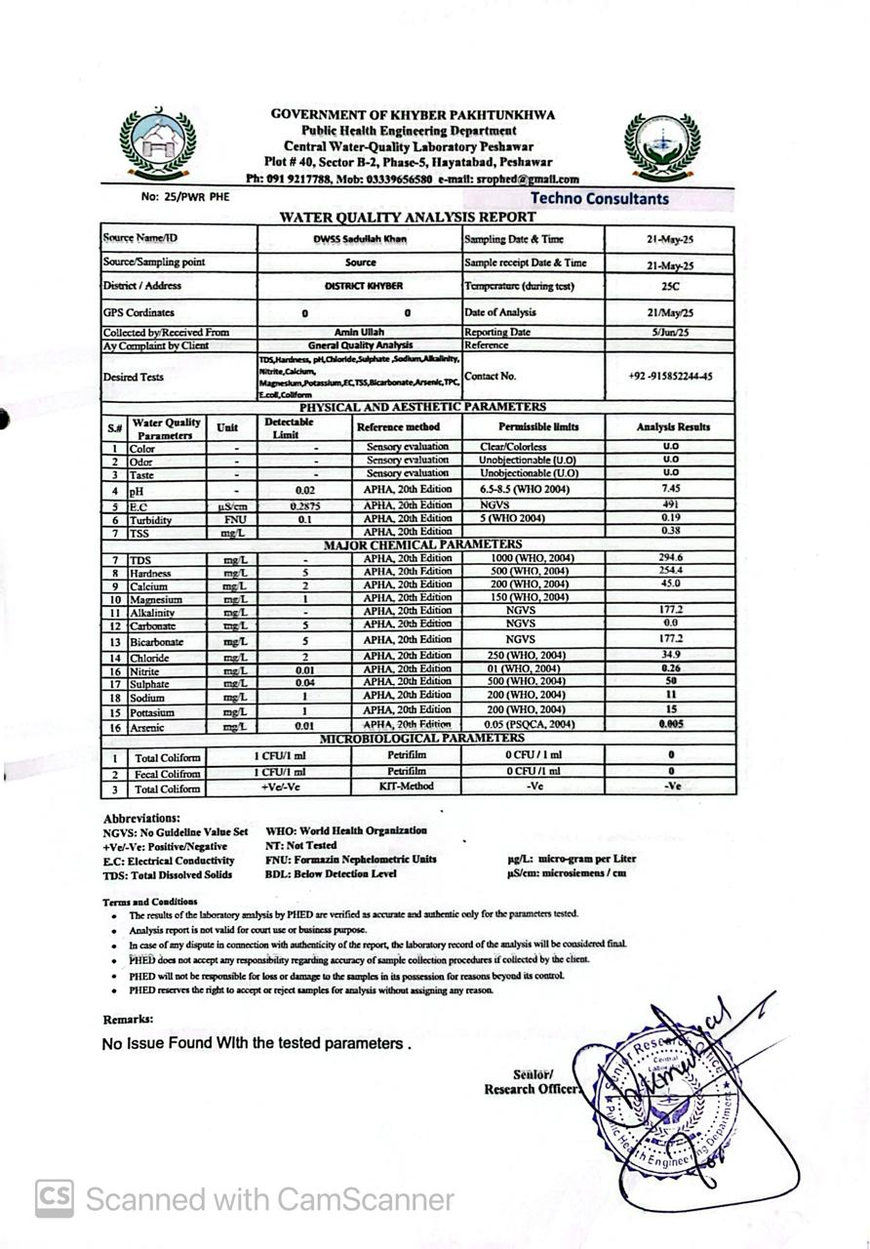

DWSS Fazal Malik Kalli
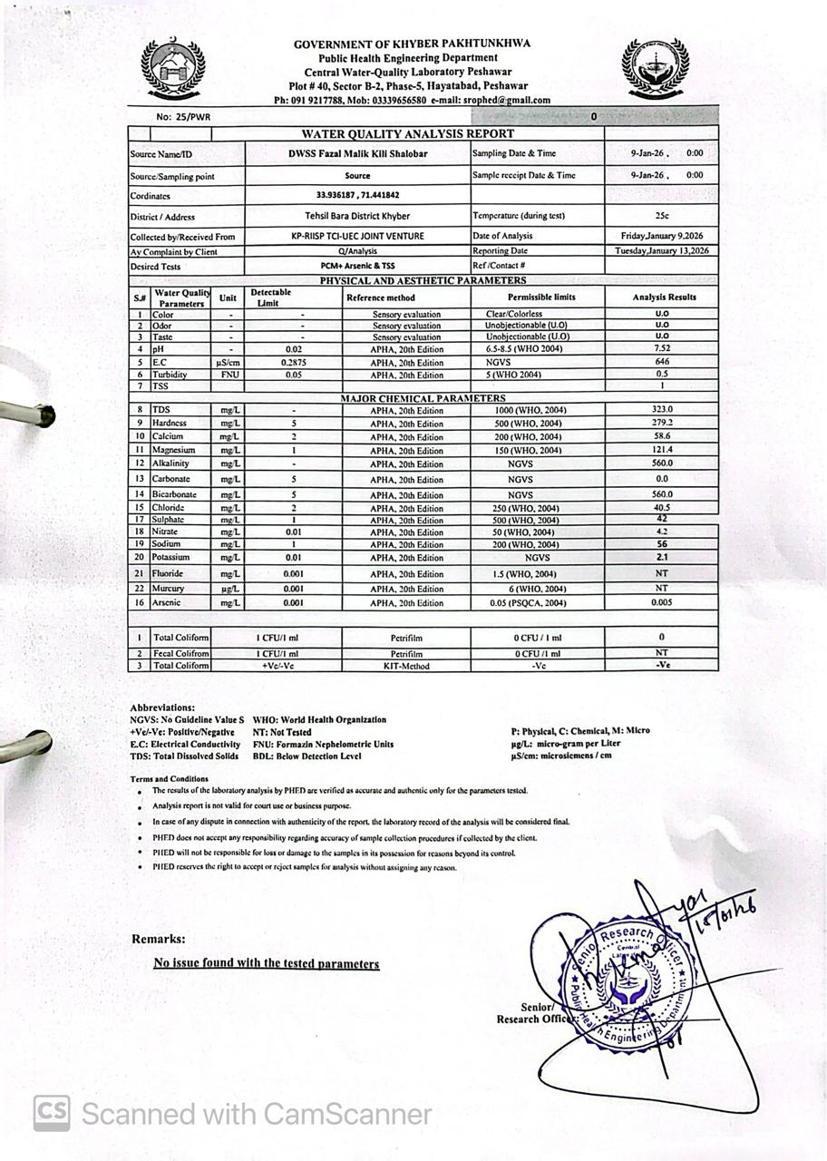

DWSS Ghazi Tubewell Nala MDK
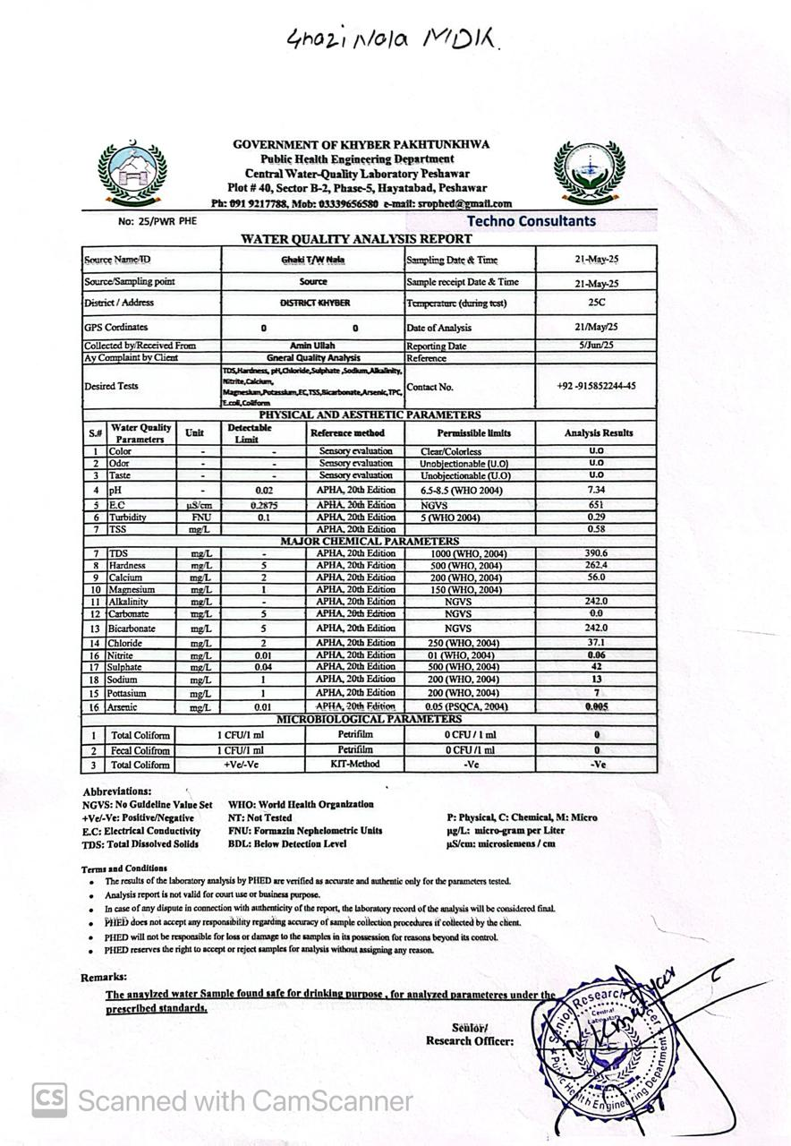

Annex 6. Participants’ List of Stakeholders’ Consultation

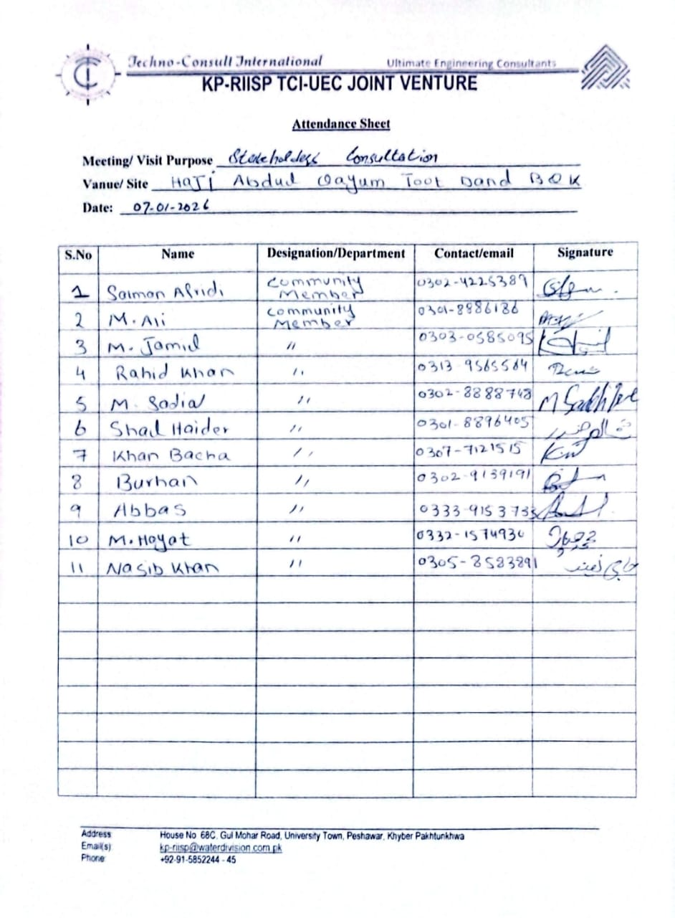

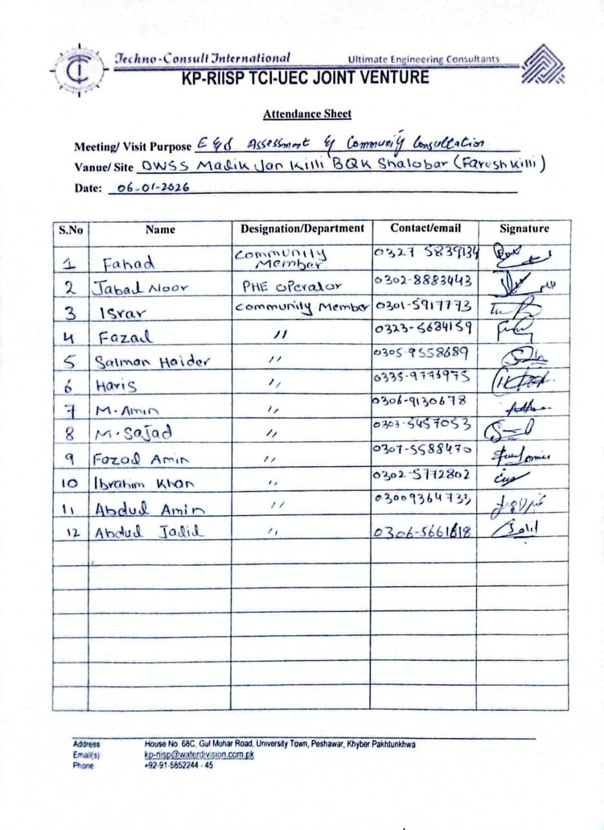

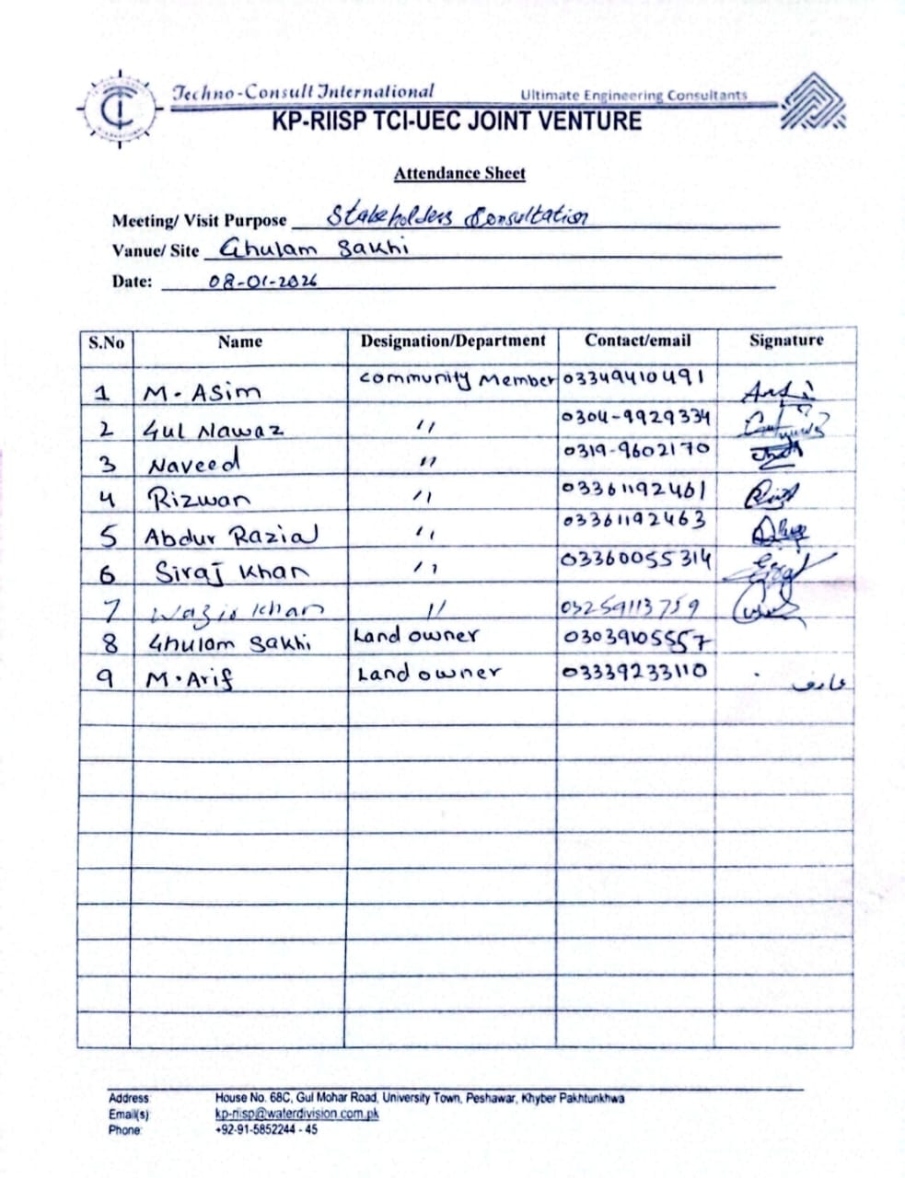

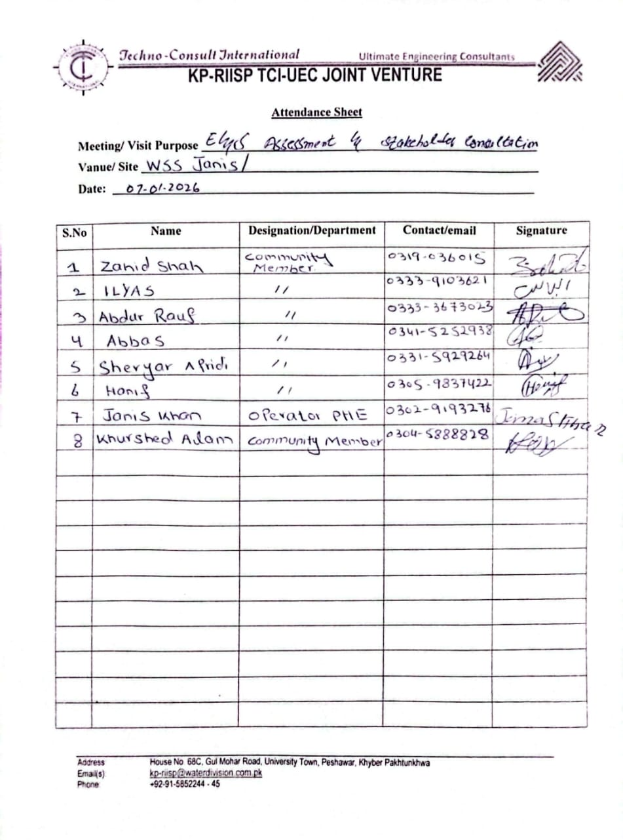

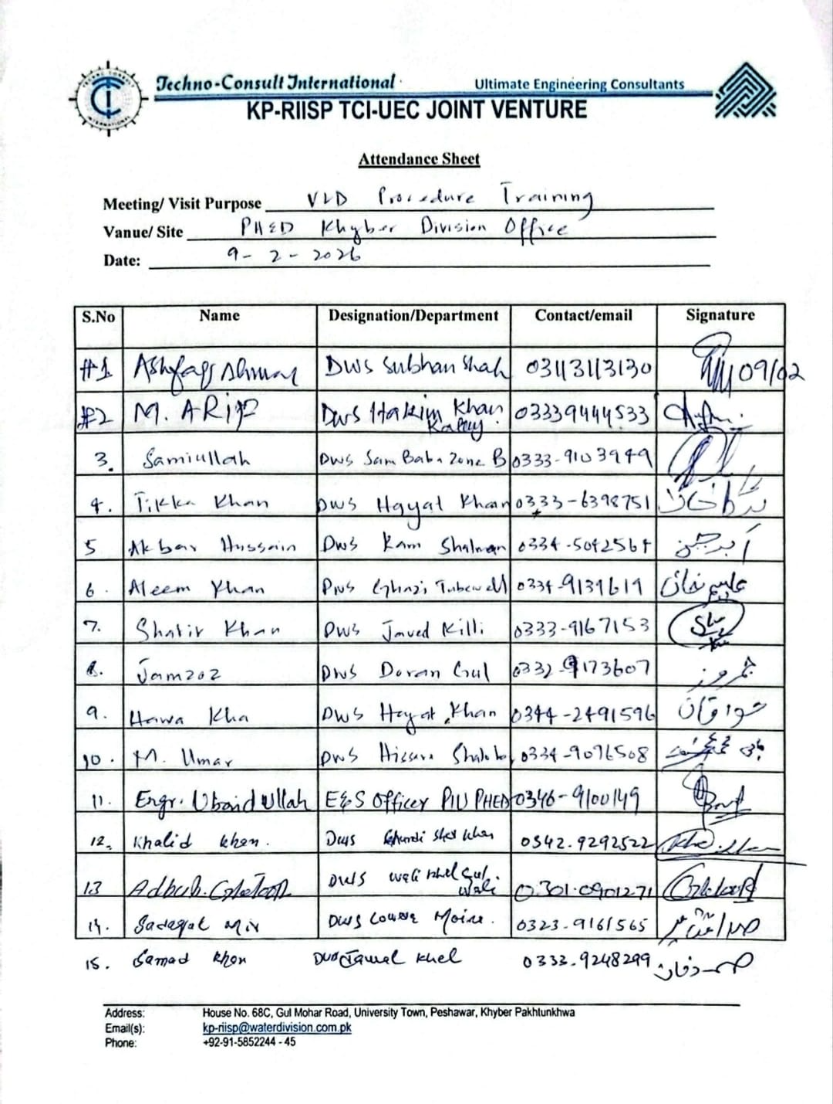

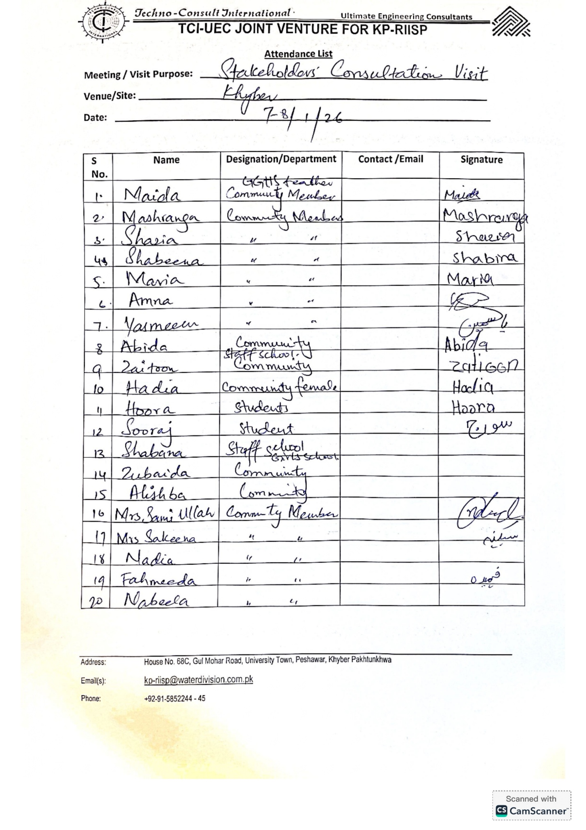

Annex 7. Photos (with captions) of the Consultation Activities

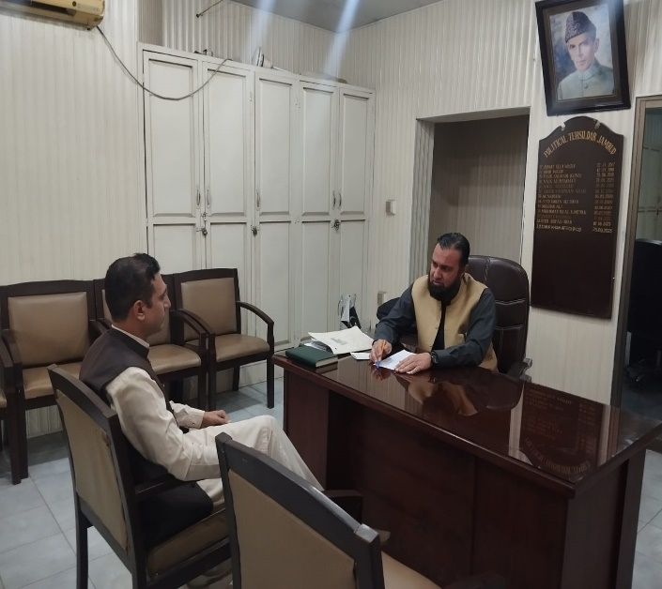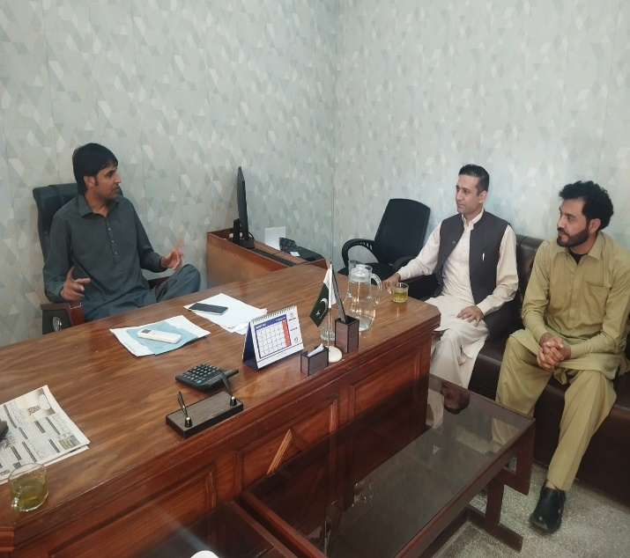

Stakeholder consultation with Tehsildar and TMO Jamrud, Khyber. Both the offices were briefed regarding their roles in the project and their feedback was noted

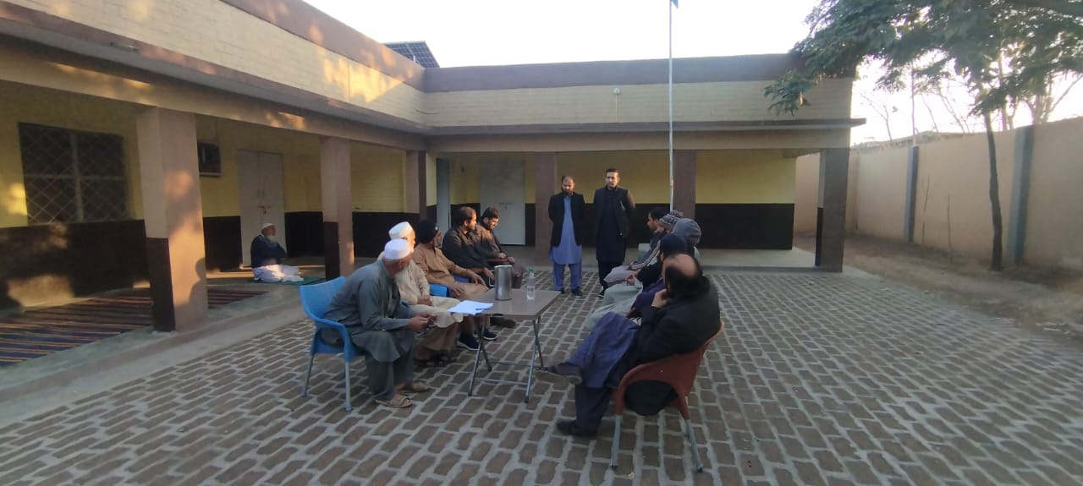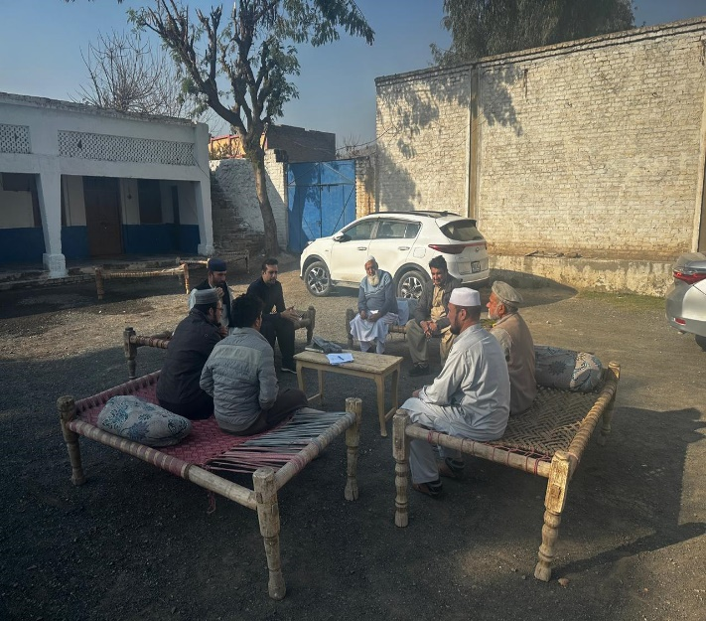

Consultations with community members and land owners at DWSS Haji Abdul Qayum Toot Dand and DWSS Sam Baba Zone-B

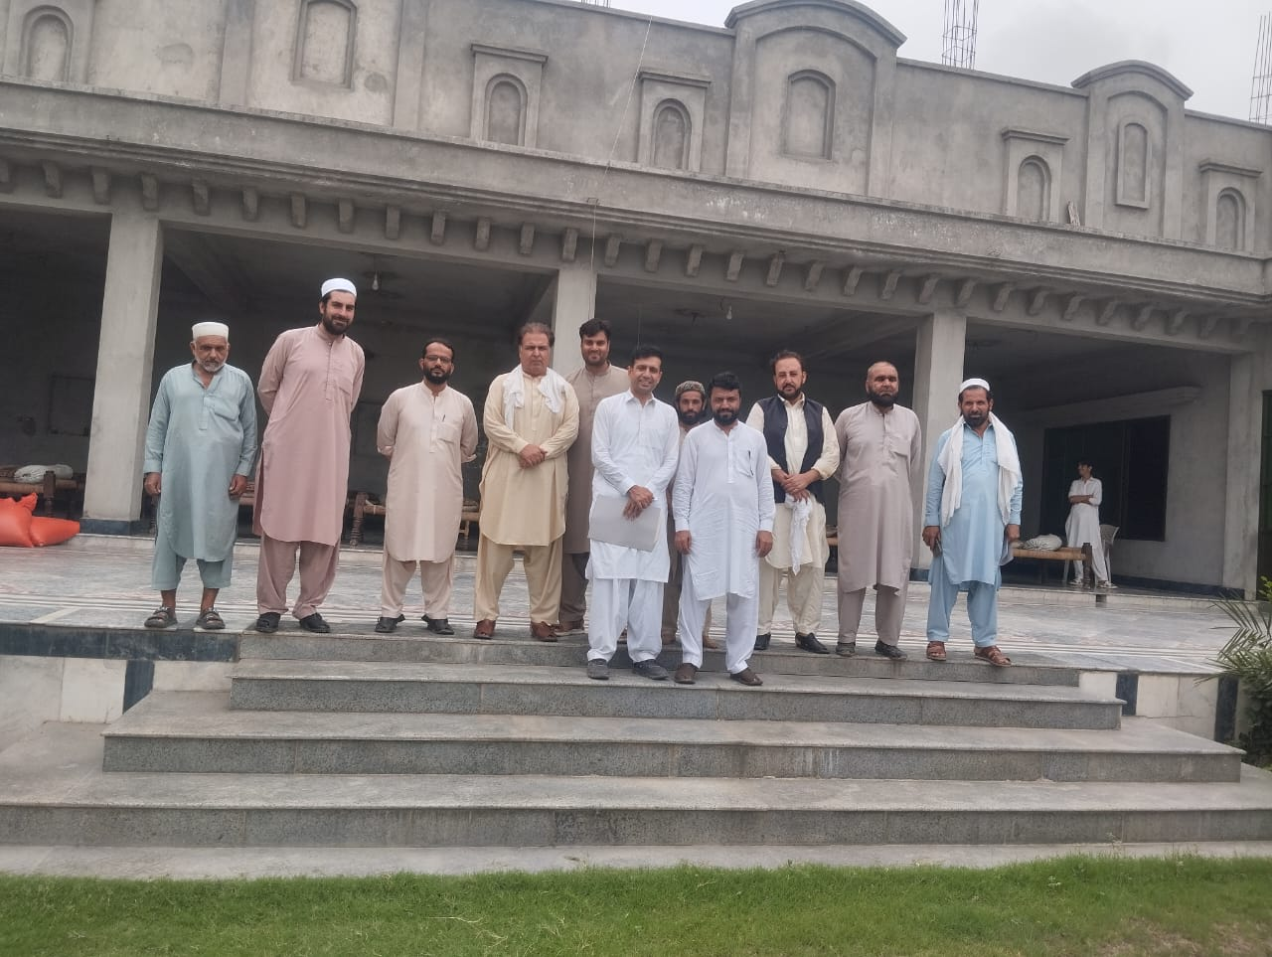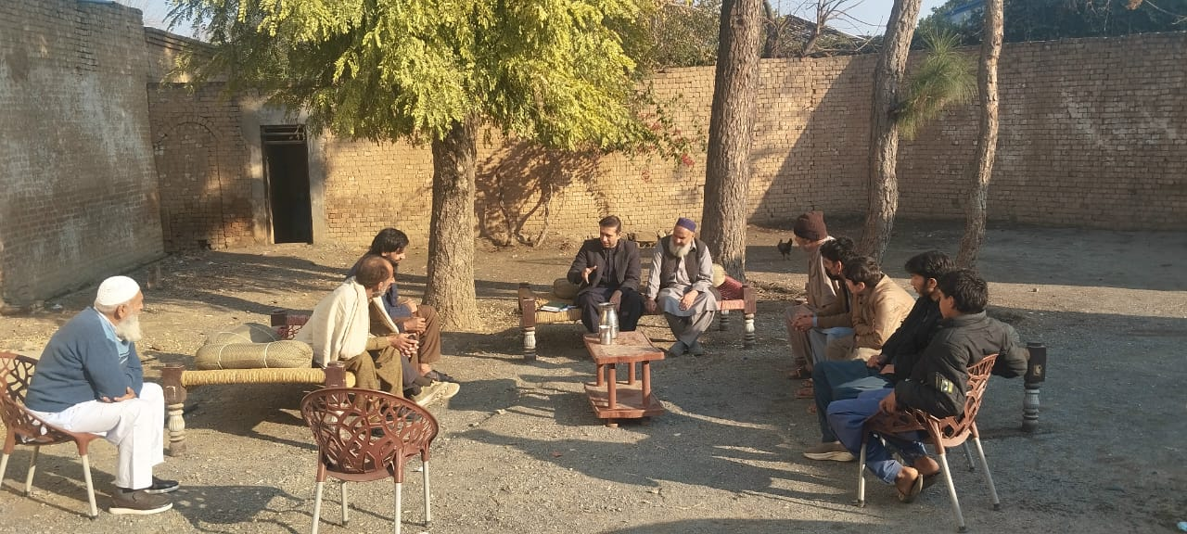

Consultations with community members at DWSS Ghundi Sher khan Khel and DWSS Haji Janis/Tawas khan
kily BQK

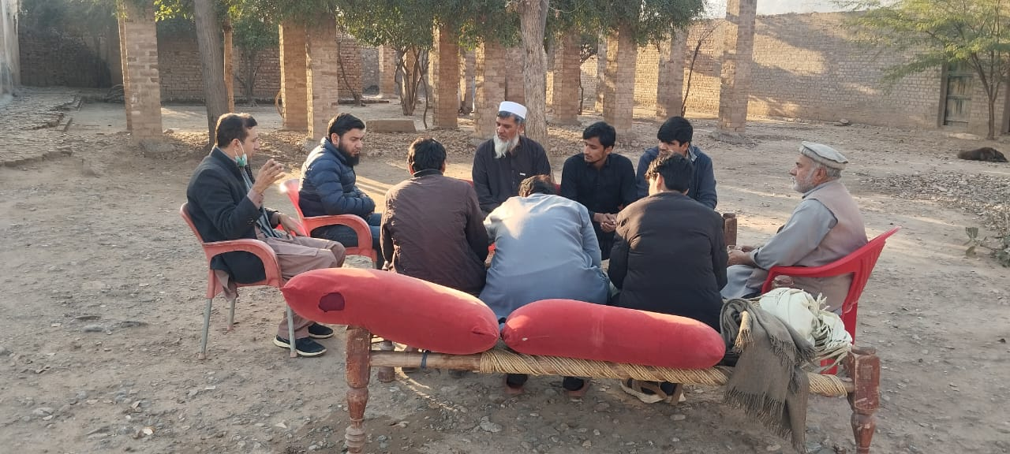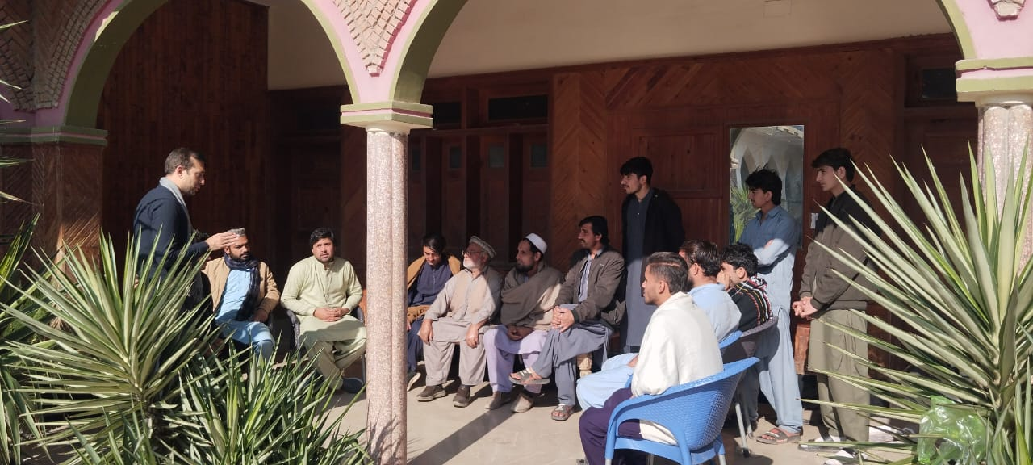

Consultations with community members at DWSS Hissara Shalobar and DWSS Malak Jan kily BQK Shalobar

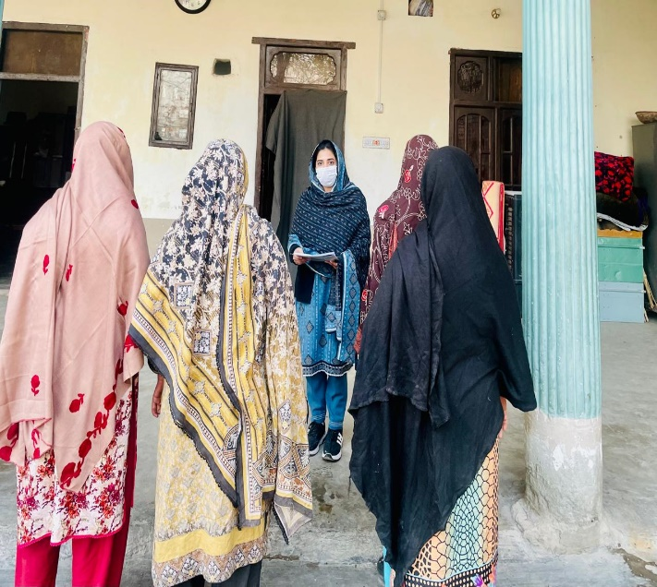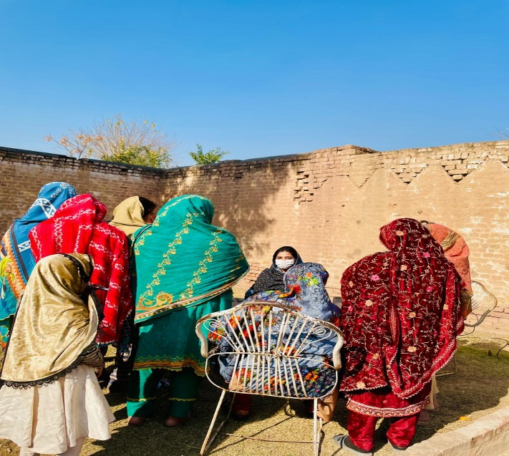

Consultation with female community members at DWSS Haji Abdul Qayum Toot Dand and
DWSS Sam Baba Zone-B

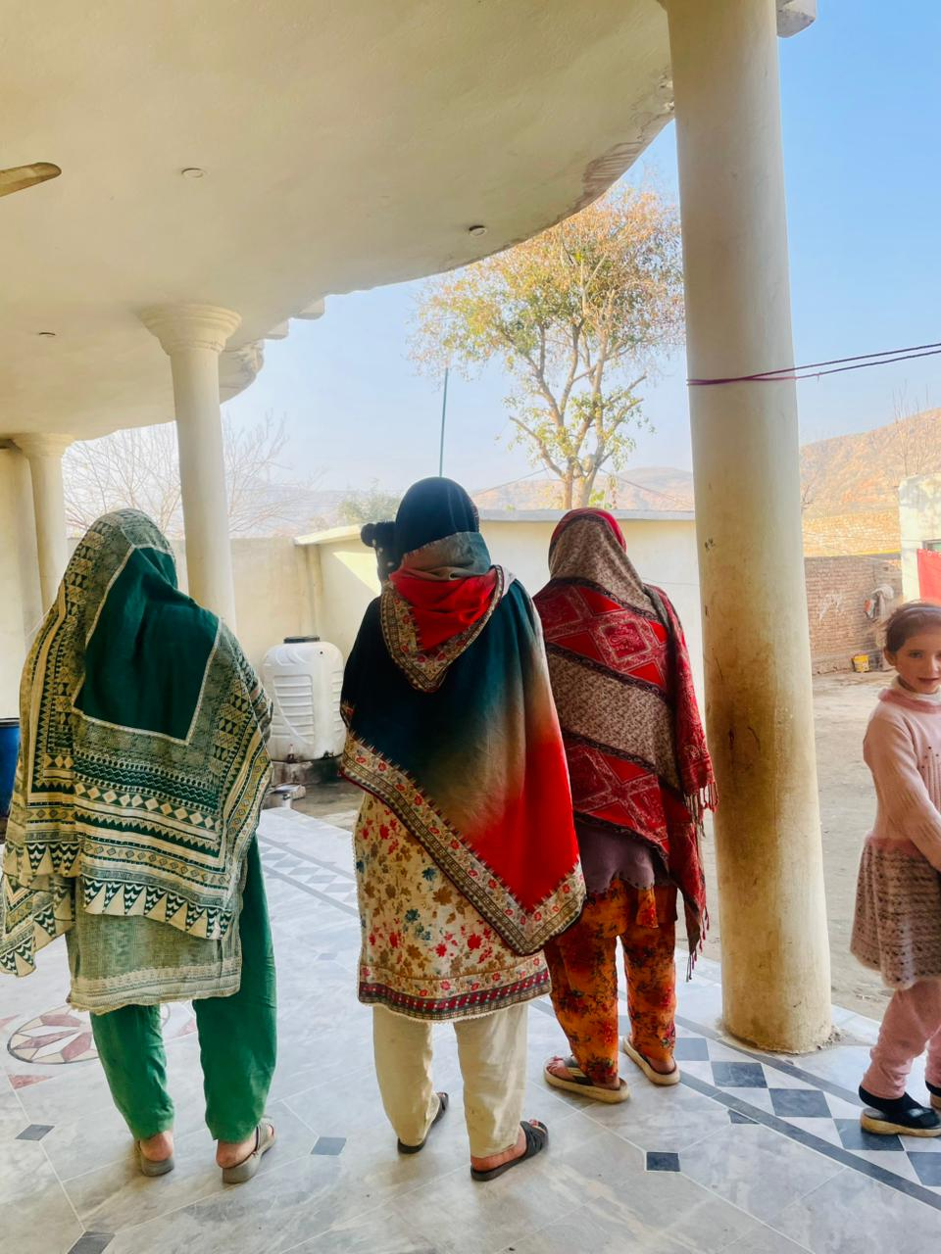
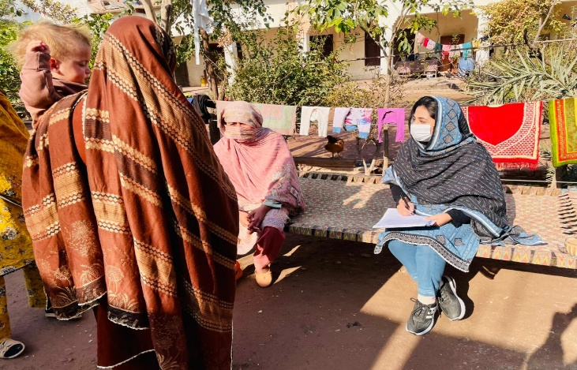

Consultation with female community members at their homes
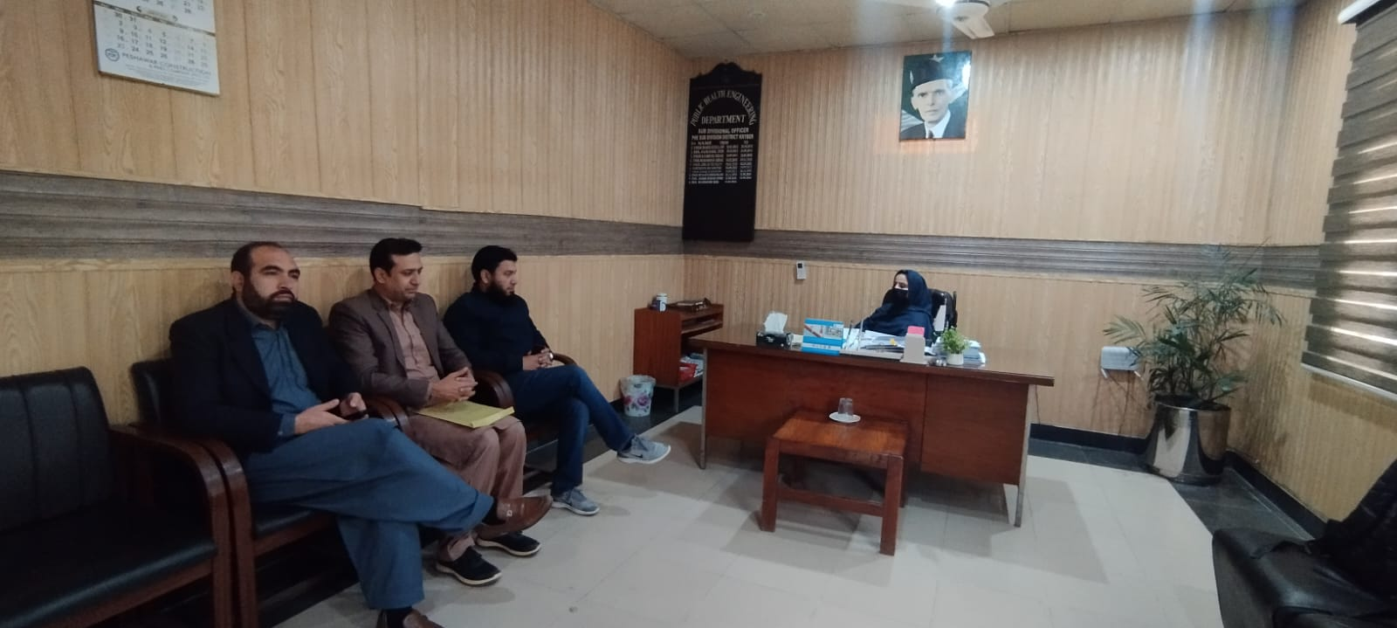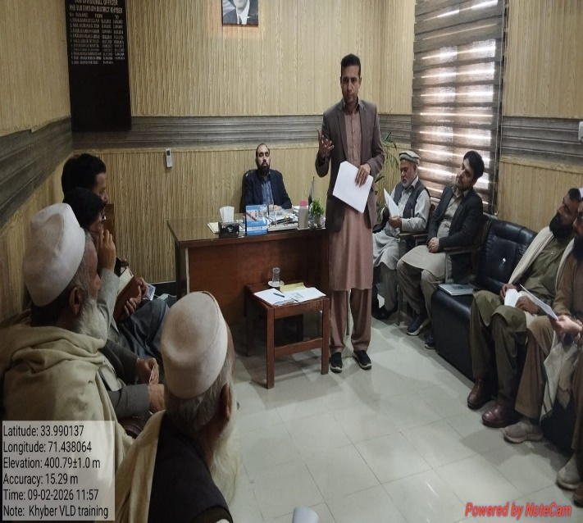

Stakeholder consultation with SDO Jamrud and PHED Khyber district staff-Land owners’ training about the procedures and execution of Voluntary Land Donation (VLD)

Annex 8: Components of Site Specific OH&S Plan

1. Risk Assessment & Planning
- Hazard Identification:
  - Working at Height: Construction/repair of overhead reservoir (OHR) presents fall hazards for workers.
  - Climate Hazards: Extreme heat during June/July (mean max 40°C) increases the risk of heatstroke and dehydration for laborers.
  - Traffic Hazards: Construction material delivery vehicles
  - Excavation & Soil Stability: Excavation activities include proposed replacement of damaged water distribution pipes while and for the construction of septic tanks/soakage pits and laying of sewerage lines; may pose risks of dust generation and fall hazard at the excavated sites
  - Electrical works including; installation, replacement, or repair of solar panels, wiring, charge controllers, installation of meters and motors pose electric shock hazard

- Planning:
- All safety tools related to Work at Height including scaffoldings, safety harness, platforms shall be provided for all the construction activities involving work at height. Training regarding the use of these tools shall be provided
- To prevent heat stroke and dehydration for laborers during extreme heat / high temperature seasons; labor camp shall be provided with shaded, ventilated areas with free access to cool drinking water and oral rehydration solution (ORS)
- traffic management plan will be prepared by the contractor at the time of starting the construction in accordance with the on-ground site conditions, submit it to the PIU PHED for approval, and later, for monitoring purposes, and implemented to avoid traffic jams/public inconvenience
- All sites where excavation work will be carried out will be daily (twice) sprinkled with water to control dust; excavated sites will be barricaded using green mesh (net) and “caution” warning tape to prevent entry of irrelevant personnel and to prevent any type of fall hazard; all the excavated sites shall be marked with warning sign “Deep Excavation – Entry prohibited” (in local language)
- For all electric works; safety measures including isolation of equipment, use of required PPEs, provision of required trainings shall be ensured

2. Clear Roles & Responsibilities
- Contractor’s E&S Specialist:
  - Responsible for implementing this OH&S plan, conducting daily safety inspections, and ensuring workers wear PPE.
  - Must prepare sub-plans (Traffic Diversion, Site Rehabilitation) and submit them to the Supervision Consultant.
- Site Supervisor:
  - Ensures that only authorized workers enter the construction boundary and that visitors follow safety protocols.
- Supervision Consultant’s E&S Specialist:
  - Oversees the Contractor’s performance and issues instructions for corrective actions regarding safety violations.
- PIU (PHED):
  - Conducts spot checks and monitors compliance with the World Bank’s Environmental and Social Standards (ESS2 & ESS4).
3. Training & Awareness
- Induction Training: All laborers will receive mandatory training on site safety, cultural norms, and the Code of Conduct (GBV/SEA/SH) before accessing the site.
- Toolbox Talks: Daily briefings will be conducted on specific daily hazards (e.g., "Working on Scaffolding," "Electrical Safety," "Handling Hazardous Materials").
- Specialized Training:
  - Heat Stress Management: Educating workers on hydration and recognizing heatstroke symptoms during the hot summer.
  - First Aid & Fire Safety: Designated staff will be trained in basic medical services and firefighting.
4. Safe Work Procedures
- Personal Protective Equipment (PPE):
  - Mandatory: Safety helmets, high-visibility vests, and safety shoes for all workers.
  - Task-Specific:
    - Dust Masks: For excavation and demolition crews (preventing respiratory issues).
    - Ear Muffs/Plugs: For workers operating heavy machinery or drill rigs (noise abatement).
    - Safety Harnesses: For work on OHR.
- Machinery Maintenance: Regular checks of mixer machines and vehicles to prevent hydraulic leaks or mechanical failure.
5. Site Safety Controls
- Barriers & Fencing:
  - fencing around the rehabilitation site using green mesh shall be provided to prevent entry of any irrelevant personnel.
- Signage: Safety signs (e.g., "Hard Hat Area," "Work at Height," "No Entry," "Emergency Exit") will be displayed in Urdu and Pashto at prominent locations.
- Traffic Management:
  - Construction vehicle movement will be restricted during school start/end times to protect students.
  - Speed limits will be enforced.
- Dust Control: Regular water sprinkling on sites and construction material storage yard to maintain air quality and visibility.
6. Monitoring & Reporting
- Inspections:
  - Daily: Site Supervisor to check PPE compliance, hygiene of toilets/kitchens, and machinery safety.
  - Weekly: Use the Environmental Monitoring Checklist (Annex 11) to audit comprehensive safety measures.
- Incident Reporting:
  - Any accident or "near-miss" must be recorded using the Incident Reporting Format (Annex 5) and reported to the PIU within 24–48 hours.
- Audits: Quarterly OH&S audits will be conducted by the Supervision Consultant.
7. Emergency Preparedness
- Emergency Response Plan: A specific plan will be developed by the contractor for fire and medical emergencies.
- Medical Facilities:
  - On-Site: Fully stocked First Aid Box and trained first-aiders available at all times.
  - Referral Hospital: The respective DHQ Hospitals of Tehsil Bara, Jamrud, Landi Kotal and Mula Gori are located approximately within 4 km radius from the DWS sites, allowing for rapid transport in case of serious injury.
- Fire Safety: Fire extinguishers and sand buckets will be strategically placed near fuel storage, kitchens, and electrical panels.
- Emergency drills: The contractor E&S specialist will be required to perform quarterly emergency drills (fire and medical emergencies etc.) to strengthen contractors’ staff capacity of handling such events
- Reporting: Any emergency event must be reported to the PIU within 2 hours and detailed report on the event must be submitted by the contractor E&S specialist within 24 hours.
- Communication: Emergency contact numbers (Hospital, Fire Brigade, PIU E&S Officer) will be posted at the sites and labor camp. At each site, a focal person from the community will be nominated who will be informed regarding any major accident/incident (e-g fire, traffic accident etc.). The contact details of the contractor project manager and E&S Specialist will be shared with the local community to ensure timely communication in cases of any accident/incident

Annex 9: KPRIISP Code of Conduct


Code of Conduct (GBV and SEA/SH Prevention)
Khyber Pakhtunkhwa Rural Investment & Institutional Support Project (KP-RIISP)
Responsible Authority: KPRIISP E&S Unit | Applicability: All Staff, Consultants, Contractors
Definitions
To ensure clarity and alignment, basic key terms are defined below:
GBV (Gender-Based Violence):
GBV is an umbrella term for any harmful act that is perpetrated against a person’s will, and that is based on socially ascribed (i.e., gender) differences between males and females. It includes acts that inflict physical, sexual or mental harm or suffering, threats of such acts, coercion, and other deprivations of liberty. These acts can occur in public or private (2015 Inter-Agency Standing Committee Gender-based Violence Guidelines, pg. 5).
SEA (Sexual Exploitation and Abuse):
Sexual Exploitation: any actual or attempted abuse of a position of vulnerability, differential power or trust for sexual purposes, including, but not limited to, profiting monetarily, socially or politically from the sexual exploitation of another (UN Glossary on Sexual Exploitation and Abuse 2017, pg. 6).
Sexual Abuse: actual or threatened physical intrusion of a sexual nature, whether by force or under unequal or coercive conditions (UN Glossary on Sexual Exploitation and Abuse 2017, pg. 5).
SH (Sexual Harassment):
Any form of unwanted verbal, non-verbal or physical conduct of a sexual nature with the purpose or effect of violating the dignity of a person, in particular when creating an intimidating, hostile, degrading, humiliating or offensive environment. This may include unwelcome sexual advances, requests for sexual favors, and may take place through online activity or mobile communications as well as in person.
GRM (Grievance Redress Mechanism):
The KPRIISP has set up a GRM to respond to the concerned grievances in both community and workplace settings. Under the project’s GRM there will be a dedicated GBV reporting mechanism ensuring confidentiality and survival centered approach. It will further ensure that every report is handled professionally, with the survivor’s safety, dignity, and access to support services as top priorities.
1. General Responsibilities
All personnel must:
· Consent to a security background check.
· Treat all individuals (women, men, children, persons with disabilities, transgenders, etc.) with respect and dignity, free from discrimination.
· Comply with National & Provincial Laws, World Bank’s Good Practice Note, GBV Risk Assessment Tool, and KPRIISP’s GBV and SEA/SH Mitigation Plan.
Maintain a safe environment by:
· Ensuring workplaces are risk-free.
· Following emergency procedures (availability of first aid box, fire extinguishers, displaying of CoC in English, Urdu & local dialect and all mitigation measures must be in effect).
· Report concerns via KPRIISP’s GRM or to the designated focal person.
· Attend mandatory annual GBV and SEA/SH training, with bi-annual refreshers for field teams.
2. GBV/SEA/SH and Child Protection
Prohibited Conduct:
· Inappropriate language/behavior, sexual advances, or transactional sex.
· Any sexual activity with children (consent or mistaken age is no defense).
Mitigation Measures:
· Report suspicions to the GBV Grievance Redress Committee/designated focal person.
· Ensure workplaces/communities are harassment-free as per the Khyber Pakhtunkhwa Protection Against Harassment of Women at Workplace (Amendment) Act, 2020.
· Collaborate with provincial/local authorities/NGOs to support survivors.
· Collaborate with gender desk officer at the local police stations for cases pertaining to GBV/SEA/SH.
· Ensure confidential referral pathways for survivors.
3. Contractor/Consultant Obligations
Contractors/consultant must:
· Implement CoC requirements in HR policies, site protocols, and grievance mechanisms.
· Ensure compliance is a condition of contract performance.
4. Accountability & Compliance
· Zero Tolerance: Violations lead to warnings, termination, or legal action.
· Confidentiality: Whistleblowers and survivors are protected.

Signature Section
By signing, I commit to upholding this Code:
Name: _________________________
Designation: ____________________
Organization: ___________________ (for contractors/consultants/staff)
CNIC: __________________________
Signature: ______________________
Date: __________________________

Reporting & Enforcement:
Focal Persons:
· PCMU: Senior Social Development Specialist/Gender Officer
· PIU: Senior Social Development Specialist/Gender Officer/ Established Arrangements
Process:
1. Report to focal persons via GRM (anonymous options available)/direct report to senior management.
2. Preliminary inquiry within 15 days.
3. Outcomes: Verbal/written warnings, disengagement, or legal referral.
4. Confidentiality: Survivor identities protected; retaliation prohibited.

Implementation Requirements
· Visual Display: Mount CoC in English, Urdu, and Pashto across offices.
· Onboarding: Include CoC in orientation kits for all personnel.

Approved by:
Project Director
Project Coordination and Management Unit (PCMU)
Khyber Pakhtunkhwa Rural Investment and Institutional Support Project (KP-RIISP)
Planning and Development Department, Khyber Pakhtunkhwa

Annex 10. Environmental & Social (E&S) Monitoring Checklist

The following checklist will be used by the Contractor/Consultant field staff during site monitoring visits to assess E&S compliance at the sub-project sites.
Khyber Pakhtunkhwa Rural Investment and Institutional Support Project (KP-RIISP)

Environmental & Social (E&S) Monitoring Checklist

Contractor/Consultant and Package Name: ______________________District: _________________
Date of Visit: ___________________Sub-Project/Location: ____________________________
ENVIRONMENTAL COMPLIANCE CHECKLIST
# | Questions | Response | Remarks
 | Exposure of soil surface to erosion/grubbing of the topsoil during site preparation
1 | Has the excavation been carried out as per actual excavation plan? | Yes / No
2 | Is all the excavated material been reused in backfilling? | Yes / No
3 | Is the waste from excavated material (if any) been disposed of in the nearest Municipality container or community dumping site? | Yes / No
4 | Did the site clearance/excavation involve removal of trees/vegetation? | Yes / No
5 | After the completion of work, grubbed soil is used in landscaping? | Yes / No
 | Air quality impacts (Dust and Exhaust emissions)
6 | Is the construction site been sprinkled with water daily (twice) for dust control? | Yes / No
7 | Has the machinery been regularly checked for excessive exhaust emissions on-site? | Yes / No
8 | Has the carried material been properly covered with green cloth or a tarpaulin sheet to avoid dust emissions? | Yes / No
9 | Have the drivers been trained with caution signage to follow the speed limit at the premises? | Yes / No
10 | Is the raw material been covered in the storage yard with the cover sheet? | Yes / No
11 | Are the workers using proper PPEs for dust, i.e. face masks, on site? | Yes / No
12 | Are all those activities which create dust been scheduled off-peak hours? | Yes / No
 | Noise Generation
13 | Has the contractor scheduled all noisy activities during the off-peak hours? | Yes / No
14 | Have all the workers signed the Code of Conduct? To avoid disturbance and shouting on site. | Yes / No
15 | Is the machinery i.e. excavator, concrete mixing machine and generator etc. well maintained to avoid excessive noise? | Yes / No
 | Waste Generation (Solid & Liquid)
16 | Are bins of 04 Colors (RED, Yellow, Green, and Blue) used for disposal of different type of waste on site? | Yes / No
17 | Is the waste disposed in the nearby municipality container or dumping site on daily basis? | Yes / No
18 | Is the equipment washout been discharged to the existing drainage system by saving/ avoided the natural water bodies? | Yes / No

WORKERS HEALTH & SAFETY INSPECTION CHECKLIST
# | Questions | Response | Remarks
1 | Is appropriate personal protective equipment (PPE) provided, used, and maintained when required? | Yes / No
2 | Is the site free from tripping hazards, e.g., cables, potholes, footpath defects, etc.? | Yes / No
3 | Are in-house procedures for handling employee safety and health complaints is in place? | Yes / No
4 | Have current weather conditions created new hazards to be addressed? | Yes / No
5 | Are all potentially hazardous activities segregated and/or fenced as required? | Yes / No
6 | Have any unanticipated hazards been introduced? | Yes / No
7 | Are first aid boxes and fire extinguisher facilities in place and in working condition? | Yes / No
8 | Is the Grievance Redress Mechanism (GRM) of KP-RIISP in place for the workers and community members, and is it working? | Yes / No
9 | Were any incidents/accidents reported during the work? | Yes / No
10 | Are all ladders/scaffolding, safety harness, platforms used during work at height maintained and in good condition? | Yes / No

COMMUNITY HEALTH & SAFETY CHECKLIST
# | Questions | Response | Remarks
1 | Have the members of the community adjacent to the sub-project been consulted and notified/informed prior to construction activities to limit unnecessary disturbances or interference? | Yes / No
2 | Has the construction site been appropriately cordoned off (with a green sheet) or barricaded to prevent stray animals and vagrant persons, particularly children, from entering the site? | Yes / No
3 | Have the excavated areas and pits been marked with appropriate signage, with provision of do not enter/do not pass signs and danger signs ensured at the site. | Yes / No
4 | Have the awareness sessions been organized to sensitize construction workers and local communities regarding the project objectives and activities? | Yes / No
5 | Is the free flow of traffic around the work site maintained? | Yes / No
6 | Do the vehicles accessing the site abide by speed limits and other traffic rules? | Yes / No
7 | Are the drivers briefed on safety requirements and exercise caution? | Yes / No
8 | Are the construction activities undertaken during the daylight hours between the hours of 07:00 am – 4:00 pm? | Yes / No
9 | Did the sub-project activities cause any interruption to existing utilities (water supply, electricity etc.)? | Yes / No

IMPLEMENTATION OF GRM AND SEA/SH MITIGATION MEASURES
# | Questions | Response | Remarks
1 | Have all workers signed the CoC, confirming conduct aligned with SEA/SH sensitivities? | Yes / No
2 | Are CoCs displayed at worksites in local languages? | Yes / No
3 | Have workers received training on the CoC, SEA/SH, and the GRM? | Yes / No
4 | Is the GRM active and accessible (e.g., through complaint boxes) at worksites? | Yes / No
5 | Are GRM information materials/banners displayed at worksites with contact details for focal points? | Yes / No
6 | Have any instances of child labor been identified at the worksite? | Yes / No
7 | Have brochures with GRM/complaint cell information been distributed to community members? | Yes / No
8 | Have community members received awareness sessions or consultations on SEA/SH and the GRM? | Yes / No

LABOR CAMP MANAGEMENT
# | Questions | Response | Remarks
1 | Labor camp area is clean and solid waste is properly managed | Yes / No
2 | Adequate safety and security measures in place (lighting, gates/locks, boundary, guards) | Yes / No
3 | Labor camp located at a safe distance from nearby communities | Yes / No
4 | Clean and adequate living accommodations provided (ventilation, space, bedding) | Yes / No
5 | Clean and adequate washroom and bathing facilities available and functional | Yes / No
6 | Adequate and hygienic kitchen/cooking facilities available | Yes / No
7 | Clean and safe drinking water provided | Yes / No
8 | Separate facilities for male and female workers (if applicable) | Yes / No
9 | Camp rules and grievance mechanism communicated to workers | Yes / No

Major Non-Compliance at site:
- _______________________________________________________________________________________________________________________
- _______________________________________________________________________________________________________________________
- _______________________________________________________________________________________________________________________
Corrective Actions advised with timeline:
- _______________________________________________________________________________________________________________________
- _______________________________________________________________________________________________________________________
- _______________________________________________________________________________________________________________________

Visiting Officer: _________________________________ Signature________________________________________

Annex 11. Incident Reporting Format (ESIRT) Form

Details of Incident (e.g., to a worker or visitor) and Treatment

Date of incident
Time of incident
Nature of incident | ☐ Near miss ☐ First aid ☐ Medical treatment/doctor
Name of injured person
Address
Occupation
Date of birth
Telephone
Employer
Activity in which the person was engaged at the time of injury
Exact site location where injury occurred
Nature of injury–e.g. fracture, burn, sprain, foreign body in eye etc.
Body location of injury
Treatment given onsite and Name of Treating Person
Referral for further treatment?  ☐ Yes ☐ No | Name of doctor or hospital | Medical certificate received?  ☐ Yes ☐ No
Injury management required?  ☐ Yes ☐ No | Return date

Witness to Incident (Include all witnesses)

Witness name and contact

Details of Incident

Date of incident
Time of incident
Details of damage to equipment or property
Name of person who received the report
Description of incident

Annex 12. Waste Management Plan

- Purpose
This Plan aims to
- Provide a guideline through which the contractor will manage the waste produced from the project activities.
- Ensure control over the waste generated within the work sites.
- Ensure that consistent and environmentally friendly methods are adopted for disposal of waste.
- Scope
This procedure is applicable at all the sub-project sites for collection and disposal of waste.

3. Responsibilities
Contractor’s Project Manager and E&S Specialists are responsible for the implementation of this procedure. While Consultant Environmental Specialist and Assistant Resident Engineer are responsible for monitoring of the implementation.

4. Procedure
For the purpose of Waste Management Procedure, the following four main categories of waste have been identified

5. Waste Segregation & Storage
All wastes, hazardous and non-hazardous, must be segregated and stored in designated waste containers at the appropriate waste storage area at each work site. The waste containers must be clearly marked, such as;
5.1 Chemical Waste (RED)
Chemical waste will have one or more of the characteristics of ignitibility, corrosively, reactivity and toxicity. This includes waste such as: Printing Material, Ink, Paint and Thinner
5.2 Hazardous waste (YELLOW)
Hazardous waste will have one or more of the characteristics of ignitibility, corrosively, reactivity and toxicity. This includes waste such as:
- Medical waste
- Oily sludge
- Filter cartridges
- Batteries Acids
- Electrical Waste
- Lubricating oils
- Oily water
- Material or packaging of material classified as harmful to environment.
5.3 Recyclable Waste (GREEN)
The Recyclable waste is a waste which does not have the characteristics of the hazardous waste & can be recycled such as Paper and card, Wood
5.4 General Waste (BLUE)
General waste, also known as residual waste, refers to materials produced by businesses and households that cannot be recycled or composted. This includes items such as non-recyclable plastics, broken glass, certain packaging, and kitchen scraps.

4 colour waste bins (as shown below) shall be used at all sub-project sites to ensure effective waste segregation and disposal
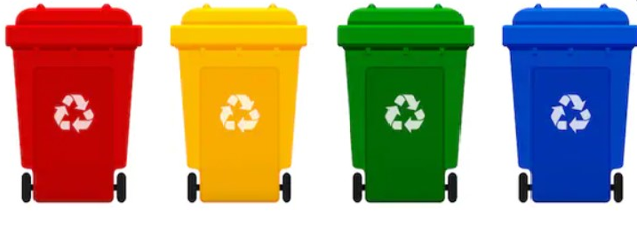
Chemical (Red) Hazardous (Yellow) Recyclable (Green) General (Blue)

Annex 13: Voluntary land Donation (VLD) document (Urdu) and VLD/Due Diligence Screening Checklist template

KP-RIISP
معاہدہ برائے رضاکارانہ زمین عطیہ
یہ رضاکارانہ عطیہ کی دستاویز مورخہ __________________ کو ترتیب دی گئی ہے۔
فریق اول
_____________________________ جناب/محترمہ_________________________ ولد/دختر/زوجہ
_____________________________ شناختی کارڈ نمبر
فریق دوم
حکومت خیبر پختونخوا بذریعہ ویلج کونسل / نیبرہڈ کونسل _____________________________، جو کے________________________________________ کی نگرانی کی خدمت سرانجام دے گی۔
آئندہ اس کو "وصول کنندہ" کہا جائے گا، جو کہ "پراجیکٹ مینجمنٹ یونٹ، رورل انویسٹمنٹ اینڈ انسٹیٹیوشنل سپورٹ پراجیکٹ حکومت خیبر پختونخوا" کی طرف سے ہوگا، اور اس میں ان کے جانشین، نامزد افراد اور مجاز نمائندے شامل ہوں گے۔
زمین اور مقام کی تفصیلات:
GIS کوآرڈینیٹس | مقام / گاؤں
تحصیل اور یونین کونسل | ضلع
زمین کا رقبہ | زمین پر موجود تعمیرات
جنوبی حد کی وضاحت | شمالی حد کی وضاحت
مشرقی حد کی وضاحت | مغربی حد کی وضاحت
(نوٹ: نقشہ بمعہ پیمائش منسلک ہے)
زمین کے مالک کی تفصیلات
والد/شوہر کا نام شناختی کارڈ نمبر | مالک زمین کا نام شناختی کارڈ نمبر
حیثیت | عمر  پیشہ
صنف | رہائش

شرائط و ضوابط:
زمین کے مالک کے پاس مذکورہ زمین پر قابل منتقلی حق موجود ہے۔
زمین کے مالک کی گواہی ہے کہ زمین پر کوئی قانونی یا دیگر دعویٰ موجود نہیں ہے۔
زمین کا عطیہ مکمل طور پر رضاکارانہ بنیاد پر کیا جا رہا ہے، بغیر کسی دباؤ یا مجبوری کے۔
عطیہ کنندہ کو عطیہ شدہ زمین پر بننے والے انفراسٹرکچر تک دوسرے کمیونٹی ممبران کی طرح مساوی رسائی حاصل ہوگی، اور کوئی ترجیحی سلوک نہیں کیا جائے گا۔
عطیہ کی جانے والی زمین مالک کی مجموعی زمین کے 10 فیصد سے زیادہ نہیں ہے۔
وصول کنندہ پبلک ہیلتھ انجینئرنگ ڈیپارٹمنٹ کی طرف سے تعمیر کردہ سہولیات اس پروجیکٹ کے مقصد کے لیے ہوں گی اور ارد گرد کے اثاثوں کو نقصان سے بچانے کا خیال رکھا جائے گا۔

دستخط کنندگان
زمین کا مالک |  |  | تحصیلدار
 |  | نام |  |  |  | نام
 |  | شناختی کارڈ |  |  |  | مہرِ سرکاری
 |  |  |  |  |  | رجسٹریشن نمبر کی منتقلی
ویلج کونسل / نیبرہڈ کونسل چیئرمین |  |  | قبائلی بزرگ / معتبر
 |  | نام |  |  |  | نام
 |  | شناختی کارڈ |  |  |  | شناختی کارڈ
گواہان
دستخط |  |  |  | نام | سیکرٹری (VC/NC)
دستخط |  |  |  | شناختی کارڈ
دستخط |  |  |  | نام | ویلج نمبر دار
دستخط |  |  |  | شناختی کارڈ
دستخط |  |  |  | نام | نمائندہ PHED
دستخط |  |  |  | شناختی کارڈ

VLD/DUE DILIGENCE:

All Voluntary Land Donation (VLD) processes shall ensure:

- Free, prior, and informed consent (FPIC) without coercion
- Independent verification by Tehsildar and VC/NC representatives
- Written documentation of consent in presence of witnesses
- Confirmation that donor is not economically or socially vulnerable unless direct net benefit exists
- Clear record of land size, percentage of holding, and no encumbrances

VLD/DUE DILIGENCE SCREENING CHECKLIST
Screening for Due Diligence | Yes | No | Remarks
Is the land in question free from any dispute on ownership or any other encumbrances?

Has the land been jointly identified by the Revenue Department, beneficiary community and project representative?
Has the Project team ensured that the land is appropriate for sub- project purposes and that the sub-project will not result in any adverse social or environmental impacts by using this land?
Have the Titleholders or landowners donating land been made to understand that they will have equal access to the infrastructure built on the donated land like any other community member and that they cannot claim for any priority treatment?
Is the land to be donated no more than 10% of the total land holding of the individual?

In case of communal land, has consent of 90% of land-owners through a consultative process been acquired?
Has it been ensured that the land titleholder/owner does not belong to vulnerable sections of society, unless he/she is a direct beneficiary of the subproject (i.e., donated parcel of land would result in net gains in that person’s livelihood)? Vulnerable sections are:
- households below the poverty line (with a valid government issued proof);
- Women headed households who may lose their shelter of livelihood due to land donation;
- Handicapped persons who may lose their shelter or livelihood due to land donation,
Has free and informed consent through meaningful consultations in good faith with all potential land donors been ensured?

Have separate discussions been held with vulnerable donors such as women, elderly and orphans to facilitate meaningful participation and ensure there is no coercion by other land donors?
Has it been verified that land is free from any encumbrances?
Has it been verified that land donation will not displace tenants or labor, if any, from the land?
Has it been verified that land donated is not land used traditionally or customarily for any religious or cultural practice?

